Introduction
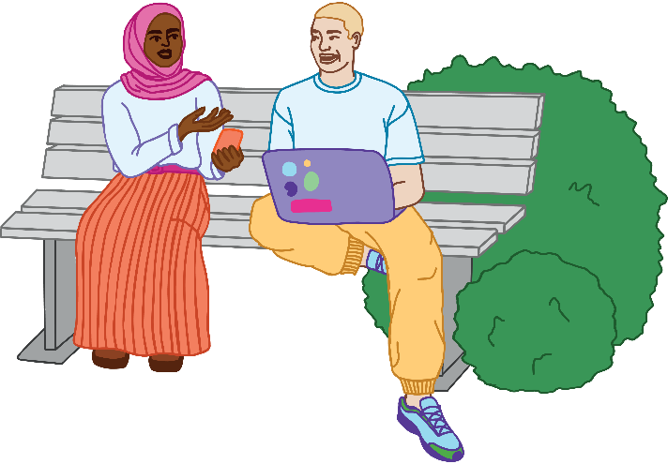
The Sunshine Coast community were invited to provide feedback on the Draft Youth Plan 2026-2031 in late 2025. An online survey was made available to gather feedback on the draft actions, and five workshops were held with young people to encourage more detailed feedback.
Residents were able to have their say between 27 October and 24 November 2025. During this four-week period:
- 560 people visited the Have your Say Sunshine Coast project webpage
- 52 responses to the survey were received
- 54 young people participated in a workshop.
Findings from the survey and workshops are presented separately below.
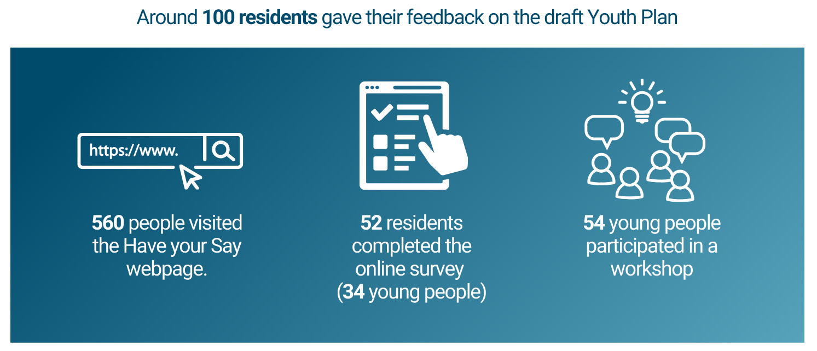

Survey results

Survey respondents
Of the 52 people who completed the survey:
- 26 were young people aged 12-17 years (50%), 8 were young people aged 18-24 years (15%) and 18 were older people aged 25 years or older (35%)
- 29 were women or girls (56%), 17 were men or boys (33%), 5 had a non-binary or other gender (10%), and 1 person didn’t state their gender (2%)
- 4 identified as First Nations people (8%)
- 9 had a disability (17%)
- 22 had participated in the first stage of the Youth Plan engagement (42%), for example, the youth forum, pop-ups or survey.

Survey results: Feedback on draft actions
Residents were asked to identify actions they thought would have a positive impact on the lives of young people, as well as actions that need improvement. The feedback from young people is summarised first below, followed by respondents aged 25 years and over.
Young people provided strong positive feedback on the following actions:
- Action 1.1: Facilitate delivery of dedicated places and spaces for young people that offer areas to hang out, things to do and, where appropriate, youth services, in settings that are safe, inclusive and welcoming. (14 votes)

Feedback: Young people supported having more safe, inclusive and affordable spaces to connect and socialise, noting that these spaces would contribute to both physical and mental health outcomes.

- Action 3.5: Coordinate and promote delivery of life skills workshops featuring practical information and skills (for example, car maintenance, sustainable living, tax and financial advice, cooking, resume development, etc.). (11 votes)

Feedback: Young people supported opportunities to develop practical life skills - such as budgeting, preparing healthy meals, job readiness and car maintenance - recognising these skills as important for becoming capable and independent adults.

- Action 3.3: Support youth-led advocacy to the Queensland and Australian Government about the challenges facing young people in our region such as housing, transport, safety and career opportunities. (9 votes)

Feedback: Housing, transport and climate change were identified as critical challenges impacting the lives of young people, and they supported this action to amplify their voices in decision-making.
Young people thought the following actions could be improved:
- Action 1.6: Promote existing Council events, activities and programs through youth-relevant information platforms. (8 votes)

Feedback: Young people felt that promoting existing Council events would be ineffective if the activities do not align with their interests and suggested that a focus on new initiatives are needed instead.

- Action 1.3: Develop an online information sharing network for young people that provides activities and things to do as well as information relevant to young people (careers, practical skills, health information) (subject to funding availability). (7 votes)

Feedback: Young people acknowledged that online networks can be useful, however they suggested face-to-face interactions are more valuable. One respondent also questioned whether, in the age of social media, an additional website would capture young people’s attention. Some also found the reference to an online information sharing network confusing.

- Action 2.7: Run a pilot program to recruit diverse Sunshine Coast Youth Connectors who can share information with young people and provide input into Council projects. (7 votes)

Feedback: Young people expressed concerns that this action would be too demanding on young people. They also worried it would be ineffective as Youth Connectors could be bullied or perceived as untrustworthy.

- Action 3.4: Investigate establishment of a ‘Youth in Action’ initiative, to complement the Kids in Action program, and explore opportunities to connect with global sustainability initiatives through the Sunshine Coast Biosphere (subject to funding). (4 votes)

Feedback: Young people mostly didn’t understand this action or didn’t provide further information to explain their opinion.
The results were similar for older residents (aged 25 years or older), except that the Youth Connectors program (Action 2.7) was well supported. They suggested that peer-to-peer influence will help engage young people in Council programs.

Survey results: Ideas for other actions
Residents were asked if they had suggestions for other actions that were not included in the draft Youth Plan. Some suggested actions include:
- Work experience in Year 10 as well as Year 9
- A café for LGBTQIA+ young people
- Creative spaces for young people
- Mock online voting for young people aged 16-17 during elections
- Getting young people involved in fundraising for charity.
Here are some positive quotes from the survey feedback:
- Great Plan! We just need to make sure changes happen from this. (18-24 years)
- Great work, really think this is a great start :) (25-49 years)
- This looks like a fantastic draft that has listened to the youth consulted. While there could be minor additions, I would not be angry at this being the final plan. (12-17 years).
One negative comment from a respondent emphasised the need to focus on delivery:
- Actions speak louder than words. (70+ years).

Workshop results

Workshop participants
Five workshops were held with young people from across the Sunshine Coast:
- Lookout 07, Warana
- IFYS, Maroochydore
- Nambour Community Centre
- Beerwah State High School
- Online session.
54 young people (12-24 years) participated in the workshops, with the majority being 12-17 years.

Workshop results: Feedback on draft actions
Young people provided strong positive feedback on the following actions:
- Action 1.1: Facilitate delivery of dedicated places and spaces for young people that offer areas to hang out, things to do and, where appropriate, youth services, in settings that are safe, inclusive and welcoming. (22 votes)
- Action 2.7: Run a pilot program to recruit diverse Sunshine Coast Youth Connectors who can share information with young people and provide input into Council projects. (21 votes)
- Action 1.3: Develop an online information sharing network for young people that provides activities and things to do as well as information relevant to young people (careers, practical skills, health information) (subject to funding availability). (20 votes)
- Action 3.5: Coordinate and promote delivery of life skills workshops featuring practical information and skills (for example, car maintenance, sustainable living, tax and financial advice, cooking, resume development, etc.). (19 votes)
- Action 3.2: Prioritise & invest in Council’s entry-level employment programs, including traineeship, internship, apprenticeship, graduate and cadetship programs, to expand employment and skill-building opportunities for young people (subject to funding availability). (18 votes)
Young people didn’t understand the following actions, or thought they could be improved:
- Action 1.6: Promote existing Council events, activities and programs through youth-relevant information platforms. (16 votes)

Feedback: Young people provided feedback that they wanted a range of new events and raised concerns that social media might not be useful for promoting Council activities to young people.
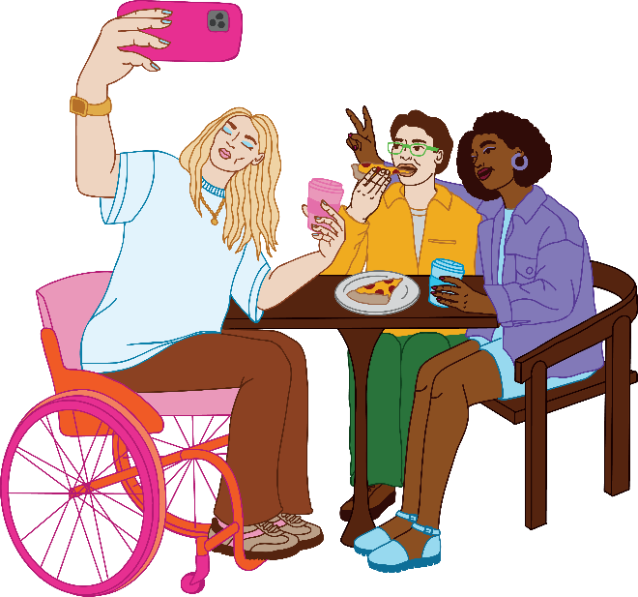
Action 2.3: Facilitate the Young Leaders Academy to support young people to develop participatory leadership skills to strengthen their communities. (13 votes)

Feedback: Many young people didn’t fully understand this action. Some young people felt there were enough leadership opportunities already (for example, at schools) or that this program could be expanded to reach a larger group of young people, rather than be limited to around 12 young people.

- Action 2.6: Support conversation circles in schools to build connections amongst young people and as a method for youth engagement. (7 votes)

Feedback: Young people felt this initiative might not be successful as young people will not want to talk about challenging issues in a school environment. The perceived risk of bullying may also limit participation.

Summary of feedback
Here is a summary of the community feedback received on the draft Youth Plan:
- Support for youth spaces and activities: Actions that aim to deliver more welcoming youth places and spaces and in-person activities, events and programs were supported. Spaces and activities support connections amongst young people which contributes to self-confidence and feelings of belonging, which were identified as challenges for young people. (Action 1.1, Action 1.4, Action 1.6, Action 1.7, Action 2.1)
- Support for life skills workshops: Life skills workshops were generally supported. While some respondents noted that certain schools already offer life skills courses, they mostly expressed negative views about these programs. (Action 3.5)

- Support for advocacy on significant issues facing young people: The significant challenges facing young people, including cost of living, housing affordability, transport, safety and career opportunities were acknowledged in the feedback, and residents supported efforts by Council to amplify the voices of young people to governments primarily responsible for these topics. (Action 3.3)

- No consistent view on how Council can communicate better with young people: There were mixed opinions about how Council should communicate with young people, with concerns raised about the effectiveness of the proposed youth-focused website, Youth Connectors program and conversation circles in schools. Young people also acknowledged that Council messages on social media platforms may be ineffective. Therefore, there was no clear response on the best way for Council to communicate with young people, especially aged 12-17 years. (Action 1.3, Action 1.6, Action 2.5-2.7)

Next steps
Council will consider this community feedback as the actions in the Youth Plan are finalised. The actions will also be reviewed in consideration of Council’s resourcing and budget availability. The final Youth Plan is expected to be presented to Council in early 2026.

