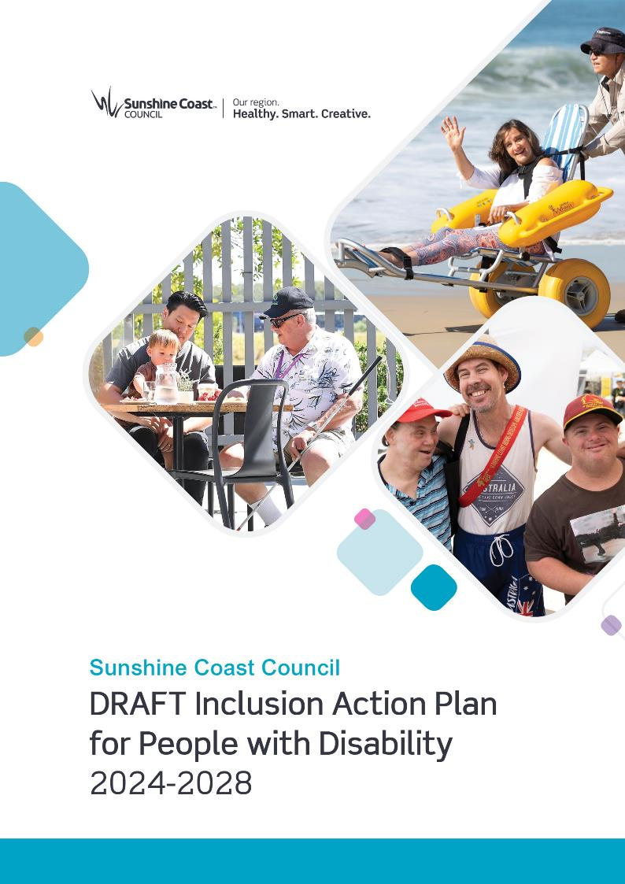
DRAFT

Sunshine Coast Council: Draft Inclusion Action Plan for People with Disability 2024-2028
Draft for Broad Engagement: June-July 2023

sunshinecoast.qld.gov.au
mail@sunshinecoast.qld.gov.au
07 5475 7272
Locked Bag 72 Sunshine Coast Mail Centre Qld 4560
© Sunshine Coast Regional Council 2009-current.
Sunshine Coast Council™ is a registered trademark
of Sunshine Coast Regional Council.
Acknowledgements
Council wishes to thank all contributors and stakeholders involved in the development of this document, including:
- Sunshine Coast Council’s Inclusion Action Plan Reference Group
- Residents of the Sunshine Coast region who have participated and contributed to the engagement activities supporting this development
- All council staff who contributed their time and expertise to the development of the action plan.
Reference document
This document should be cited as follows: Sunshine Coast Council. Draft Inclusion Action Plan for People with Disability 2024-2028.
Disclaimer
Information contained in this document is based on available information at the time of writing. All figures and diagrams are indicative only and should be referred to as such. While the Sunshine Coast Regional Council has exercised reasonable care in preparing this document it does not warrant or represent that it is accurate or complete. Council or its officers accept no responsibility for any loss occasioned to any person acting or refraining from acting in reliance upon any material contained in this document.

Acknowledgement of Traditional Custodians
Sunshine Coast Council acknowledges the Sunshine Coast Country, home of the Kabi Kabi peoples and the Jinibara peoples, the Traditional Custodians, whose lands and waters we all now share.
We recognise that these have always been places of cultural, spiritual, social and economic significance. The Traditional Custodians’ unique values, and ancient and enduring cultures, deepen and enrich the life of our community.
We commit to working in partnership with the Traditional Custodians and the broader First Nations (Aboriginal and Torres Strait Islander) communities to support self-determination through economic and community development.​​​​​​​
Truth telling is a significant part of our journey. We are committed to better understanding the collective histories of the Sunshine Coast and the experiences of First Nations peoples. Legacy issues resulting from colonisation are still experienced by Traditional Custodians and First Nations peoples.
We recognise our shared history and will continue to work in partnership to provide a foundation for building a shared future with the Kabi Kabi peoples and the Jinibara peoples.
We wish to pay respect to their Elders – past, present and emerging, and acknowledge the important role First Nations peoples continue to play within the Sunshine Coast community.
Together, we are all stronger.

Language of Disability
Sunshine Coast Council acknowledges that the preferred language of disability varies between individuals and groups and preferred language may change into the future.
Council does not want to exclude anyone based on the language used. We endeavour to work with and continue to learn from people with lived experience of disability to ensure language choice is respectful.

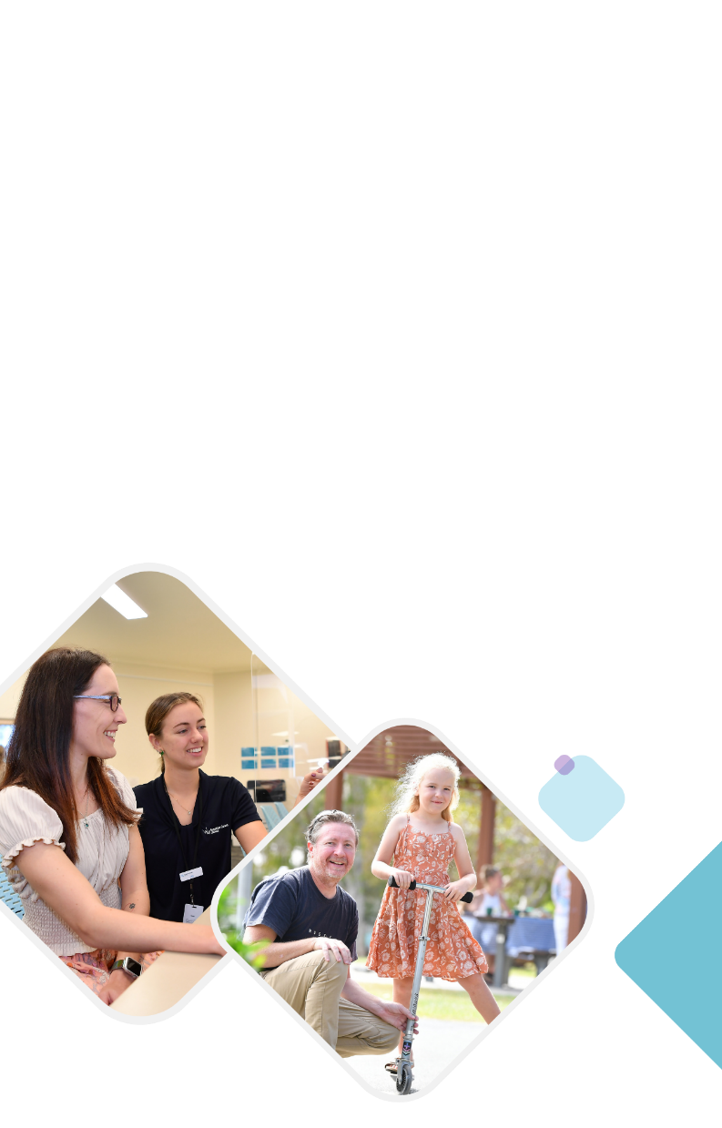
Contents
1. Introduction 8
2. Snapshot of People with Disability 15
3. Policy Context 17
4. How this Plan was Developed 21
5. Guiding Principles and Commitments 25
6. Achievements to Date 27
7. Action Plan 29
Glossary 69

Message from the Mayor
To be added in final action plan.

Message from the CEO
To be added in final action plan.

Message from Cr Law
To be added in final action plan.

Message from the Inclusion Action Plan Reference Group
To be added in final action plan.

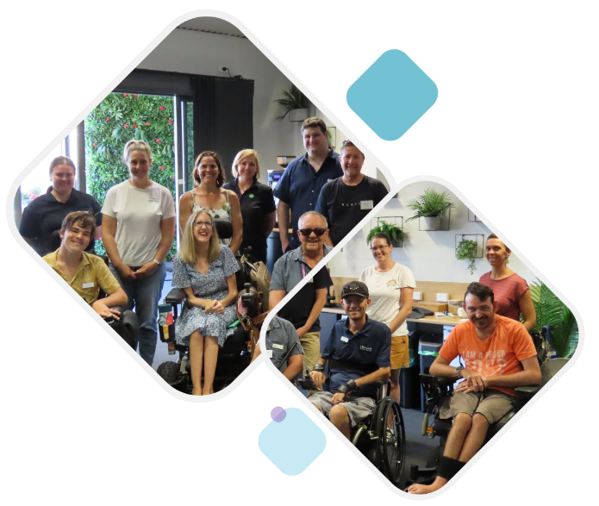

1. Introduction

An Inclusive Sunshine Coast for People with Disability
By 2028, the Sunshine Coast will be a region where people of all abilities have equitable opportunities to live, work, visit and play.
According to the United Nations Convention on the Rights of Persons with Disabilities:
“Disability is a long-term physical, mental, intellectual or sensory impairment, which in interaction with various barriers, may hinder full and effective participation in society”¹.
Over 21,000 residents of the Sunshine Coast have a severe disability². People with disability are an important part of our community, with most disabilities being invisible. It is likely that everyone either knows someone with disability or will experience disability at one point or another in their lives. Disability is part of being human.
Discrimination, however, is one of the many challenges that people with disability face in their day-to-day lives. Barriers, whether attitudinal or environmental, restrict people with disability from being able to participate in all parts of community life. By removing these barriers, people with disability can reach their true potential as equal members of our community with opportunities to contribute fully, and feel valued, respected and that they belong.
The Sunshine Coast Region is growing and changing, from our built environments to our evolving communities. With 8000 new residents arriving to the Sunshine Coast each year, this trajectory is set to continue to 2041 when our region will be home to more than 500,000 people³. The number of people on the Sunshine Coast with severe disability will increase. We have the opportunity now to expand on the great work to date to remain inclusive, connected and accessible as we grow – to build a Sunshine Coast Region with opportunities for all to participate socially and economically. Inclusive communities provide a broad range of benefits for everyone in our community, from the economic aspects of broader workforce participation and improved tourism potential and attraction, to increased social connections, a sense of belonging and enhanced wellbeing.
Whilst the Sunshine Coast Council is proud of the work we are already doing to improve inclusion for people with disability, we recognise there is always more work to be done.
The draft Inclusion Action Plan for People with Disability is a demonstration of council’s continuing commitment to improve inclusion for people with disability on the Sunshine Coast.
The draft action plan has a 5-year timeframe and closely aligns with council’s Community Strategy 2019-2041 and its goal to build a ‘strong community’, which meets the needs of people of all abilities, and where opportunities are available for all. The Sunshine Coast will also be the backdrop for a number of events at the Brisbane 2032 Olympic and Paralympic Games. This action plan supports the legacy vision for a more connected, active and sustainable future Sunshine Coast.
Through implementation of the draft Inclusion Action Plan for People with Disability, council aims to increase inclusion for people with disability, to create a region where everyone belongs, can participate and thrive.

Action Plan
The draft action plan outlines four principles and commitments for how council will implement actions over the next five years to build an inclusive, accessible region. Actions are outlined across five priority action areas.
Principles and commitments:
- Promoting and protecting human rights
- Increasing disability awareness
- Valuing lived experience
- Improving access.
Priority action areas:
- Awareness and education
- Employment and training
- Events and programs
- Built environment and public spaces
- Participation and communication.
The priority areas were developed with input from the Action Plan Reference Group. The reference group was set up for the project and comprised of members of the community with diverse lived experience.
Each priority area is also accompanied by a personal story of a person with lived experience.
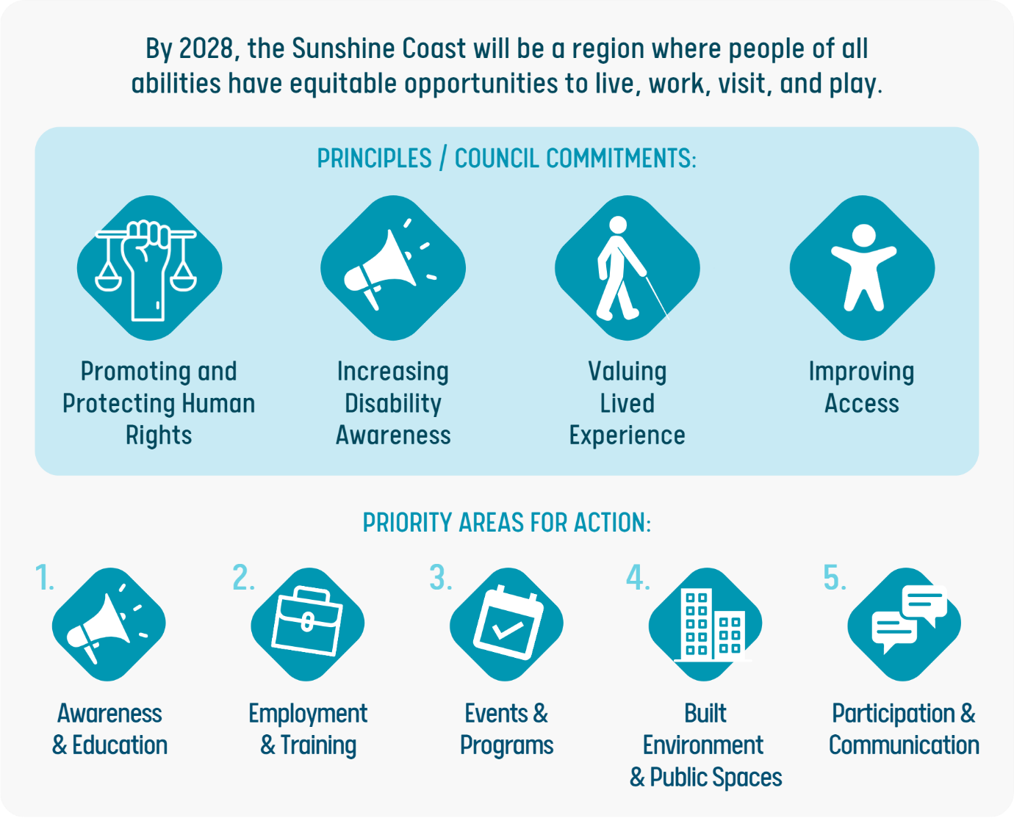
Lived Experience
Lived experience belongs to people with a first-hand experience of a particular topic or situation, rather than knowledge that is gained through research. Involving people with lived experience in action plan development ensures that the perspectives, needs and insights of people with direct experience are appropriately heard, valued and understood.

Supporting this action plan is a series of information sheets on relevant topics to help provide further context for this plan.
Information Sheet 1: What is Disability?
Information Sheet 2: Concepts and Principles
Information Sheet 3: Our Engagement Process
Information Sheet 4: Policy Context
Information Sheet 5: Benchmarking Analysis

Evaluation and Review
Each action in this draft action plan will be delivered by council between 2024 and 2028. Some of the actions are written to be specific and others are flexible to allow community need to determine what is delivered, allowing for partnerships between council and community.
Each action will be accompanied by associated measures to monitor implementation. The action plan will be reviewed halfway through the plan’s implementation, with annual reporting of achievements.
Council will track the impacts of the action plan through the existing Community Strategy evaluation framework.

Alignment with United Nations 2030 Agenda for Sustainable Development
Council is committed to sustainable development. In 2022, the Sunshine Coast region was recognised as a biosphere reserve by UNESCO.
The United Nations 2030 Agenda for Sustainable Development and the Sustainable Development Goals (SDGs) provide the foundational promise to “leave no one behind”.
The outcomes in this draft action plan align with many of the United Nations 2030 Agenda for Sustainable Development Goals (SDGs), including:
- Goal 3: Good health and well-being
- Goal 4: Quality education
- Goal 5: Gender equality
- Goal 8: Decent work and economic growth
- Goal 10: Reduced inequalities
- Goal 11: Sustainable cities and communities
- Goal 16: Peaceful, justice and strong institutions
- Goal 17: Partnerships for the goals
The diverse value people of all abilities bring to our region is recognised and respected.
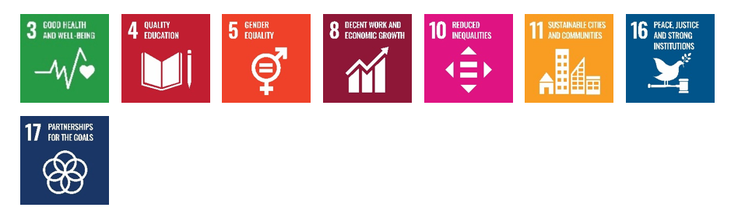
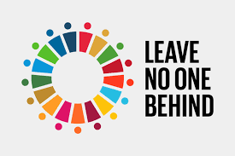

Brisbane 2032 Olympic and Paralympic Games
The Brisbane 2032 Olympic and Paralympic Games presents a unique opportunity for the Sunshine Coast to put itself on the map as an accessible and inclusive region, and destination for people with disability. This draft action plan recognises the value the upcoming Brisbane 2032 Olympic and Paralympic Games brings to the region, in serving as a catalyst for change, to improve inclusion across our region for people of all abilities.

Accessible Tourism
2023 is the year of accessible tourism in Queensland. Accessible tourism means that all people with disability have the opportunity to visit and enjoy the quality lifestyle that our region offers. Council endeavours to continue partnering with the community sector, government and private organisations to support opportunities to increase accessible tourism in our region.

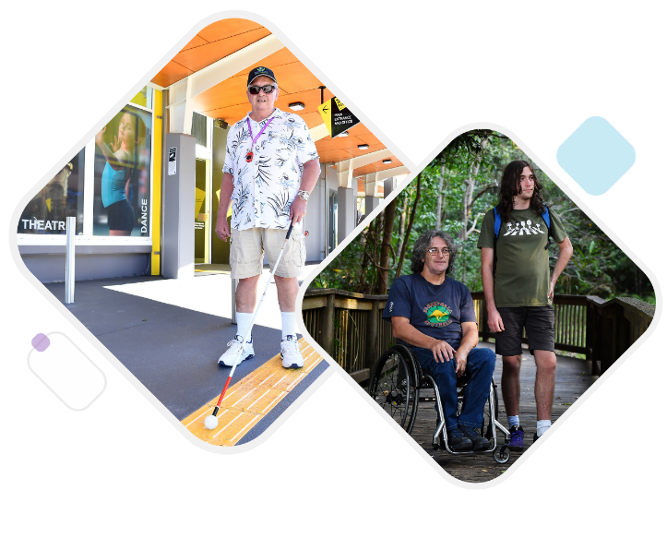

2. Snapshot of People with Disability

Australia
4.4 million Australians had a disability in 2018 (18% of the population)⁴. This includes 1.4 million people with a severe or profound disability (32% of those with disability) and 1.0 million people with a non-physical disability (as their main disability – 23% of those with disability). Up to 90% of disabilities are invisible (not immediately evident to others)⁵ and only around 4% of people with disability use a wheelchair⁶.
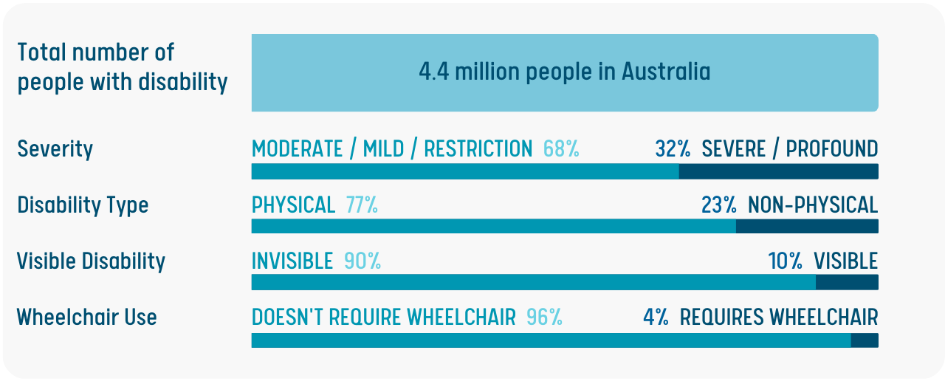
1 in 6 working aged people with disability experienced discrimination in the previous year, and 4 in 9 avoided situations because of their disability⁷.
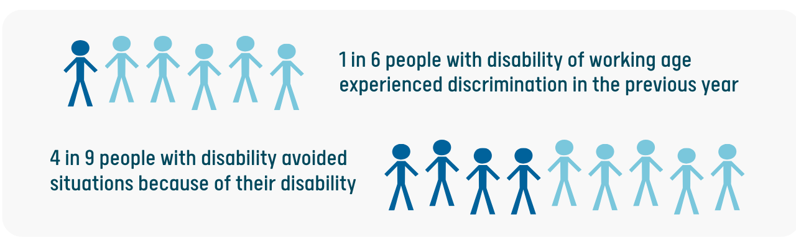

Sunshine Coast
21,211 residents of the Sunshine Coast have a severe disability (6.2%)⁸. The number has more than doubled in the last 15 years and is expected to double again in the next 20 years⁹.
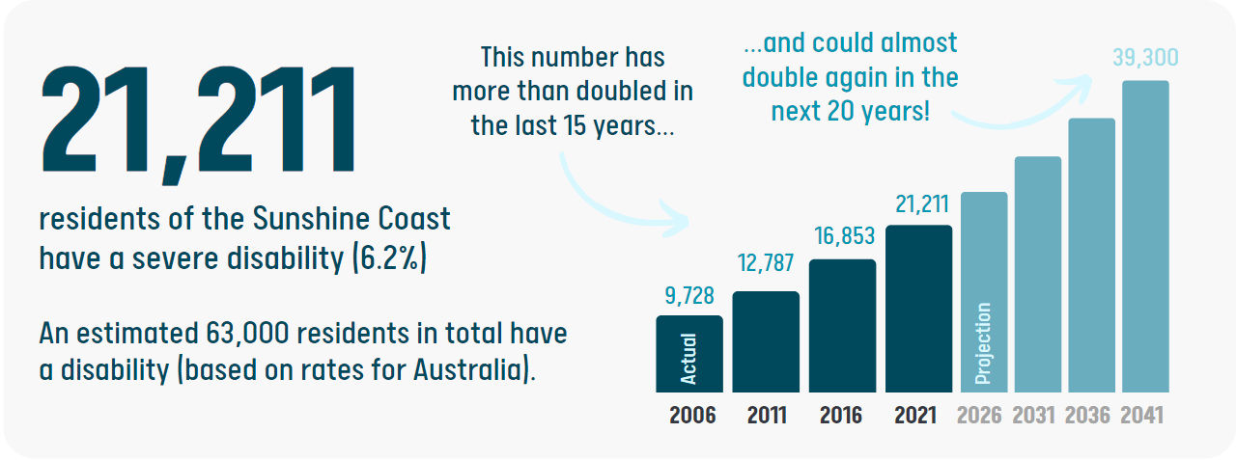
Rates of severe disability were higher for older people (16% of older people aged 65 years and older have a severe disability), and First Nations people (9.0% of Aboriginal and/or Torres Strait Islander people have a severe disability)¹⁰. Rates of severe disability were lower for residents born overseas (4.9% of residents born overseas have a severe disability)¹⁰.
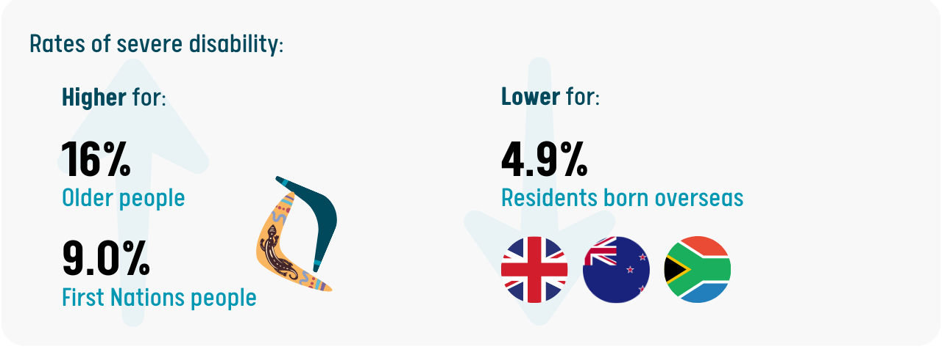
20% of people aged 15-64 years with a severe disability were employed which is significantly lower than for those without a disability (79%)¹⁰.
More statistics about people with disability in Australia and the Sunshine Coast are included in Information Sheet 1.

3. Policy Context

International, National and State Policy Context
The development of this draft action plan was informed by a review of the relevant international, national, and state strategies and legislation for people with disability, which includes:
- United Nations Convention on the Rights of Persons with Disabilities 2008
- United Nations 2030 Agenda for Sustainable Development
- United Nations Disability and Development Report 2018
- Disability Discrimination Act 1992 (Cth)
- Australia's Disability Strategy 2021-2031
- Human Rights Act 2019 (QLD)
- Anti-Discrimination Act 1991 (QLD)
- Disability Services Act 2006 (QLD)
- Local Government Act 2009 (QLD)
- Queensland’s Disability Plan 2022-2027
- Communities 2032 Strategy (QLD)
- Disability (Access to Premises-Buildings) Standard 2010 (Cth)
- Building Code of Australia & Standards
- National Construction Code.
Further information about the policy context is provided in the Information Sheet 4.

Council Policy Context
This draft action plan fits within a broad suite of existing council policies and strategies which govern implementation and resourcing.
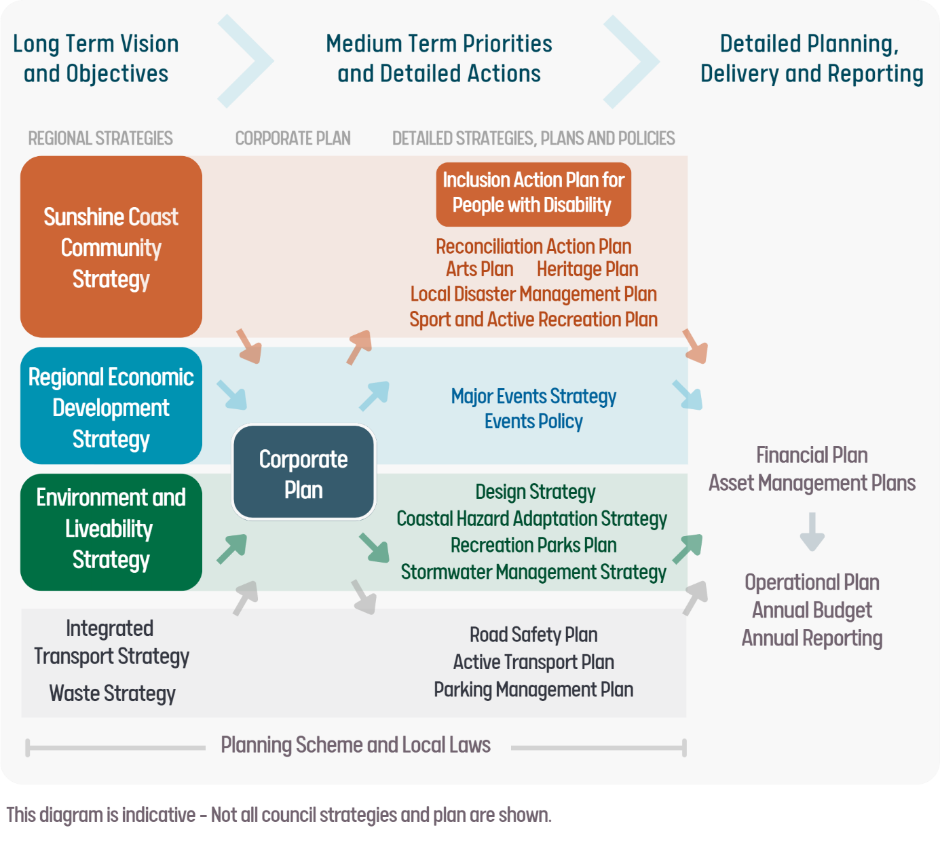

Regional Strategies and Corporate Plan
Council has three regional strategies which provide a long-term vision for the future of the Sunshine Coast:
- Sunshine Coast Community Strategy 2019-2041
- Environment and Liveability Strategy 2017
- Regional Economic Development Strategy 2013-2033.
All three regional strategies are relevant to inclusion for people, and demonstrate council’s commitment to:
- An accessible and inclusive community for people with disability
- A robust and diverse economy that supports training and employment opportunities for people with disability
- A liveable and connected urban and natural environment, including appropriately zoned land for housing and a consolidated urban form, supporting multiple transport modes.
Council’s Corporate Plan 2023-27 provides strategic direction for the next five years, to advance council’s vision for the Sunshine Coast as “Australia’s most sustainable region”. All of council’s activities flow from the strategic priorities outlined in the Corporate Plan. There is strong alignment with these strategic priorities and the actions in this draft action plan.

Other Strategies and Plans
Other relevant council strategies and plans include:
- Active Transport Plan 2011-2031
- Aquatic Plan 2011-2026
- Asset Management Plans (various)
- Community Engagement Policy and Excellence in Engagement Framework 2021
- Design Strategy 2019
- Human Rights Policy and Implementation Plan (in development)
- Integrated Transport Strategy 2019
- Local Disaster Management Plan 2019-2022
- Major Events Strategy 2018-2027
- Open Space Landscape Infrastructure Manual (LIM)
- Parking Management Plan 2017
- People Plan (in development)
- Recreation Trail Plan 2012
- Recreation Parks Plan 2021-2031
- Smart City Framework and Implementation Plan 2022-25
- Sport and Active Recreation Plan 2011-26
- Urban Lighting Master Plan 2016.

4. How this Plan was Developed

Inclusion Action Plan Reference Group
Fourteen members of the Sunshine Coast community with lived experience of disability volunteered to be part of the Inclusion Action Plan Reference Group to guide development of this draft action plan.
Members included people with a broad range of disabilities and representatives from organisations and advocacy groups. The group had a mix of young people and older people, and a balanced gender mix.
Members participated in workshops to develop a list of their priority actions which were then further developed by council to inform the development of this draft action plan.

Access and Inclusion Coordination Group
Council coordinates an Access and Inclusion Coordination Group which was set up as part of the previous Access and Inclusion Plan 2011-2016. The group includes council officers, representatives from stakeholder organisations, and community members with disability. It continues to meet regularly.
The group was briefed about the project and helped to spread the word about engagement opportunities for people with disability and the disability sector. The group also provided feedback on the project development and provided input into priorities for action.

Targeted Surveys
Targeted surveys were developed for residents of the Sunshine Coast with disability and carers, and workers in the disability sector. The surveys gave residents the opportunity to provide input into improvements that could be made, to make the region more inclusive for people with disability.
A total of 97 people completed the surveys, including people with disability, carers, and people who work in the disability sector.
The top five issues/challenges raised were:
“Please educate the greater community that disability is more than just a wheelchair spot.”
- Discrimination
- Connectivity and transport
- Accommodation and housing
- Having a say
- Job opportunities.
The top three places to improve accessibility were: beaches; bushland and natural reserves; and pools and leisure centres.
A summary of the results of the surveys is included in Information Sheet 3.

Internal Engagement
Focus group sessions were undertaken with council staff from a range of teams to identify existing initiatives and future opportunities to increase inclusion.
The top five areas for council to improve inclusion for people with disability were:
- Organisation-wide communication and engagement
“We can be proud of what we are doing and where we can work together to make a difference in other areas.”
- Public realm
- Disability awareness training for council staff
- Council-owned venues and facilities
- Support for accessibility in private sector development

Local Government Policy Comparison
Disability inclusion plans from local governments in Queensland, New South Wales, and Victoria were reviewed to identify possible initiatives.
Common actions pursued by other local governments were:
- Physical improvements to the public realm and community facilities
- Inclusive council and community events
- Disability awareness training for council staff
- Inclusive council communications and engagement.
A summary of the analysis is included in Information Sheet 5.

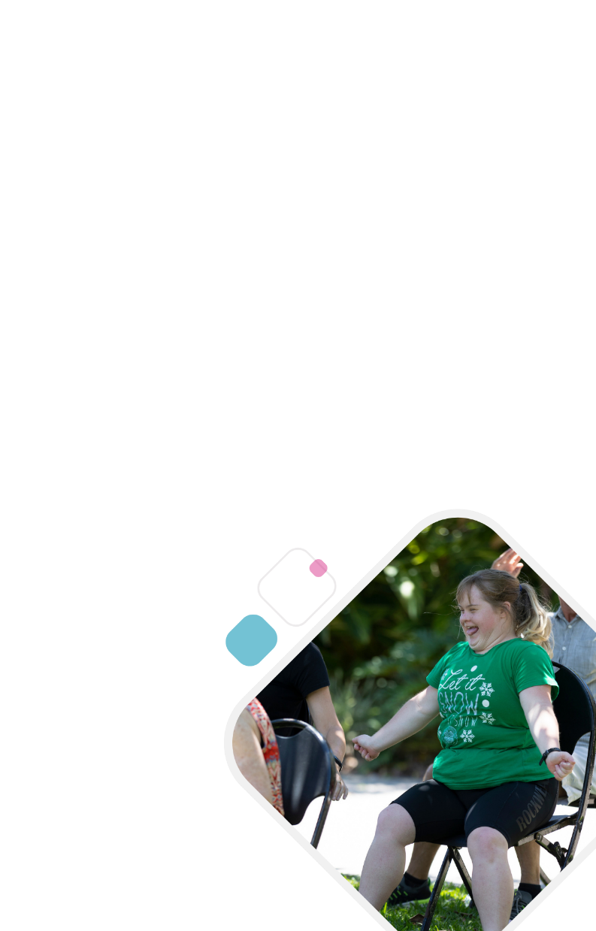
Broad Community Engagement (upcoming)
The Sunshine Coast community will have the opportunity to have their say on this draft action plan before it is finalised and adopted by council.
Broad community engagement will occur during June-July 2023 and will include a range of activities to hear from as many people as possible. Activities may include:
- Online resources, including information sheets
- Online and printed survey
- Phone survey option
- Easy English version of the draft action plan
- Face-to-face events attended by people with disability
- Presentations to groups of people with disability, community organisations, networks and agency groups
- Meeting of the Access and Inclusion Coordination Group.

5. Guiding Principles and Commitments

1. Promoting and Protecting Human Rights
Everyone has the right to participate with dignity, independence and respect, without discrimination.
We commit to promoting and protecting the human rights of people with disability in our activities and will contribute to a region where everyone has equitable opportunities to live, work, visit and play.

2. Increasing Disability Awareness
It is recognised that a disability may be visible or invisible. A person may have multiple disabilities or other personal characteristics that interplay with disability, to create different experiences of life. Disability may or may not be a significant part of a person’s identity. A person’s perception of disability identity is unique.
We commit to treating all community members with care and respect as part of our core values.

3. Valuing Lived Experience
The value of listening to and learning from the lived experience of people with disability, is understood and prioritised.
We commit to providing people with disability the opportunity to participate in decision-making processes, particularly those directly concerning them.

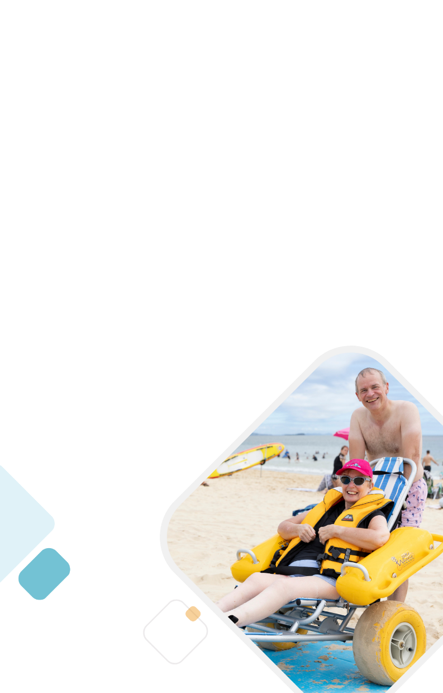
4. Improving Access
There may be physical and non-physical barriers in places that restrict people with disability from accessing council infrastructure, programs, services and resources. We recognise that people with disability may require additional support to achieve equitable access.
We commit to working with people with disability to understand their needs and help overcome barriers to accessing council-led initiatives.

6. Achievements to Date
There are many council achievements to date to improve inclusion for people with disability, including national recognition of some of our projects and programs. Council has delivered a wide range of initiatives to increase opportunities for people with disability to enjoy the best of what the Sunshine Coast has to offer.

Achievements
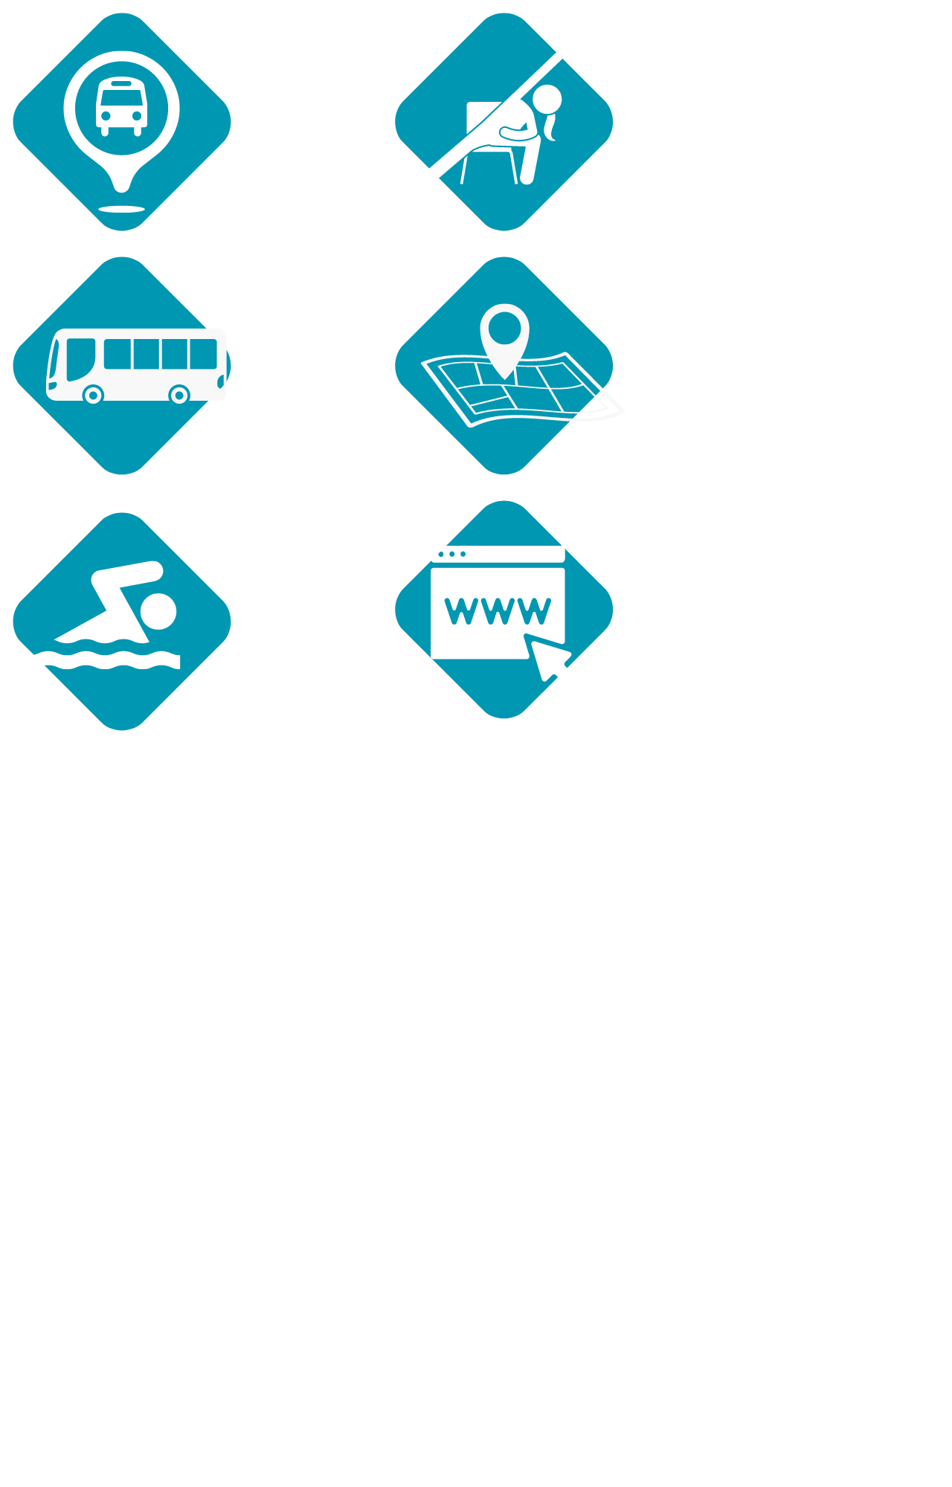 | 719 out of 730 (98%) of bus stops are now DDA compliant.
 | 11,203 passengers travelled a total of 59,924km using the Council Link service.
 | Pool hoists now available at all nine aquatic centres, and pool wheelchairs will be available at all centres soon (wheelchair to be provided at Kawana Aquatic Centre as part of upgrade works).
 | All abilities exercise classes included as part of the Healthy Sunshine Coast program.
 | Mobility mapping of accessibility features across multiple areas of the region making the Sunshine Coast the most mapped local government area in Australia.
 | Council’s corporate website WCAG upgraded for greater accessibility.

Awards
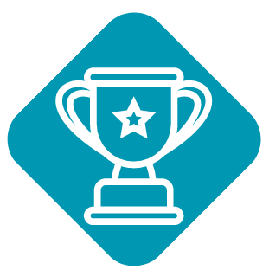 | Sunshine Coast Mobility Mapping – National Award for Local Government 2022
 | Caloundra Main Street Urban Revitalisation project - Landscape Architecture Award in Urban Design category at the Australian Institute of Landscape Architects 2021 Awards.
 | Community Strategy 2019-2041 – A Commendation for Public Engagement and Community Planning at the Planning Institute of Australia 2021 Awards
 | Stage One Northern Parkland Mooloolaba Foreshore Revitalisation Project – Project of the Year at the Institute of Public Works Engineering Australasia 2022 Awards
 | Community Engagement: Excellence in Engagement Framework 2021 – Highly Commended for Organisation of the Year at the IAP2 Australasian 2022 Core Values Awards

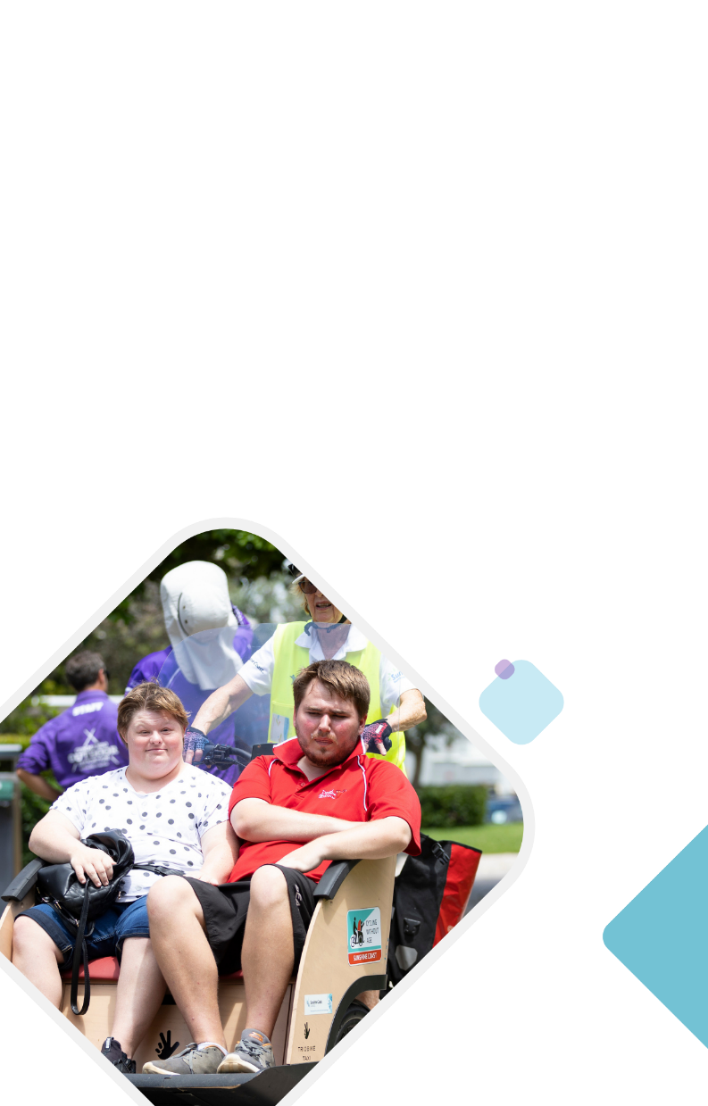
7. Action Plan
Council already delivers a range of activities that support inclusive communities and outcomes. This draft action plan seeks to recognise that work, but also extend upon this impact by focusing on key initiatives over the next five years.
A summary of the current and future actions for each priority area is detailed below.

1. Awareness and Education

Fin’s Story
“My name is Finley (Fin) Coll. I’m 15 years old and I’m in Year 10 at Meridan State College and live with Quadraplegic Cerebral Palsy. I live at home with my mum, dad, younger brother and my dog, Wilson. I like technology, being with mates, politics and calling hotlines for government services!
My Cerebral Palsy is from complications at birth, and it means I use a powered wheelchair to get around and use a communication device to talk. My device is called Bob!
One of my big goals in life is to be part of the community through volunteering and helping.
Unfortunately, the few times I’ve tried to volunteer, people have shut me down before they’ve got to know me to find out what I have to offer. This has made me feel sad and angry. But I think this is often because people haven’t met people like me before and don’t know how to work with me.
One of the ways we can get better at understanding how to work with and support people with disability is to have people like me in mainstream schools or the community. It becomes normal.
A great example of this for me was at school when I approached my case manager, Jacki. I shared with her my idea about Disability Action Week (DAW) becoming a big celebration in our school, similar to NAIDOC week.
My simple, small idea to start with was to organise a game of wheelchair basketball for the teachers to play during Disability Action Week, where I got to be the referee. Jacki was a huge support because she thought it was a great idea and would help to create awareness of disability. She helped organise the wheelchairs, locked dates in and organised with the school to make it happen.
When Jacki agreed to help and took me seriously, I was so happy and excited.
After the game, my PE teacher, who’d had a good time, realised that wheelchair basketball would be a good unit for all the students to do. He set about making that fit the curriculum alongside the standard basketball unit. That unit of study continues each year along with the DAW teachers’ game.
Since then, the school has also made me the first Access Liaison Leader to help lead access and inclusion across the school.
This makes me proud.
Awareness and education on disability helps us change thinking and responses to disability and that makes us more inclusive.”
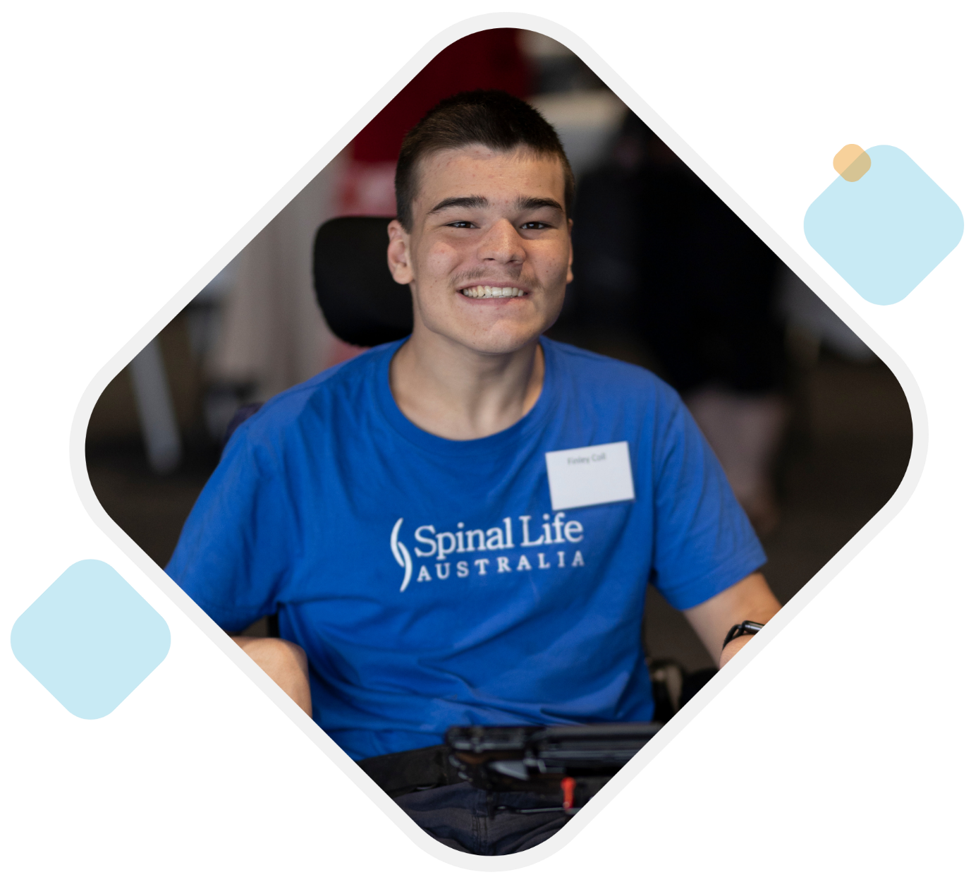

Awareness and Education
Our community is aware and educated about disability which contributes to people with disability being valued and included and feeling that they belong.
This priority area includes disability awareness and education for council staff and the community (including business community and industry groups).
Awareness and education are the first steps to removing participation barriers and reducing discrimination of people with disability.
Our community told us that discrimination was a major challenge for people with disability. Community members also suggested that greater community awareness and education would make it easier for people with disability to participate in community life. Disability awareness and education were also suggested as opportunities to improve interactions with council and local businesses.
Our research suggested that some important concepts that need to be understood to reduce discrimination include:
- 90% of disabilities are invisible (not immediately evident to others)
- Disability is diverse and each person has unique needs and experiences. People with disability should be engaged and worked with to achieve shared goals
- People with disability often want to participate but societal barriers prevent this. These societal barriers include attitudinal, environmental, organisational and communication barriers.

Project Highlights
Disability Awareness Training
In 2022, elected Councillors, the Executive Leadership Team and some council staff members participated in a disability awareness training day held by Spinal Life Australia. The training was run as a ‘Realistic RACE’ and provided participants with the opportunity to assume a disability in the built environment for part of a day. Feedback from the training was very positive and participants reported a broadening of understanding about some of the barriers people with disability face out in community.

Current Actions
Examples of what council is currently doing:
- Disability Awareness Training for Councillors and Executive Leadership Team by Spinal Life Australia in 2022.
- Inclusive Habits training for Branch Managers across the organisation to foster inclusive leadership.
- Unconscious Bias training for all council staff.
- Training for council staff working at major sport and community venues about inclusive principles.
- Human Rights Awareness Training available to all council staff based on the Queensland Human Rights Act 2019.
- Training for library staff on disability inclusion by Spinal Life Australia.

Future Actions
- 1.1 Deliver disability awareness training for all council staff and elected councillors.
- 1.2 Coordinate an annual week of activities that celebrates Disability Action Week within council and the community.
- 1.3 Develop and deliver a community education campaign to raise awareness of disability and the value people with disability bring to council and the community.
- 1.4 Work with business and tourism event organisers to promote the benefits related to inclusion.
- 1.5 Raise awareness and recognition of businesses that demonstrate excellence in inclusion.

2. Employment and Training

Payge’s Story
“Finishing up school, I wasn’t 100% sure what was going to be my next step. I wasn’t sure where my life was heading. I just knew that like anyone else it was time to get my resume together and start looking for my first job. With the help of my mum, I applied for several positions, but it seemed like the word "disability" on my resume was a barrier for everyone but me. The constant feeling of rejection began to wear on me, and it made me feel like I was not good enough. I got the feeling that businesses just saw me as slow and not capable, and they didn’t give me a chance to prove myself.
I started to fill in my time with other activities that I enjoyed and began to make some friends to build on my social skills, and my community connections. Having people give me the chance to show my potential in these social areas led to not one but two job interview opportunities. I’m proud to say that I was successful with both and now hold two paid (parttime) jobs with Equity Works and Parent 2 Parent Qld.
Working has given me a sense of freedom and independence. It allows me to make friends outside of my family, it gives me the ability to make my own money, it gives me skills that improve me personally and as an employee. Working makes me happy and keeps me busy, it gives me a sense of belonging and achievement. It gives me a goal and I feel like it allows me to achieve the things I want to achieve.
I love to be independent and earn my own money.
Working has changed my life! Sometimes I do fear that if I didn’t have my job, I would end up sitting around feeling like I'm worthless, and lose hope. I work really hard to be the best I can be in my job, and hope to learn new things and get faster as time goes by.
I want people to know that everyone is employable. People can surprise you in unexpected ways so give us a chance to prove ourselves. I may have a disability, but I was brought up never to give up and neither should other people in my situation. Inclusive employers are out there, we just need to continue to connect, and I am doing that now through the Here Now Next Project and through my role at Parent 2 Parent. I enjoy supporting young people to give them the strength to connect with future employers.
People with disabilities have so many abilities - we are worth it.”

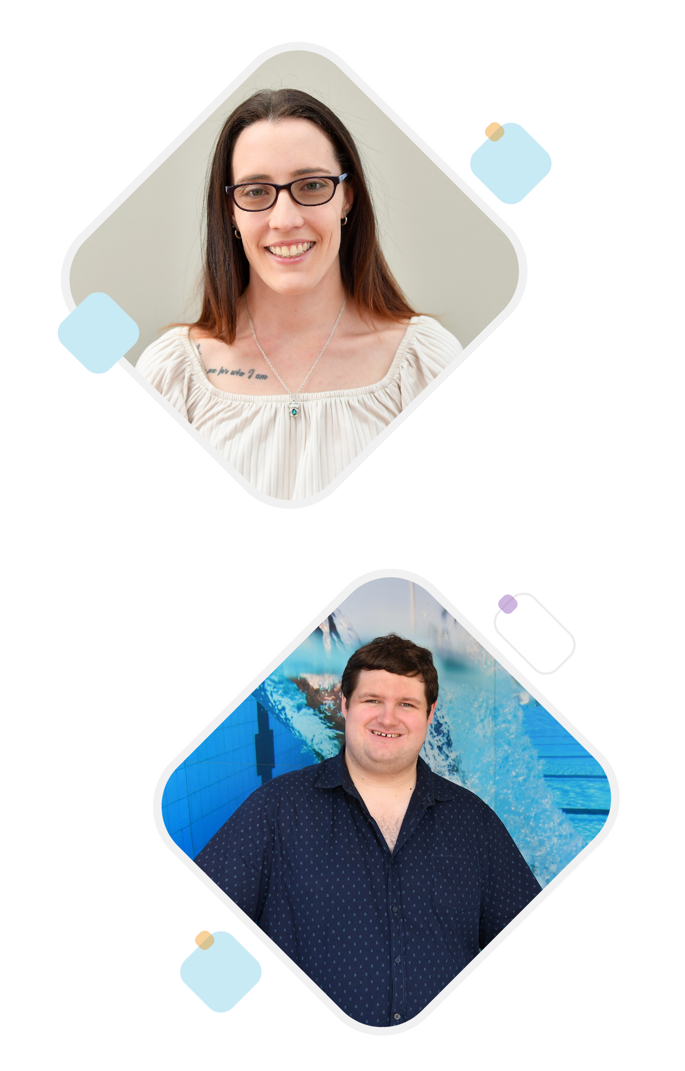

Employment and Training
Our community provides equitable opportunities for training and employment of people with disability so that they can experience the independence, self-confidence, and social benefits of work.
This priority area includes training, volunteering, work experience and employment at council and in the community.
Most workplaces tend to have barriers for employment of people with disability that need to be removed to increase participation.
Stigma and misconceptions from hiring managers can mean people with disability are not even considered for roles. Application processes and face-to-face interviews can disadvantage people with certain disabilities. Physical accessibility and availability of bathroom facilities can be an issue in many workplaces. Some workplaces also have inflexibility in their work practices which preclude people with disability.
Our community told us that job opportunities on the Sunshine Coast were a major challenge for people with disability. Community members suggested that more employment and training opportunities were needed to make it easier for people with disability to participate in community life. Barriers to employment included a lack of available jobs, discrimination, lack of support, inflexible work arrangements and accessible transport.
Innovative options for training and employment of people with disability can also create new opportunities, such as supporting social enterprise development and the impact sector.

Current Actions
Examples of what council is currently doing:
- Partnering with Disability Employment Services provider to promote employment and work experience opportunities with Design and Placemaking Services and Parks and Gardens branches.
- Volunteering opportunities available for people with disability at council parks and libraries and Venue 114.
- BushCare Mates program under BushCare Sunshine Coast working with students from Currimundi Special School and Caloundra State High School - Lighthouse Centre.
- Meaningful Employment Project to engage people with disability to help them overcome barriers to employment.
- Council’s internal Diversity and Inclusion Advisory Group are in the process of developing an action plan to improve diversity and inclusion representation at council.
- Review of the Regional Economic Development Strategy will help to continue to grow local employment opportunities and will have a focus on impact sector.

Future Actions
- 2.1 Promote council’s employment opportunities, work experience and traineeship programs to people with disability.
- 2.2 Continue to expand and promote council’s volunteering opportunities available to people with disability.
- 2.3 Promote and expand training initiatives provided by the disability sector to increase disability awareness within local businesses and the value inclusive workplaces bring to individuals and the community.
- 2.4 Review council’s recruitment and application process to strengthen inclusion for people with disability.
- 2.5 Undertake an audit of council workplaces to improve accessibility and processes for workplace adjustments.

3. Events and Programs

Belinda’s Story
“Attending concerts and experiencing live music is something I thoroughly enjoy. As an avid concert goer, I have attended numerous live concerts, even traveling to other states to see some of my favourite performers. I have cerebral palsy which affects the mobility and I use an electric wheelchair to get around, which makes the accessibility of a concert or music event of the upmost importance. In 2019, I attended the Caloundra Music Festival, and it was an absolutely amazing experience, not only for the music, but also for its accessibility. There were two things that really stood out for me – the shuttle buses were accessible and there were various viewing options. For many people with disabilities, including myself, half the battle of attending a festival is getting there.
The event provided free shuttle bus transport from multiple locations which were accessible, which meant I had an easy way of getting to the festival. Riding on the bus was half the fun of attending, because at the end of the day, festival goers shared their experiences from the day. When I arrived at the festival and started to explore my surroundings, I was pleasantly surprised that there were lots of seating locations that I could choose to access. The ability to choose where I wanted to sit gave me the opportunity to design my own experience. In that moment, I was listening to the music, having fun, and all the other people around me were doing the same, and it seemed as if there was no separation between us.

Festivals and events can get more inclusive in many ways, including giving festival goers access to a variety of viewing options, accessible toilets, quiet zones, pathways if there’s an uneven surface, reducing strobe light usage, and having Auslan interpreters, just to name a few. A festival is a unifying experience, a chance to share the heart-swelling transcendence of a favourite band (or find out about the greatness of a new artist) with others.”

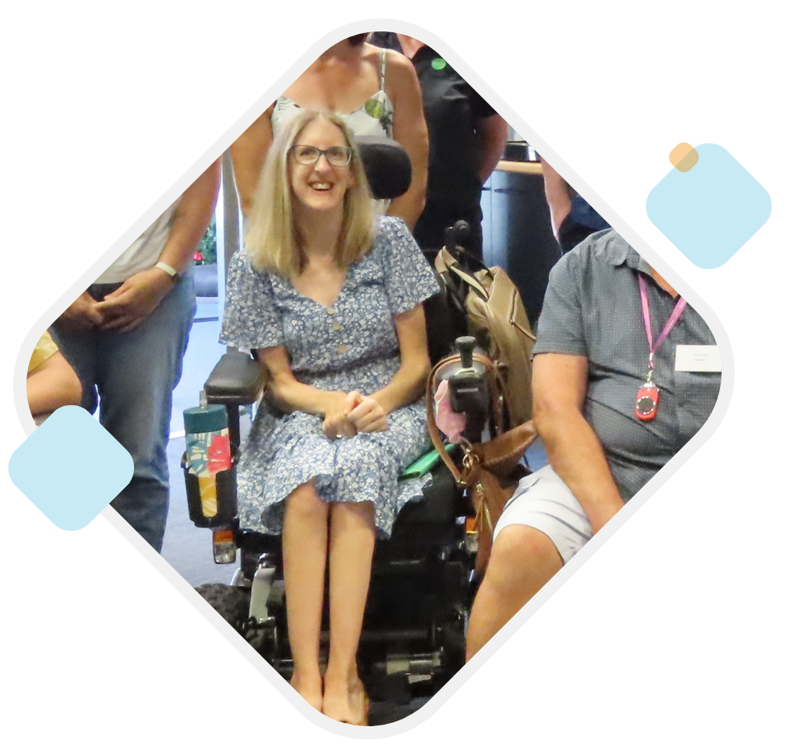

Events and Programs
Everyone can participate in community events, activities and programs. People are provided with the additional support and information they need to plan ahead and attend important events, activities and programs.
This priority area includes events, activities and programs provided by council and others, including major events at facilities and in public spaces.
Our community told us that people with disability enjoy participating in community events and programs because they offer new experiences and the opportunity to learn new skills. They can also offer connection, companionship, a feeling of acceptance and inclusion, and a feeling of safety and comfort.
Participating in activities has been identified as a challenge for people with disability on the Sunshine Coast. Some of our community thought that people with disability should be able to attend all events and programs on the Sunshine Coast – “just like everyone else”. While others thought this might not be possible, and that special events should be offered targeting people with different types of disability.
Removing barriers to participation in events, activities and programs can be achieved by providing information about the activity, accessible features at the event space, or providing extra support. Also, having information available in accessible formats that describes the inclusive features of an event or program can help people with disability to plan their attendance. Some people with disability cannot attend an event without accessible features (such as accessible transport, parking, toilets, quiet room, dimmed lighting, etc.) but not all events and programs provide these options. Additional support may also be required based on individual needs; having disability confident and aware staff goes a long way to having this extra support provided.

Project Highlights
Mindful Art Program
The Mindful Art Program occurs on a monthly basis and provides people living with dementia and their carers in the community a safe and friendly experience within the Caloundra Regional Gallery. Two artworks are selected for each session and are used as a prompt to help stimulate conversation from the visiting group. Each session is attended by council staff members and volunteers.
The Mindful Art Program recommenced in March 2023 after a three-year break with COVID-19 lockdowns

Accessible Beach Program
Council’s Accessible Beach program provides an opportunity for people with disability to access and enjoy the beach. Beach matting is available at Coolum Beach Surf Life Saving Club and Mooloolaba Surf Lifesaving Club on weekends and public holidays from September until May. Beach wheelchairs are available for hire free of charge from Compass Institute all year round (excluding public holidays).

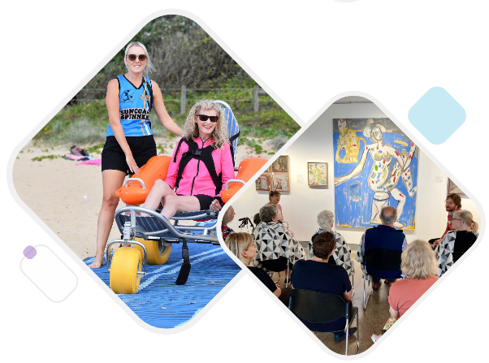
Photo 1: Woman enjoying access to the beach via a beach wheelchair and matting.
Photo 2: A group of people view an artwork piece at Caloundra Regional Gallery as part of the Mindful Art Program.

Current Actions
Examples of what council is currently doing:
- Healthy Sunshine Coast all abilities classes.
- All Access Day at the Beach event held annually.
- Beach Clean Up program is working towards becoming all abilities friendly.
- Mindful Art Program held at Caloundra Regional Gallery for people with dementia and their carers.

Future Actions
- 3.1 Promote existing guidelines for holding inclusive events, activities and programs.
- 3.2 Embed consideration of inclusion into council's permitting processes for events.
- 3.3 Promote Hidden Disabilities Sunflower program amongst business and event organisers.
- 3.4 Include a sensory space at all major council event venues and events e.g., Caloundra Music Festival, New Years Eve, Australia Day.
- 3.5 Engage an Auslan interpreter for formal council events, such as announcements, presentations and ceremonies e.g., citizenship ceremonies, media events, disaster management presentations.
- 3.6 Investigate and install hearing augmentation systems / voice to text technology (or other system) at all major council venues and events.
- 3.7 Develop a communication campaign toolkit to improve inclusion and participation for people with disability in community, cultural and sporting groups.

4. Built Environment and Public Spaces

Trevor’s Story
“Shortly after I was declared legally blind in 2007, I was sitting at my kitchen bench sipping my coffee feeling very sorry for myself. “What will I do now?” I had no peripheral vision sideway and down, with only 25 percent upper central vision remaining. I could no longer drive, and I stayed at home long-term because I couldn’t safely navigate out in public.
I was determined to find a solution for myself as is my way of dealing with life’s problems. I grabbed the phone book and found a 1800 number and dialed it. It was Vision Australia in Brisbane. I explained my problem and was advised that I needed to be assessed for the use of a long white cane, but they could not get to me for several months. They advised that I try Guide Dogs.
Within about one week I was assessed and subsequently commenced white cane training over a period of 8 weeks. My confidence improved straight away. Once training was complete, I received my first long white cane and have been using it and others ever since. The use of a white cane gave me back my confidence in public and improved my mobility. I could not do without it today.
Longer distances were still an issue.
Driving was no longer an option, so I needed to use taxis or public transport. I obtained a Travel Pass for public transport, and I have a TSS Card (Taxi Subsidy Scheme) for using taxis at a subsidised rate. These have helped me to attend many and varied activities. But it can still be a long wait for a taxi – a 45-minute wait is not unusual.
I have found most bus and taxi drivers are helpful, but occasionally I get a grumpy one. Before boarding a train, I can ring my departing station and arrange assistance there and to be met and assisted at my destination station. Most times the train staff will keep an eye on me in case of unruly passengers. It is inconvenient to call ahead when I want to travel but having transport staff who are aware and helpful makes a big difference.
I want to say that if you have a problem, find a solution and do not sit in a hole waiting for someone else to solve your problem; find your own solution. There is support available.
And when you see someone using a long white cane give them a wide birth so they can navigate freely!”

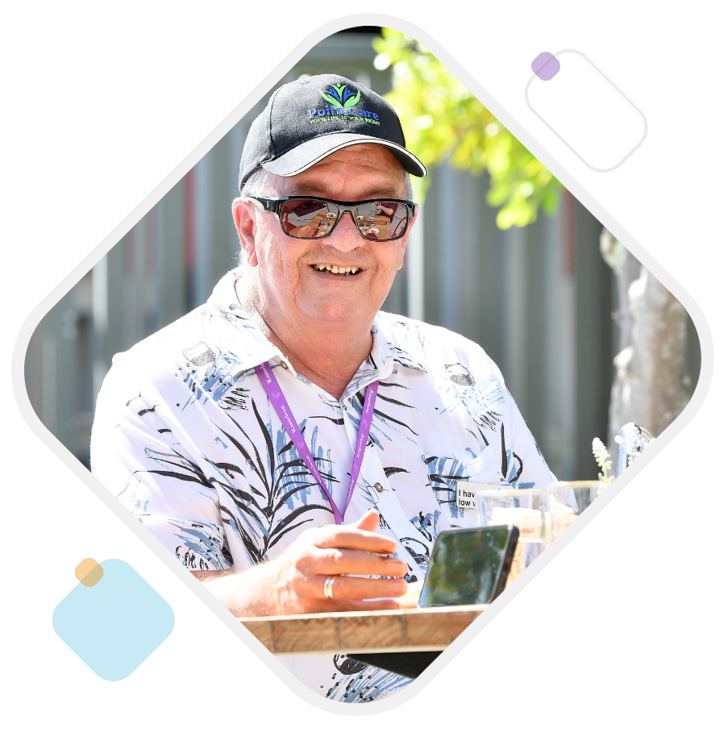

Built Environment and Public Spaces
Our built environment and public spaces are designed to be inclusive by delivering on the principles of universal design but also involving a diversity of people with disability in the planning and delivery to maximise inclusion and accessibility.
This priority area includes buildings, community facilities, housing, streets and streetscapes, pathways and sidewalks, natural areas, parks, open space and sports facilities, public amenities, and transport.
Everyone in our community should be able to access and utilise buildings and public spaces and be able to get around. This is fundamental to inclusion. Access to buildings and public spaces for people with disability should be similar to people without disability, for example, people with disability should not need to use a back entrance or travel a significantly longer distance than others. Public transport should be an option available to anyone, and community transport can help fill gaps in the network.
There are building regulations for disability access, however, there are still examples of poor outcomes that meet the requirements of regulation. Involving people with disability in planning and design may assist in delivering better outcomes. The principles of universal design are well understood, however there is lower uptake of universal design in commercial and residential development than is needed.
Our community told us that difficulty getting around and access to suitable and affordable housing were challenges for people with disability. Improvements to the public realm, transport and parking were identified as priorities to make it easier for people with disability to participate in community life. The top five places that people with disability value were beaches, bushland and natural reserves, pools and leisure centres, town centres and playgrounds. There is the opportunity to continue to improve accessibility outcomes in these areas to enable inclusion and participation for all.

Project Highlights
Mooloolaba Northern Parkland
The Mooloolaba Northern Parklands Development provides a coastal link between Alexandra Headlands to Maroochydore Foreshore. The Northern Parklands development includes the following accessibility features:
- 200 metre accessible boardwalk – connecting Alexandra Headland to the Mooloolaba Esplanade
- Accessible ocean pathways and public seating which enable people in wheelchairs to enjoy the ocean views and sit alongside family and friends.
- Inclusive play elements which foster the physical, cognitive, sensory and social skills in children of all abilities.
- Accessible BBQ areas and picnic benches
- Accessible toilets.
The Mooloolaba Foreshore project won Project of the Year at the Institute of Public Works Engineering Australasia Queensland and Northern Territory (IPWEA) 2022 Excellence Awards in 2022.

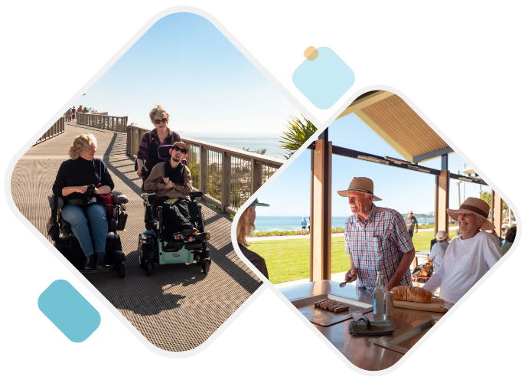
Photo 1: Two electronic chair wheelchair users use the accessible boardwalk at Mooloolaba Northern Parkland.
Photo 2: A group of people have a BBQ at one of Mooloolaba Northern Parkland’s accessible BBQ facilities.

Council plans and strategies
There are various council plans and strategies which contribute towards the development of accessible and inclusive built environments and public spaces for people with disability. These include, but are not limited to:
- Community Strategy 2019-2041
- Environment and Liveability Strategy 2017
- Design Strategy
- Recreation Parks Plan 2021-2031
- Integrated Transport Strategy
- Aquatic Plan
- Smart Infrastructure Manual 2023
- Sport and Active Recreation Plan
- Open Space Landscape Infrastructure Manual
Council is committed to continuing to prioritise accessibility and inclusion in our strategic planning and place and space outcomes.

Current Actions
Examples of what council is currently doing:
- Open Space Landscape Infrastructure Manual outlines design principles, including the accessibility required for council controlled open space.
- Play Opportunities Plan (in development) will provide a framework for planning a network of inclusive playgrounds.
- Development of new Capital Renewal Prioritisation Matrix for public amenities which will better ensure accessibility is a key driver for renewal or replacement of public amenities.
- Changing Places facility at Grahame Stewart Park.
- A Changing Places facility is planned to be delivered at Mooloolaba as part of the Mooloolaba Foreshore Stage 2 Central Meeting Place project.
- Investigation of the delivery of a regional-scale accessible kayak pontoon.
- Braille incorporated into venue signage at Beerwah Meeting Place and Maroochydore Library.
- The stage one upgrade of Kawana Aquatic Centre is currently underway to provide new 20m indoor pool with accessible access.
- Pool hoists are available at all nine aquatic centres, and pool wheelchairs will be available at all centres soon (wheelchair to be provided at Kawana Aquatic Centre as part of upgrade works).
- Upgrade of boardwalk at Mary Cairncross to increase accessibility.
- Involving people with disability in streetscape improvement works and accessibility requirements in all placemaking projects
- Working with business owners when completing streetscape improvement works to provide more accessible access to business entry points.
- Streetscape funding specifically targeting accessibility improvements including pathways, kerbs and ramps
- Bus field trips with people from the Sunshine Coast Access Advisory Network (SCAAN) and other people with lived experience of disability to review the accessibility of bus stops across the region.
- Council Link – provides a transport service for people 60+ years and people with disability to be picked up from their home and taken to a nearby shopping centre.
- Working with community groups to ensure evacuation and disaster management centres are more inclusive during events.

Future Actions
- 4.1 Plan and deliver new physical and mobile Changing Places facilities.
- 4.2 Investigate locations where permanent accessible beach mats can be installed safely and raise awareness of their availability.
- 4.3 Review prioritisation of existing Accessibility Improvements Fund investments to improve inclusion outcomes.
- 4.4 Raise awareness with development industry about the social and economic benefits of universal design.
- 4.5 Raise awareness of the importance of physical and portable location specific communication boards at council facilities, service centres, recreational spaces and events.
- 4.6 Deliver additional accessible on-street parking bays in activity centres.
- 4.7 Investigate smart city solutions to improve accessibility in the built environment and public spaces.
- 4.8 Expand existing program of mobility mapping to new areas of the region.
- 4.9 Increase the number of accessible cabins at council’s Holiday Parks.
- 4.10 Provide dignified and equitable access to all stages at council-owned district and regional level community venues.
- 4.11 Identify, plan and secure enduring accessibility inclusion legacy initiatives / outcomes as a key delivery partner in the Brisbane 2032 Olympic and Paralympic Games.

5. Participation and Communication

Drew’s Story
“My name is Drew Russell and I grew up on the Sunshine Coast and I have always loved my community in the area. I attended the same school on the coast from pre-school to year 12 and I am a foundation student.

While I hold great memories of the school, the people I know and the friends I have made, I also have felt that near the end of my schooling I was not able to achieve the educational goals I had hoped for myself. I felt left behind compared to some of my friends. This led to a feeling of not being “bright” and caused me to lack confidence in my judgement and decision making and to rely on others a lot instead of trusting my own instincts. Because of this I would tend not to step into the limelight and I missed out on a lot of valuable opportunities for my future.

I, however gained a rejuvenated sense of confidence after being introduced to a community who share my values and beliefs. As well as highlighting my strengths they have provided me with valued support, friendship, and opportunities. I completed my Bachelor’s Degree in Film and Television. I have achieved high honours in speech and drama for acting and I have also worked on numerous community-based projects throughout the Sunshine Coast based around community engagement.

Within these roles I have been able to showcase my strengths and I have grown as a person. As a result, I now find that I can be that support for others who have experienced similar situations.

Being employed in roles I feel passionate about has allowed me to thrive. Through the ‘Here Now Next’ Project I can share my story and help others see the skills and abilities that make them unique and assist them to find meaningful paid employment. I feel that I am a great example of someone who has overcome their barriers and I love the opportunity I now have to share and support others. I continue to work on community engagement and awareness, sharing information and support about services available to young people and their families through the ‘Stand by Me’ Project.

I have come a long way since finishing school and it hasn’t always been easy, but with the support of my family, friends, and community I continue to learn and grow as a person. I urge anyone to keep trying and never give up. Your uniqueness will be of value to your community and your community will value that you are unique.”

Participation and Communication
Everyone can access the information they need to participate in community life and be involved in decision making that is important to them.
This priority area includes information provided by council and others, and participation of people with disability in decision making processes.
Our community told us that having a say on important community issues was a challenge for people with disability. Being involved in decision making was also identified as needed to make it easier for people with disability to participate in community life.
Community members suggested that information should be provided with accessible layouts, large print, Easy English, image descriptions, video with captions and audio format to make it more inclusive.
Providing inclusive information will assist in maximising the involvement of people with disability in decision making processes. But additional planning and tailored engagement methods are also important to reduce participation barriers.
They would also like information about how places, spaces, activities and services are accessible so that people with disability and their carer can plan ahead.

Project Highlights
Inclusive Engagement Guideline
Council is committed to ensuring all people have the opportunity to participate in community engagement. Council has prepared an Inclusive Engagement Guideline for internal staff members which considers groups that may experience additional barriers to participating in community engagement. These include people with disability, older and younger people, people experiencing homelessness, the First Nations community, and people from culturally and linguistically diverse communities (CALD).

Briometrix Mobility Maps
Council has partnered with Briometrix to undertake mobility mapping across the Sunshine Coast region. Maps have now been created for the areas between Maroochydore to Mooloolaba, Caloundra coastal area, the Sunshine Coast University Hospital Precinct, Sunshine Coast Stadium and Maleny. The maps identify footpaths, shared pathways, and accessible toilets and trails for people of all abilities.

Current Actions
Examples of what council is currently doing:
- Leading the way on Mobility Mapping for residents and visitors of the Sunshine Coast to identify the most navigable route for everyone's varying needs.
- Adventure Sunshine Coast website now adding information on accessibility features of paths.
- Council’s corporate website platform upgraded to improve accessibility features.
- Level Up website provides information to assist businesses with improving accessibility.
- Inclusive Engagement Guideline created to encourage council staff to better reach and involve people with disability in engagement.
- Accessibility features of public amenities across the region audited and updated on the National Amenity Network Map.

Future Actions
- 5.1 Promote council’s Access and Inclusion Coordination Group internally to increase participation and the opportunity to listen to, and learn from, people with lived experience of disability, and showcase the work council is doing.
- 5.2 Fund specialised accessible communication training for interested staff across council to act as a resource when called upon.
- 5.3 Update council’s reception check-in system to be more accessible and uphold customer privacy and security.
- 5.4 Develop a guideline for online content to direct how to convey accessibility specific information for council facilities (e.g., evacuation centres, venues, holiday parks, parks), events and programs.
- 5.5 Collaborate with Visit Sunshine Coast to improve information about accessible tourism including accommodation, venues and activities to allow visit planning.
- 5.6 Update Disaster Hub with information on the accessibility of evacuation centres.
- 5.7 Consider alternative methods of communication for people with diverse needs in a disaster.
- 5.8 Develop a guideline to outline accessible standards for a range of communication formats including documents, interpretive signage, website content and videos.

Detailed Action Plan
Action | 2024 | 2025 | 2026 | 2027 | 2028 | Lead Council Team | Measure | Funding
1. Awareness and Education
1.1 Deliver disability awareness training for all council staff and elected councillors. | ● | ● | ● | ● | ● | People and Culture and Community Development | Measures will be outlined in the final action plan | Subject to additional funding
1.2 Coordinate an annual week of activities that celebrates Disability Action Week within council and the community. | ● | ● | ● | ● | ● | Community Development |  | Achievable within existing resources
1.3 Develop and deliver a community education campaign to raise awareness of disability and the value people with disability bring to council and the community. | ● | ● | ● | ● | ● | Community Development and People and Culture |  | Achievable within existing resources
1.4 Work with business and tourism event organisers to promote benefits related to inclusion. | ● | ● | ● | ● | ● | Economic Development |  | Achievable within existing resources
1.5 Raise awareness and recognition of businesses that demonstrate excellence in inclusion. | ● | ● | ● | ● | ● | Economic Development |  | Achievable within existing resources
2. Employment and Training
2.1 Promote council’s employment opportunities, work experience and traineeship programs to people with disability. | ● | ● | ● | ● | ● | People and Culture |  |  | Achievable within existing resources
2.2 Continue to expand and promote council’s volunteering opportunities available to people with disability. | ● | ● | ● | ● | ● | Arts, Heritage and Libraries, Environmental Operations, Tourism and Major Events, People and Culture, and Sport and Community Venues |  |  | Achievable within existing resources
2.3 Promote and expand training initiatives provided by the disability sector to increase disability awareness within local businesses and the value inclusive workplaces bring to individuals and the community. | ● | ● | ● | ● | ● | Community Development and Economic Development |  |  | Achievable within existing resources
2.4 Review council’s recruitment and application process to strengthen inclusion for people with disability. | ● |  |  |  |  | People and Culture |  |  | Achievable within existing resources
2.5 Undertake an audit of council workplaces to improve accessibility and processes for workplace adjustments. | ● | ● | ● |  |  | People and Culture and Property Management |  |  | Subject to additional funding
3. Events and Programs
3.1 Promote existing guidelines for holding inclusive events, activities and programs. | ● |  |  |  |  | Creative Arts and Events, Sport and Community Venues and  Community Development |  |  | Achievable within existing resources
3.2 Embed consideration of inclusion into council's permitting processes for events. | ● |  |  |  |  | Community Land Permits |  |  | Achievable within existing resources
3.3 Promote Hidden Disabilities Sunflower program amongst business and event organisers. |  | ● |  |  |  | Community Development and Economic Development |  |  | Achievable within existing resources
3.4 Include a sensory space at all major council event venues and events e.g., Caloundra Music Festival, New Years Eve, Australia Day. | ● | ● | ● | ● | ● | Creative Arts and Events, Tourism and Major Events and Sport and Community Venues |  |  | Subject to additional funding
3.5 Engage an Auslan interpreter for formal council events, such as announcements, presentations and ceremonies e.g., citizenship ceremonies, media events, disaster management presentations. | ● | ● | ● | ● | ● | All relevant council teams |  |  | Subject to additional funding
3.6 Investigate and install hearing augmentation systems / voice to text technology (or other system) at all major council venues and events. | ● | ● | ● | ● | ● | Creative Arts and Events, Tourism and Major Events and Sport and Community Venues |  |  | Subject to additional funding
3.7 Develop a communication campaign toolkit to improve inclusion and participation for people with disability in community, cultural and sporting groups. | ● | ● | ● | ● | ● | Community Development |  |  | Achievable within existing resources
4. Built Environment and Public Spaces
4.1 Plan and deliver new physical and mobile Changing Places facilities. |  |  |  |  | ● | Property Management |  |  | Subject to additional funding
4.2 Investigate locations where permanent accessible beach mats can be installed safely and raise awareness of their availability. | ● |  |  |  |  | Environmental Operations and Community Development |  |  | Subject to additional funding
4.3 Review prioritisation of existing Accessibility Improvements Fund investments to improve inclusion outcomes. | ● | ● | ● | ● | ● | Design and Placemaking,  Property Management, Parks and Gardens, Capital Works, Environmental Operations,  Civil Asset Management, and Transport Infrastructure Management |  |  | Subject to additional funding
4.4 Raise awareness with development industry about the social and economic benefits of universal design. |  | ● |  |  |  | Development Services, Urban Design Integration and Advisory and Economic Development |  |  | Achievable within existing resources
4.5 Raise awareness of the importance of physical and portable location specific communication boards at council facilities, service centres, recreational spaces and events. | ● |  |  |  |  | Community Development |  |  | Achievable within existing resources
4.6 Deliver additional accessible on-street parking bays in activity centres. | ● |  |  |  |  | Transport |  |  | Achievable within existing resources
4.7 Investigate smart city solutions to improve accessibility in the built environment and public spaces. | ● | ● | ● | ● | ● | Business and Innovation |  |  | Achievable within existing resources
4.8 Expand existing program of mobility mapping to new areas of the region. | ● | ● |  |  |  | Customer and Planning Services |  |  | Achievable within existing resources
4.9 Increase the number of accessible cabins at council’s Holiday Parks. |  |  | ● |  |  | Sport and Community Venues – Holiday Parks |  |  | Subject to additional funding
4.10 Provide dignified and equitable access to all stages at council-owned district and regional level community venues. |  |  | ● | ● | ● | Property Management |  |  | Subject to additional funding
4.11 Identify, plan and secure enduring accessibility inclusion legacy initiatives / outcomes as a key delivery partner in the Brisbane 2032 Olympic and Paralympic Games. | ● | ● | ● | ● | ● | SCC Brisbane 2032 Branch |  |  | Achievable within existing resources
5. Participation and Communication
5.1 Promote council’s Access and Inclusion Coordination Group internally to increase participation and the opportunity to listen to, and learn from, people with lived experience of disability, and showcase the work council is doing. | ● | ● | ● | ● | ● | Community Development |  |  | Achievable within existing resources
5.2 Fund specialised accessible communication training for interested staff across council to act as a resource when called upon. | ● | ● | ● | ● | ● | People and Culture |  |  | Subject to additional funding
5.3 Update council’s reception check-in system to be more accessible and uphold customer privacy and security. |  | ● |  |  |  | Customer Response |  |  | Achievable within existing resources
5.4 Develop a guideline for online content to direct how to convey accessibility specific information for council facilities (e.g., evacuation centres, venues, holiday parks, parks), events and programs. | ● |  |  |  |  | Community Development, Sport and Community Venues, Creative Arts and Events and Parks and Gardens |  |  | Achievable within existing resources
5.5 Collaborate with Visit Sunshine Coast to improve information about accessible tourism including accommodation, venues and activities to allow visit planning. | ● | ● | ● | ● | ● | Economic Development |  |  | Achievable within existing resources
5.6 Update Disaster Hub with information on the accessibility of evacuation centres. | ● |  |  |  |  | Community Development and Disaster Management |  |  | Achievable within existing resources
5.7 Consider alternative methods of communication for people with diverse needs in a disaster. |  | ● |  |  |  | Community Development and Communication |  |  | Achievable within existing resources
5.8 Develop a guideline to outline accessible standards for a range of communication formats including documents, interpretive signage, website content and videos. | ● |  |  |  |  | Communication and Community Development |  |  | Achievable within existing resources

Glossary
Disability
A disability is a long-term physical, mental, intellectual or sensory impairments which, in interaction with various barriers, may hinder full and effective participation in society (according to the United Nations Convention on the Rights of Persons with Disabilities).
According to the Disability Discrimination Act 1992 (Cth) (S4), disability in relation to a person, means:
a) total or partial loss of the person’s bodily or mental functions or
b) total or partial loss of a part of the body or
c) the presence in the body of organisms capable of causing disease or illness or
d) the malfunction, malformation or disfigurement of a part of the person’s body or
e) a disorder or malfunction that results in the person learning differently from a person without the disorder or malfunction or
f) a disorder, illness or disease that affects a person’s thought processes, perceptions of reality, emotions or judgement or that results in disturbed behaviour; and includes a disability that:
i. presently exists or
ii. previously existed but no longer exists or
iii. may exist in the future or
iv. is imputed to a person.

Notes
- United Nations 2006, United Nations Convention on the Rights of Persons with Disabilities, https://www.un.org/development/desa/disabilities/convention-on-the-rights-of-persons-with-disabilities.html.
- ABS 2022, Census 2021, https://www.abs.gov.au/census
- Queensland Government (Queensland Treasury) 2019, Population Projections: 2018 Edition, https://www.qgso.qld.gov.au/.
- ABS 2019, Disability, Ageing and Carers, Australia: Summary of Findings, https://www.abs.gov.au/statistics/health/disability/disability-ageing-and-carers-australia-summary-findings/2018
- University of Sydney 2021, Invisible disabilities: they are more common than you think, https://www.sydney.edu.au/study/why-choose-sydney/student-life/student-news/2021/09/14/invisible-disabilities--they-are-more-common-than-you-think.html
- ABS 2019, Disability, Ageing and Carers, Australia: Summary of Findings, https://www.abs.gov.au/statistics/health/disability/disability-ageing-and-carers-australia-summary-findings/2018
- Australian Institute of Health and Welfare 2022, People with disability in Australia, https://www.aihw.gov.au/reports/disability/people-with-disability-in-australia
- ABS 2022, Census 2021, https://www.abs.gov.au/census
- Based on continuation of current trend and medium series population projections for Sunshine Coast LGA. Queensland Government (Queensland Treasury) 2019, Population Projections: 2018 Edition, https://www.qgso.qld.gov.au/.
- ABS 2022, Census 2021, https://www.abs.gov.au/census

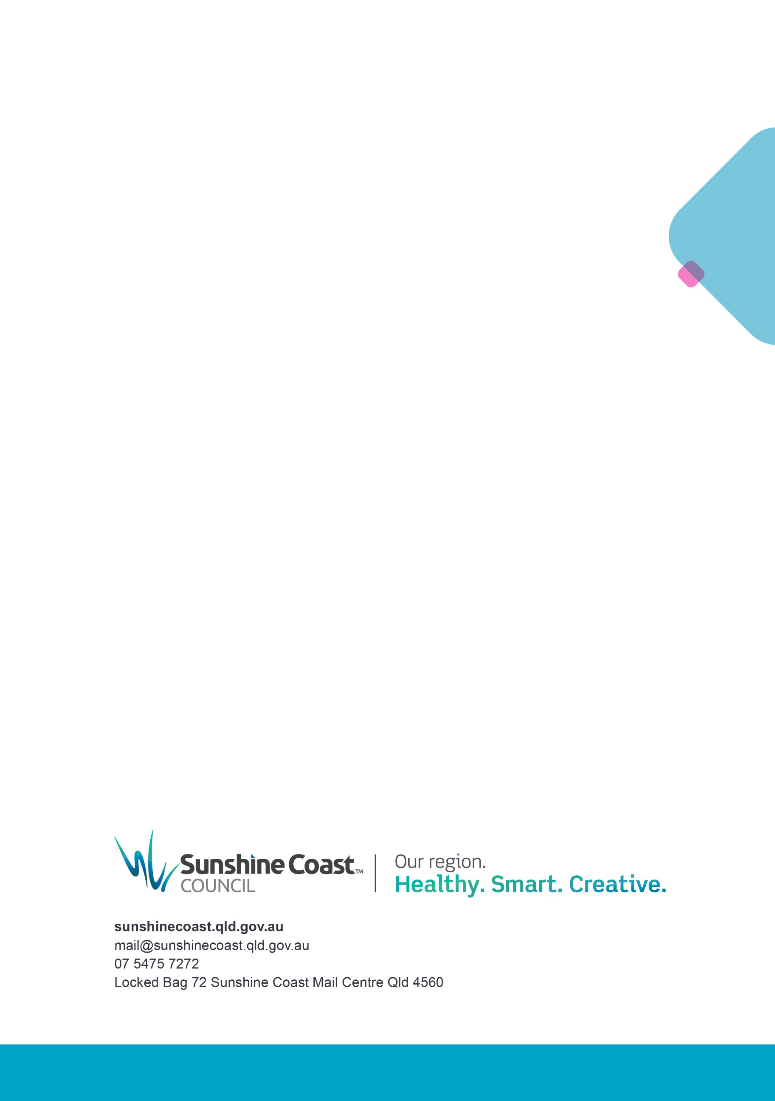

Web Content Accessibility Guidelines
The Hidden Disabilities Sunflower is a tool which allows people to voluntarily share they have a disability that may not be immediately visible. The Hidden Disabilities Sunflower allows people to notify to others that they may need a helping hand, whether that be in the shops, on public transport or at an outdoor event.
A communication board is a sheet of symbols, pictures of photos that someone who experiences difficulty communicating can point at to help communicate with those around them.
The Hidden Disabilities Sunflower is a tool which allows people to voluntarily share they have a disability that may not be immediately visible. The Hidden Disabilities Sunflower allows people to notify to others that they may need a helping hand, whether that be in the shops, on public transport or at an outdoor event.
A communication board is a sheet of symbols, pictures of photos that someone who experiences difficulty communicating can point at to help communicate with those around them.

