Promote, Influence and Encourage
Our community’s travel choices can be shaped by a variety of factors and providing a path network is only one element. Promotion, encouragement and influence can all increase a person’s willingness to choose active transport.
Best practice research indicates that to shift travel behaviour, 80% of the effort needs to focus on delivering the right infrastructure. The remaining 20% of the effort should focus on campaigns, awareness-raising and promotional activities targeting potential users.
Promotion and awareness

The Draft Plan recognises there are considerable benefits to promoting the delivery of new active transport infrastructure to the people in our community. Promoting and raising awareness of new paths to travel and facilities to use, can encourage people in our community to be early adopters of new active travel routes and changes in travel behaviours.
The Draft Plan prioritises continuing Council’s ThinkChange Program, focusing on delivering initiatives across the 5 categories: community based, education-facilities, workplaces, events and visitors. These areas will remain the primary focus of the program. Empowering everyone within the community to make small travel behaviour changes can have a large, collective and lasting impact.
Case study: ThinkChange program
Council’s ThinkChange program is aimed at empowering everyone in our community to find ways to reduce car use and the length of their car trips, contributing to a healthier, more connected and sustainable region. By partnering with organisations, community groups and individuals, the aim is to inspire meaningful travel behaviour changes.
ThinkChange provides the following tips to help with thinking about life and travel behaviours:
Rethink: planning to do things differently.
Remode: choosing an alternate transport mode.
Retime: avoiding travel during peak hours.
Reduce: using technology to avoid unnecessary travel.
Reroute: avoiding congested routes.

The Draft Plan will investigate an e-bike and e-cargo incentive program to encourage businesses, community groups and bike users to embrace the use of these car alternatives that enable efficient local travel. Lowering the purchase cost of e-bikes and e-cargo bikes and championing their use has proven to be an effective way to boost active transport and achieve key community benefits.
Collaborating with stakeholders, event organisers and community groups can raise the profile of walking, riding and wheeling through promotional events that celebrate active transport on the Sunshine Coast.
The Draft Plan will continue to support programs that encourage car-free days through programs that include National Ride2Work Day, National Ride2School Day, Walk Safely to School Day, Bike Week and Queensland Walks Month. Promoting programs that introduce supported travel by walking, riding and wheeling can encourage people to use active more frequent in the future.
Promoting active transport through Council’s website can ensure regionally specific active transport network maps and information on active transport projects, events, initiatives and community grant programs is current, contemporary and readily available. The Draft Plan intends to review Council’s website content to ensure it is current with a focus on making the information easy to access and understand.
The Draft Plan will promote a transport network culture where all users feel safe, welcome and respected. Encouraging positive and respectful behaviours by continuing and refreshing campaigns such as “Mind if We Share - One Path Many Ways”, “Share the Pathway” and “Share the Roadway” will look to reduce conflicts between users, while promoting the needs of all transport network users and creating a safer environment. Collaborating with external partners and community advocacy groups will also be important to extend the reach of these campaigns.
Influence
The Draft Plan prioritises Council taking a proactive role to deliver a high quality, connected active transport network. Crucial to this role is a strong partnership with the Department of Transport and Main Roads to integrate active transport infrastructure across both the State and locally managed networks. Taking a ‘one network’ approach is a key priority when major projects including The Wave, the Sunshine Coast Public Transport project and the Brisbane 2032 Olympic and Paralympic Games are being planned, designed and delivered.
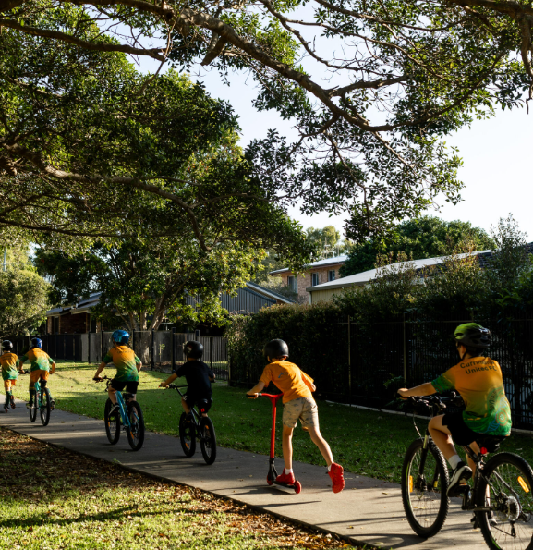
Actively collaborating with Queensland Health and Education Queensland will further ensure the Draft Plan prioritises improved health outcomes for our student community and supports local trips to health precincts and schools.
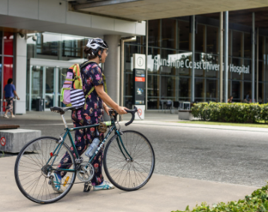
The Draft Plan recognises the importance of engaging and empowering champions for active transport from both within Council and the broader community to create real and lasting change. Continuing to engage and consult with community, businesses, the private sector and industry ensures Council is well placed to hear feedback and create better active transport outcomes for the region.
Strong partnerships with state representative bodies including Bicycle Queensland and Queensland Walks as well as local groups through the Sunshine Coast Active Transport Advisory Committee (SCATAC) ensures Council is aligned with key active transport groups.
Encourage
Supporting initiatives that encourage and promote students to walk and ride to school is essential to improve the lives of children, their families and communities. The Draft Plan will continue to prioritise the delivery of infrastructure initiatives aimed at enhancing safety and connectivity around schools. Providing the missing links and safer crossing lays the critical foundation for the Trial RideScore Active Schools program to be a success. These safety improvements will support primary school children to walk, ride and scooter safely to schools.
Council will nurture increased participation in active travel among under-represented groups such as families, younger and older adults. Active travel allows these groups to stay active, independent and connected and helps to also reduce transport disadvantages by improving access to transport, confidence in active transport use and feelings of personal safety. Our support and initiatives will be inclusive, effective and tailored to address their diverse needs enhancing the overall impact and success of this initiative.
Collaborating with community advocacy groups such as Queensland Walks, Bicycle Queensland, Heart Foundation, RACQ and other grassroots riding, walking and wheeling groups is essential to encourage active transport use. The Draft Plan recognises the benefits of partnerships to build an active transport culture across the region and looks to maximise these opportunities and the positive impacts it can have on the people in our communities.
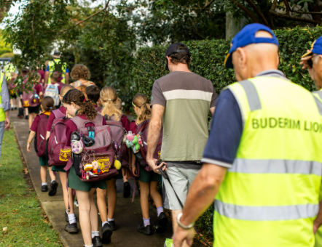

Lead by example
The Draft Plan outlines how Council will lead by example to support the community in choosing to walk, ride or wheel for everyday trips.
Council aims to be at the forefront of active transport data collection using technology to measure, monitor, assess and understand the community’s use of the network. The Draft Plan recognises this data-driven approach will inform decision making, provide valuable insights into its success and provide a feedback loop to make future improvements. Council’s Smart City Framework and Implementation Plan 2024-2027 and Internal Digital Plan 2023-27 will guide and support this initiative.
Building confidence in the community to use and invest in active transport is a key focus of the Draft Plan. Council has installed end of trip facilities within its new Maroochydore, City Hall building to promote an active transport culture for its employees and visitors. By taking the lead to showcase these facilities it can inspire other businesses to make similar investments and contribute to change.
Council regularly updates its strategies, plans, policies and manuals to ensure they remain contemporary, relevant and responsive to change. The Draft Plan emphasises the importance of ensuring active transport is considered through the update processes. Including strategic transport teams and other relevant departments across Council during the update consultation process will support this outcome. The inclusion of a broad range of teams in this process will provide opportunity for input from various disciplines across the planning, design, delivery and promotion of active transport.
Recognising that transport infrastructure design standards change means there is a need for active transport education and training to increase organisational capacity and ensure officers are striving for best practice transport outcomes. The Draft Plan prioritises opportunities to partner with the Department of Transport and Main Roads and make training courses accessible to staff and practitioners based the Sunshine Coast.
Our brand
The Brisbane 2032 Olympic and Paralympic Games and the 2028 UCI Para-Cycling Road World Championships position the Sunshine Coast to be promoted as a walking, riding and wheeling destination to the world. The Draft Plan recognises the importance of these events and the opportunities they present to connect the Sunshine Coast locally and with both the domestic and global communities.
The Draft Plan supports collaboration with the Sunshine Coast Tourism Board to promote active transport options for visitors and support riding, walking and wheeling tourism through events, trail marking and social media.

