Sunshine Coast
Draft Active Transport Plan
A connected Sunshine Coast where people can easily travel by walking, riding and wheeling

Edition September 2025
sunshinecoast.qld.gov.au
mail@sunshinecoast.qld.gov.au
07 5475 7272
Locked Bag 72, Sunshine Coast Mail Centre
Qld 4560
© Sunshine Coast Regional Council 2008 — current. Reproduction without permission is prohibited. Sunshine Coast Council™ is a trademark of Sunshine Coast Regional Council.
Acknowledgements
Council wishes to thank all contributors and stakeholders involved in the development of this document.
Reference document
This document should be cited as follows:
Sunshine Coast Draft Active Transport Plan.
Disclaimer
To the extent this document contains future plans, activities, policies and strategies, these matters are aspirational and subject to change at any time without notice.
While the Sunshine Coast Council has exercised reasonable care in preparing this document, no warranty or representation is given by Council or its officers in relation to any of the information or data contained within this document (including as to its accuracy, reliability, completeness or suitability for any purpose).
Council and its officers are not liable (including without limitation, liability in negligence) for any loss, damage, expenses or costs (including any consequential loss or damage) incurred by you relating to any use of, or reliance upon, the information and data contained within this document.

Contents
Acknowledgement of Traditional Custodians 5
Foreword 6
1. Introduction 8
Our active transport community 10
2. Developing the Draft Plan 12
What is active transport? 12
Other network users 12
Listening to our community 13
Major projects 13
Strategic frameworks 14
Objectives and priority areas 14
Remaining Contemporary 14
Benefits of active transport 15
3. Snapshot of active transport 17
Current path network 17
Types of riders 18
Types of walkers 18
Key achievements to date 19
4. How this plan was developed 21
Key engagement findings 21
Coastal and Hinterland findings 21
Sunshine Coast Active Transport Advisory
Committee 22
Community priorities 22
Our community said 23
5. Policy context 25
Our global commitment 26
Sunshine Coast Biosphere 26
Strategic framework 27
Strategic alignment 28
6. Vision and guiding objectives 31
Guiding objectives 31
7. Aspirational active transport network 33
Aspirational walking network - regional map 34
Aspirational riding network - regional map 35

8. Action plan 37
Three priority areas for action 37
Measure of success 37
Networks and infrastructure 38
Supporting activities 39
Promote, influence and encourage 40
9. Detailed action plan 42
Networks and infrastructure actions 43
Supporting activities actions 48
Promote, influence and encourage actions 51
Glossary 56
Appendices 59
Appendix 1 - United Nations sustainable
development goals 59
Appendix 2 - Divisions 1-10 aspirational walking
network maps 60
Appendix 3 - Divisions 1-10 aspirational riding
network maps 61
References 62

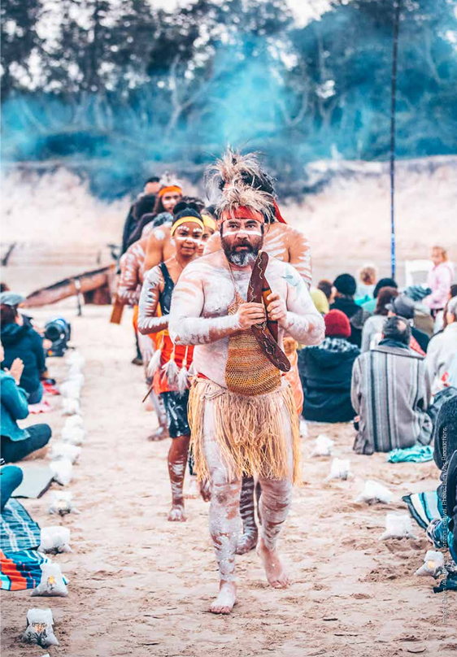
Acknowledgement of Traditional Custodians
Sunshine Coast Council acknowledges the Sunshine Coast Country, home of the Kabi Kabi peoples and the Jinibara peoples, the Traditional Custodians, whose lands and waters we all now share.
We recognise that these have always been places of cultural, spiritual, social and economic significance. The Traditional Custodians’ unique values, and ancient and enduring cultures, deepen and enrich the life of our community.
We commit to working in partnership with the Traditional Custodians and the broader First Nations Aboriginal (and Torres Strait Islander) communities to support self-determination through economic and community development.
Truth telling is a significant part of our journey. We are committed to better understanding the collective histories of the Sunshine Coast and the experiences of First Nations peoples. Legacy issues resulting from colonisation are still experienced by Traditional Custodians and First Nations people.
We recognise our shared history and will continue to work in partnership to provide a foundation for building a shared future with the Kabi Kabi and the Jinibara peoples. We wish to pay respect to their Elders – past, present and emerging, and acknowledge the important role First Nations people continue to play within the Sunshine Coast community.
Together, we are all stronger.

Foreword
The Sunshine Coast population continues to grow with people choosing the region to live, work and play. With more people moving about our region, it is important that our transport networks are well-integrated to provide connection between people, places and spaces, and support our community to thrive.

Our current reliance on the private car is not sustainable with substantial investment required to accommodate growth and manage congestion expectations. Changing our travel behaviours and investing in sustainable travel modes such as active and public transport, will support the liveability of our region.
The Sunshine Coast Community Strategy 2019-2041 (2024 Refresh) and Integrated Transport Strategy (2018) outline clear and ambitious targets to increase the share of active and public transport trips. To support our region achieve these targets, Council is committed to improving opportunities for people of all ages, genders and abilities to use active transport.
Active transport can provide an attractive, safe, inclusive and low-cost transport alternative to car travel. When people use active transport and walk, ride or wheel locally, our region benefits from improved social, economic and environmental outcomes.
This Draft Active Transport Plan (Draft Plan) aims to create a more connected, safe, healthy and sustainable region, where people feel supported to use active transport. It outlines actions for Council to implement either independently or in partnership to encourage more people to choose walking, riding and wheeling. The actions are sensible and attainable and will contribute towards achieving the targets in Council’s Community Strategy and Integrated Transport Strategy.
Through improvements to the active transport networks and supporting facilities and implementing behaviour change initiatives, we can reduce our reliance on cars while fostering greater community connection.
The Draft Plan has been shaped through broad community engagement. This process identified key patterns in walking and riding network usage, barriers to increased active transport and opportunities to encourage more people to choose walking, riding and wheeling for short trips. We would like to extend our gratitude to our community for sharing their insights which have been invaluable to guide the development of the Draft Plan.
We invite all members of our community to partner with us and embrace opportunities to walk, ride or wheel locally.
.

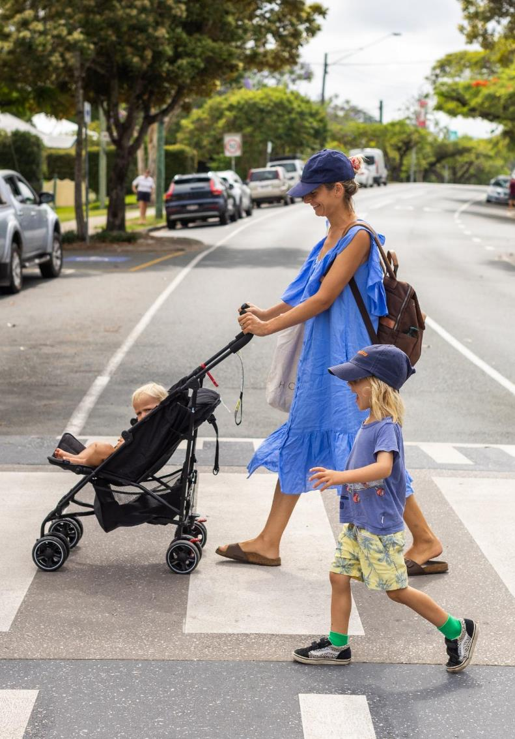
- Introduction
A connected Sunshine Coast where people can easily travel by walking, riding and wheeling.

By 2041, the Sunshine Coast will be a region where people use active transport for 20% of their trips to travel and connect with local people, places and spaces.
The Sunshine Coast Council has a vision to be recognised as “Australia’s most sustainable region: Connected. Liveable. Thriving”. The desire is for the Sunshine Coast to be a place where getting around is easy. A place where active transport infrastructure provides local connectivity and is integrated with efficient public transport systems. We want everyone to feel welcome using our transport networks by ensuring they are safe, accessible and inclusive.
Access to sustainable transport options is more important than ever before with our population continuing to grow and forecast to exceed 560,000 by 2046 ShapingSEQ 2023 (1). While people moving to our region will bring many benefits, it will also place pressure on our transport networks and shift travel expectations.
Currently people in our community have a strong reliance on their car for travel and with many other vehicles using the road networks to transport goods and services, the ability to move quickly and easily from place to place is being impacted.
Access to transport networks and services is essential for a thriving community and people within our region have voiced concern about increasing congestion affecting mobility. Adapting our travel behaviours to include sustainable transport such as active transport for local trips can support our vision for the region of being connected, liveable and thriving.
Active transport refers to walking, riding or wheeling - travelling from place to place using physical effort. Short, local trips of less than 5km are well-suited to active transport and typically include the daily commute to work or school, completing errands, accessing services or facilities and engaging in leisure or recreational activities.
Active transport can offer a connected, safe, inclusive and low-cost alternative to car travel when appropriately planned and funded. Our region and the people within it stand to benefit from significant health, economic and environmental improvements when people choose to walk, ride or wheel instead of travelling by car.
Council undertook broad community engagement to develop the Draft Plan. Our community shared valuable insights on their current use of the region’s active transport networks.
We heard that our community wants increased connectivity and improved safety through greater separation from other path users and vehicles to support them walk, ride or wheel more frequently.
We understand that many of our community ride for recreational purposes but have yet to embrace riding for travel purposes.
Council has been working hard to encourage people to walk, ride and wheel for short trips and recognises that there is more work to do. The Draft Plan reflects Council’s commitment to provide a connected, safe, inclusive and attractive low-cost transport network.
The 2023 Household Travel Survey (2) results for the Sunshine Coast tell us people use:
- Public transport for 2% of trips
- Active transport for 10% of trips
- Car for 88% of trips.
The Draft Plan spans 10 years, with a mid-term review recommended after 5 years. This timeframe supports the integration of active transport with major projects, including ‘The Wave’ - Direct Sunshine Coast Rail with metro links and the Sunshine Coast Public Transport project. Connectivity to venues hosting Brisbane 2032 Olympic and Paralympic Games events will also be delivered within these timeframes supporting the legacy vision of a more connected and active Sunshine Coast.
Implementing the actions identified in the Draft Plan will support Council to create a connected, liveable and thriving Sunshine Coast - where walking, riding and wheeling can be an easy choice for local trips.

Our active transport community
Active Wheelie
I’ve been a wheelchair user for 23 years, and I can say with confidence that being able to move freely and independently has had a profound impact on both my mental and physical health. Staying active and engaged supports my overall well-being and helps me maintain stability without the emotional ups and downs that come from relying on others at times.
I also use a handcycle, and while I sometimes need to drive to key locations where it’s safe to use, there’s nothing like the freedom of getting outdoors, exploring new areas, and connecting with others who share the same passion. That sense of adventure and community wouldn’t be possible if I had to depend solely on a vehicle to get around.
But independence takes planning. Every trip out requires careful consideration of the route. Path connectivity is critical because when a path suddenly ends or shifts to gravel or grass, that’s a barrier I can’t cross. In those moments, I have no choice but to ask for help. And while help is appreciated, it feels like a step backward for someone striving to be self-reliant.
A well-connected, accessible active transport network is life changing. It opens opportunities for people who use wheelchairs and ensures everyone, regardless of ability, can experience the benefits of moving freely, safely, and with dignity through their community.
Darron, Glasshouse resident

Active Family
The kids are excited to get out the door when we are riding our bikes. It gives us all a sense of freedom to complete our day-to-day travel under our own steam. We get to engage with the environment as it changes daily and arrive at school and work mentally and physically stimulated. It brings our family together.
Ailie, Golden Beach resident
Active School Community
Coolum Beach is a community that values health, wellbeing and outdoor activities. The school's partnership with RideScore Active Schools program complements this well and is a valued part of our school community. Not only does RideScore encourage students to take part in a healthy lifestyle by riding to and from school, it also provides a community for students to safely travel to and from school with. Students benefit both physically and mentally from the daily outdoor activity and parents feel a sense of safety and security, knowing their children have arrived at school through the beacon. Students are encouraged to participate daily and receive points to redeem for vouchers and rewards.
As a school leader, the program is easy to implement and is very well supported through the council team. Council regularly presents on our school parades, promoting the benefits of the RideScore program to students and families. These incentives and support drive the longevity of the program in our school. RideScore is a wonderful program that is positively contributing to the health and wellbeing of the students in the Coolum community.
Shannyn, Principal Coolum State School

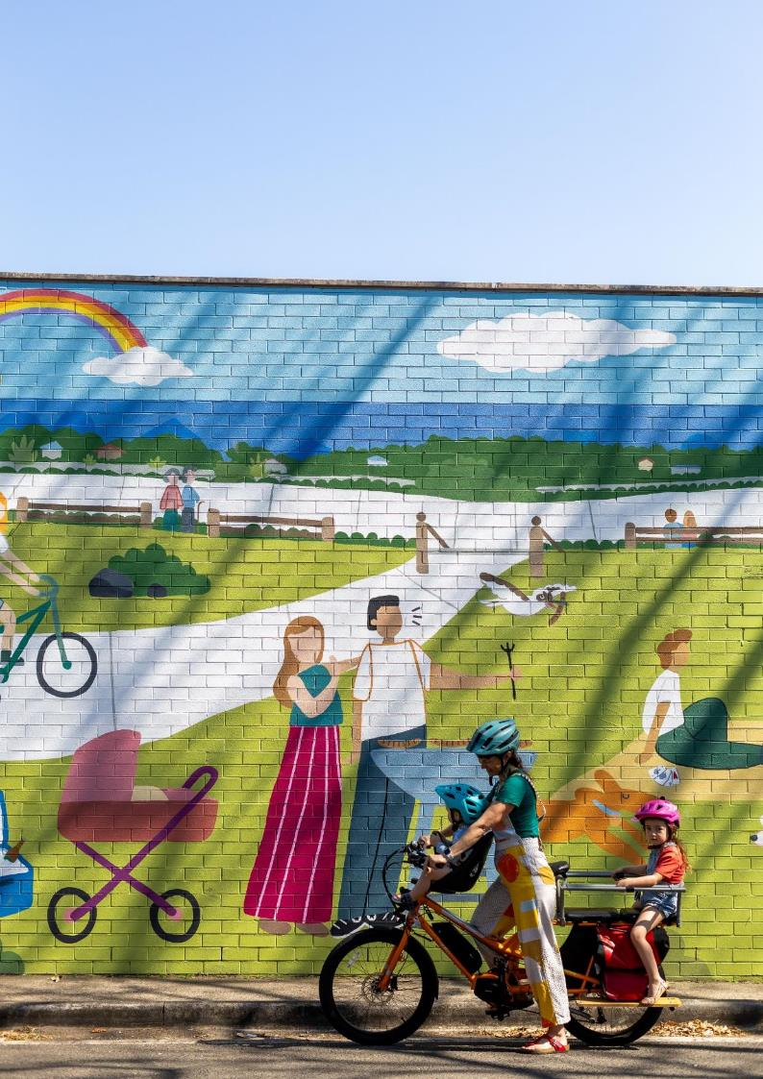
- Developing the Draft Plan
Council’s Corporate Plan 2025-30 has set a clear vision to be Australia’s most sustainable region. Connected. Liveable. Thriving. Active transport can help Council to achieve this vision.
The Draft Plan has been informed by an understanding of several important elements. These include a clear definition of what it means to travel by active transport, the insights our community shared about their use and perceptions of active transport, proposed major projects and the strategic frameworks which influence active transport outcomes. This information has provided a platform to identify 4 guiding objectives and 3 priority areas for delivering actions.
What is active transport?
Active transport refers to walking, riding or wheeling - travelling from place to place using physical effort.
Walking
People moving by walking, pushing prams, wheeling luggage, using walking canes or other aids. It can also include people jogging and running for transport.
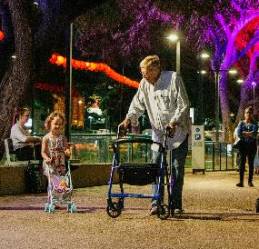
Image courtesy of Department of Transport and Main Roads © State of Queensland (3)
Riding
People riding bicycles, tricycles, adapted bikes, e-bikes or cargo bikes on shared paths, roads and cycle tracks. It also includes unpowered skateboards, scooters and roller-skates.

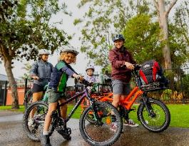

Wheeling
People using a wheelchair, mobility scooter, or other wheeled mobility aid.
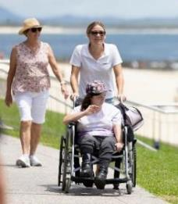
Other network users
The users of personal mobility devices may use the active transport network for their journeys. Although personal mobility devices aren’t considered to be a form of active transport, the use of these devices is expected to grow.

Personal mobility devices
Council does not recognise certain electric-assisted personal mobility devices, such as e-scooters, e-skateboards, and self-balancing one or two-wheelers, as ‘active’ transport due to their low physical effort requirements. However, Council recognises that these devices provide an affordable alternative to car travel.
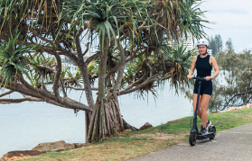
Listening to our community
Through broad community consultation we gained essential insights into perceptions of active transport across the region. From these insights we identified emerging themes that helped to shape our 3 priority areas for action:
- Increasing connectivity
- Removing barriers to inclusivity
- Valuing the needs for all.
Major projects
The Sunshine Coast is set to change over the next decade with significant public transport infrastructure being planned and funded for delivery. The region will also host Brisbane 2032 Olympic and Paralympic Games events showcasing the Sunshine Coast to the world.
Brisbane 2032 Olympic and Paralympic Games
The Brisbane 2032 Olympic and Paralympic Games are to be a car free event with private car travel to games venues not supported for spectators. Active transport networks will provide connectivity to venues from nearby public transport stops and stations. Delivering an integrated active transport network will be an important legacy outcome of the Games.
The Wave - Stages 1, 2 and 3
The State Government and Australian Government have committed to funding delivery of The Wave Stage 1. This stage includes a passenger rail line from Caloundra to Beerwah with a station at Bells Creek (Aura). Construction of The Wave Stage 1 will commence in 2026.
Planning is also underway to deliver The Wave Stage 2, an extension of the passenger rail line, through to Birtinya via a station at Aroona. The Wave Stage 3 continues onward to the Sunshine Coast Airport via Maroochydore utilising metro buses. Ensuring there is active transport connectivity between ‘The Wave’ stations and local destinations will be an important outcome to support easy, local travel choices that do not require the use of a car.
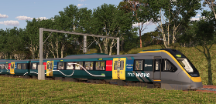
Artist’s impression, The Wave (Rail). Image supplied by the Department of Transport and Main Roads.
Sunshine Coast Public Transport
The planning of our public transport network is ongoing and a high priority for Council.
Current planning prefers a bus rapid transit solution utilising the corridor between Maroochydore and Birtinya. The development of the detailed business case is ongoing, with the aspiration that stations will integrate with local walking and riding networks.
Strategic frameworks
Our region is growing. Protecting our enviable lifestyle, the character of our communities and unique landscapes while our population grows requires strategic frameworks and policies to guide and manage the impacts to our people, places and spaces.
The Sunshine Coast Community Strategy 2019-2041 (2024 Refresh) and Integrated Transport Strategy (2018) both set out to manage the impact of population growth and private car usage by outlining clear and ambitious targets to increase active transport trips to 20% by 2041.

Objectives and priority areas
Understanding and interpreting the combined influence and impacts of these factors has provided a platform to identify 4 guiding objectives and 3 priority areas for delivering action over the next 10 years.
Guiding Objectives:
- Equitable Access
- Liveable and Sustainable
- Vibrant and Attractive Places
- Creating Change
Priority Areas for Action:
- Networks and Infrastructure
- Supporting Activities
- Promote, Influence and Encourage
Remaining Contemporary
The actions are intended to be delivered between 2026 and 2036. Many of the actions require Council to lead while others call for collaboration.
It is recommended that the Draft Plan be reviewed after 5 years to ensure it remains contemporary and responsive to change in the region.

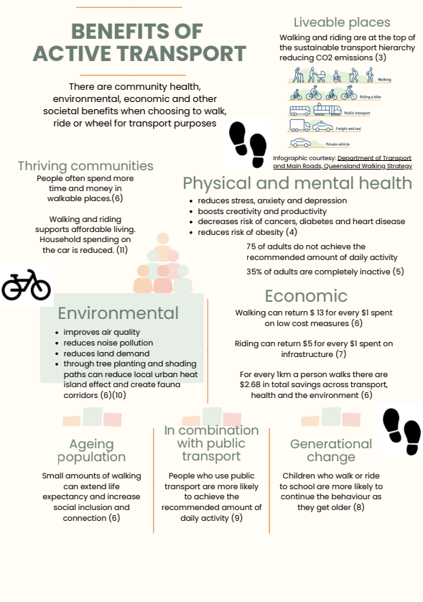
Benefits of active transport

(1) (2) (3) (4) (5) (6)

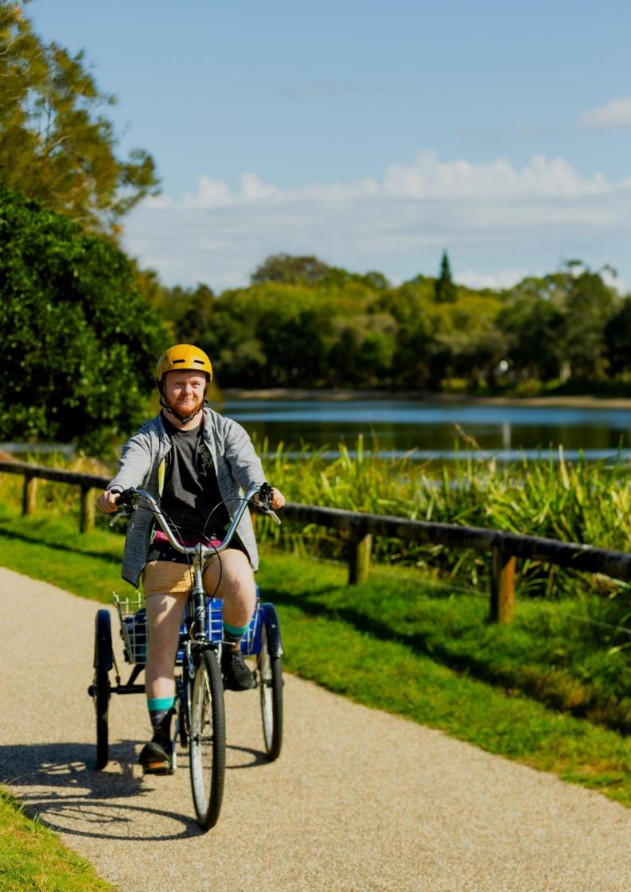
- Snapshot of active transport
In 2018 around 4.4 million Australians had a disability and around 4% of Australians with a disability use a wheelchair (12). There may be other people using wheelchairs on our networks as they recover from illness or injury.
Current path network
Established residential areas have fewer paths, with most paths located next to busy roads. Approximately 40% of the paths are not compliant with the Disability Discrimination Act as they are less than 1.8m wide.
Wider paths are predominantly located in newer, emerging communities.
Existing walking network
1,755km of walking paths
Less than 1.8m wide¹ |  | 42%  735km
Between 1.8 – 2.4m wide |  | 41%  720km
More than 2.5m wide |  | 17%  300km
Most of the separated cycle tracks are located in newer, emerging communities.
In established residential areas, there is limited separated riding infrastructure. Riding facilities were historically provided on the road.
Cycle tracks and shared paths  Suit the interested but concerned rider (see below). |  | 320km
Physically separated cycle track | Feels safe for the least confident rider. | 6%  20km
Shared path (more than 2.5m wide) | Used by people for walking, riding and wheeling - can lead to many conflicts at busy times. | 94%  300km

On-road riding network  Suit the strong and fearless rider (see below). |  | 970km
On-road bicycle lane | Used by confident riders. | 26%  257km
Bicycle Awareness Zones and shoulders | Only used by the most confident riders. | 74%  713km
Most of the people in our community consider walking and riding a recreational activity.

73 km of coastal path from Bells
Creek to Coolum
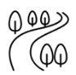
57 km of recreational off-road
walking and riding trails
Case study: Aura in Caloundra South
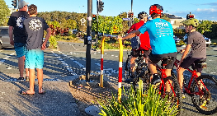
Aura Boulevard active transport corridor
Aura in Caloundra South has a network of high-quality footpaths and separated cycle tracks, connecting homes, schools, shops, employment and services.
The paths provide complete separation from private vehicles with priority crossing at intersections. The paths are influencing people’s travel choices.
In 2024 over 102,000 people were recorded walking or riding along Baringa Drive, Aura.
Types of riders
Riders can be broadly categorised into 4 different types using the Roger Geller Scale (13).
Rider type | Description
Strong and fearless | People who are highly confident using a bicycle and can ride almost anywhere. They are fit, frequent riders and are not afraid to ride on the road.
Enthused and confident | People who are confident on a bicycle and use their bike regularly. They prefer separated cycle tracks or shared paths but are comfortable riding on road with low speed vehicles.
Interested but concerned | People who enjoy riding for fun and recreation and would like to ride more but are hesitant to mix with road traffic. They prefer quiet routes on separated paths.
No way no how | People who are not interested in riding at all and are unlikely to change their mind.
Supporting the Interested but concerned group to ride more has the greatest potential to increase riding trips for transport purposes.
Comparing the responses from the broad community engagement with the National Survey results, Figure 1 below shows the proportion of Interested but concerned riders on the Sunshine Coast is consistent with the Queensland population (14).
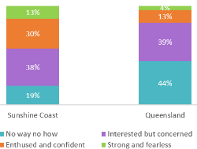
Figure 1: Comparison of Sunshine Coast and Queensland rider types
Types of walkers
People walk for many reasons. The responses to the broad community engagement indicated that people walk mostly for recreation or fitness purposes with approximately 50% of respondents walking at least once a week and over 60% walking everyday (15). These results are comparable to the National Walking and Cycling Participation Survey (2023).
The main reasons people on the Sunshine Coast walk for transport include:
- Completing errands – 28%
- Travelling to work or education – 12%
- Accessing public transport – 9%.
In South East Queensland 40% of trips were less than 5km in 2024 (16). This is similar to the Sunshine Coast where, between 2021 and 2024, 38% of trips made by private vehicle travelled 5km or less (2) and present a great opportunity for mode shift to active transport.
Case study: RideScore Active Schools Program

The RideScore Active Schools Program encourages and supports primary school children to ride or scoot to school.
Through the use of digital technology, parents are alerted when their child arrives at school in the morning or departs for home in the afternoon. Students are encouraged to continue riding and scootering, receiving rewards after the completion of milestone trips.
In 2024, 2,409 students were registered in the program at 11 participating schools.

Key achievements to date
Since the Active Transport Plan 2011-2031 was endorsed, Council has strived to deliver a range of actions. Key achievements include the construction of new walking and riding paths and bridges, the installation of safer crossings and the delivery of community programs promoting active transport.
Achievements include:
- New bridges and paths to overcome barriers that reduce connectivity and accessibility across the network were constructed.
- A bicycle parking and end-of-trip facility was established at the Maroochydore bus station in partnership with Translink.
- Education programs were delivered to promote active transport to school children, women and seniors.
- Behaviour programs were delivered to promote and encourage mutual respect between all people using the path networks.
- National programs and events including Walk to Work Day, Walk Safely to School Day, Bike Week, Ride2Work Day and Ride2School Day were delivered locally.
- Updates to travel maps for people walking and riding, identifying routes and supporting facilities such as bike parking were completed.
- A targeted cycling page on Council’s website including a link to report an issue or hazard and upload a supporting photo was developed.
- Surveys and counts to improve the understanding of local walking and riding and measure the progress towards active transport objectives were conducted. On-road bike riders were also included in the count program.
- Processes to update the Sunshine Coast spatial database regularly to record new active transport infrastructure and data were improved.
Examples of significant infrastructure delivered by Council or through partnerships with State and Federal Governments include:
Eumundi-Noosa Road Pedestrian Bridge, Eumundi 2025 (under construction)
A dedicated pedestrian bridge providing a safe link across the North Maroochy River near Seib Road.
Stringybark Road Pedestrian and Cycle Bridge, Sippy Downs 2025
A 3 m wide dedicated walking and riding bridge spanning the Sunshine Motorway connecting Buderim to Sippy Downs and the University of the Sunshine Coast.
Curlew Street raised priority crossing, Aroona 2023
A raised priority crossing delivered with other nearby pathway improvements.
Nambour Connection Road shared path, Nambour 2021
Shared path on structure from Magnolia Street south to the service station.
Alfriston Drive shared path, Buderim 2021
Shared path from Karawatha Street to Lee Street.
Mooloolah River Path, Minyama 2020
Shared paths under the Sunshine Motorway/Brisbane Road Bridge at Minyama.
Richard Scott Bridge, Maroochydore 2019
A 5 m wide dedicated walking and riding bridge, across Mayes Canal, between Bindaree Crescent and River Esplanade on the Minyama to Mooloolaba bikeway.
River Esplanade 2-way cycle track, Mooloolaba 2017
A 2-way cycle track retrofitted into the existing urban environment along River Esplanade from Foote Street to Mayes Canal.

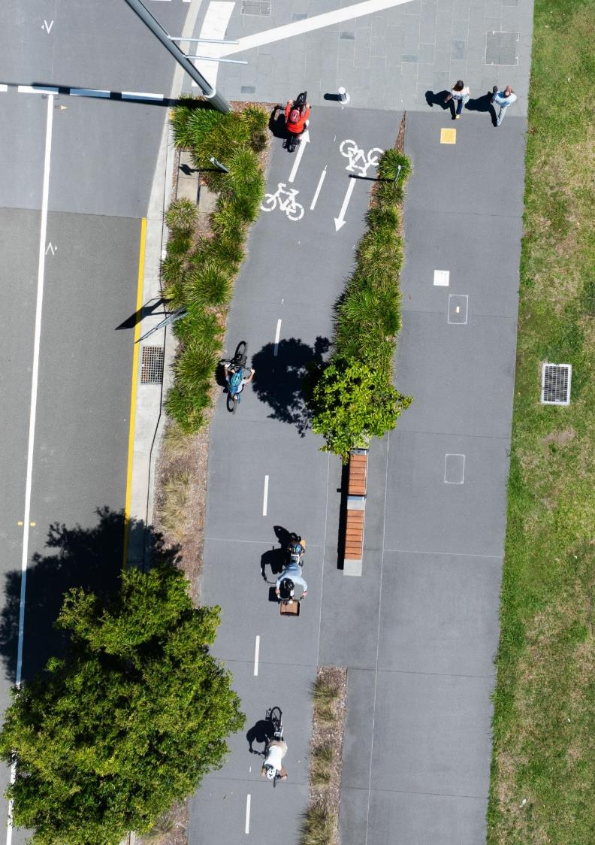
- How this plan was developed
To develop a Draft Plan that is responsive to the community’s needs and aspirations, Council called for community input to understand local travel preferences, values and barriers to using active transport.
 | 482 community survey responses.
 | 10 direct market research interviews with community sectors under-represented in survey responses.
 | 9 targeted engagement meetings with community and business groups, university students and local networks.
 | 1 focus group meeting with 8 participants from coastal and hinterland communities.
Key engagement findings
 | Road safety concerns exist regarding walking and riding around the region.
 | Personal safety is a barrier for embracing active transport.
 | Many people desire a greater active transport network to make walking, riding and wheeling easier.
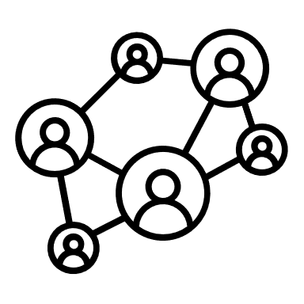 | Participants expressed a need for improved connections to local destinations like shops, schools, community facilities, recreation areas and better connectivity between suburbs.
 | There is a need to fill the missing links in the network and improve connectivity.

 | Reducing conflict between different path users and with vehicular traffic is important.
 | Respondents want safer crossing locations and lower speed limits for vehicular traffic to improve safety for non-motorised traffic.
 | Improved maintenance of the existing path network is required.
 | Active transport options must be integrated with public transport.
  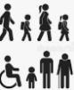 | Health, wellbeing and sustainability are key motivators across all demographics.  95% of respondents walk at least once a month for recreation or fitness.  90% of respondents ride a bike at least once a month.
Coastal and Hinterland findings
Coastal communities
 | Frequent conflict is experienced on busy paths.
 | Most paths require people walking, riding and wheeling to share, affecting user comfort.
Hinterland communities
 | There is limited path connectivity to local schools, amenities and activity centres.
 | Safety is a concern with narrow shoulders on busy roads the only option to support active transport connectivity.
 | Hilly terrain and longer distances are barriers to using active transport.
Sunshine Coast Active Transport Advisory Committee
Council coordinates the Sunshine Coast Active Transport Advisory Committee (SCATAC). SCATAC was established by Council in partnership with the State Government, inviting representative bodies and stakeholders to share ideas and support the increased uptake of active transport on the Sunshine Coast. The committee have identified their key priorities for active transport in the region.
- New Developments implement best practice walking and cycling infrastructure
- New transport infrastructure makes walking and riding as safe and easy as possible
- Trial significant and innovative active transport infrastructure
- Improve active transport at top 10 schools
- Maintain active transport infrastructure for safety and comfort
- A coastal pathway that provides comfort and safety for people walking and riding
- Build strong technical organisation capacity to lead development of a safe and connected active transport network
- Active and ongoing engagement with community and SCATAC on future planning and engineering projects.

A key finding of the community engagement is that walking and riding are considered recreational activities and not used by respondents for travel purposes.
Many people associate active transport as a high speed, on-road cycling activity undertaken by predominately confident riders.

Community priorities
The engagement activities identified 3 key priorities the community would like addressed through the Draft Plan.
- Increasing connectivity
Improving the network, connectivity and facilities.
- Removing barriers for inclusivity
Safer environments for walking and riding.
- Valuing the needs of all
Balancing the needs of different path users.

Our community said
- “There are so many beautiful places to see on the Sunshine Coast - would love if they were connected and there was mapped cycling and walking routes.”
- “Walkers get so angry at me when I ride my bike on the path.”
- “I think building up non-transport specific infrastructure in each community would really help get people to use active …give people "one of everything" in their local communities (shops/cafes etc) so people start to think "I'm going to walk/ride down to grab the milk".”
- “Even when there is the white bike logo, people do not respect the safe distance with the bike, some people try even to run over us to scare us as they don't like to see bikes on the road. Very dangerous when you have kids with you. Please add a dedicated continuous lane everywhere.”
- “I used to live near a park in Brisbane that installed a coffee van and started a park fun run. It absolutely transformed the park, hugely increasing the number of people who engaged in active transport - simply because the focus was no longer on active transport itself, but on something fun like walking down to get coffee or watching a fun run etc.”
- “I'm noticing more wheeled movements at speed (bikes / scooters) using the pathways in the parks and quite often there is conflict between the walkers and riders.”
- “Riding as a family of 4 instead of using a car becomes very difficult… because there are so many people using the path. In the end is becomes easier to drive…such a pity since it is flat.”
- “Walking my dog means that I get to communicate with others and helps with improving mental health.” (7)

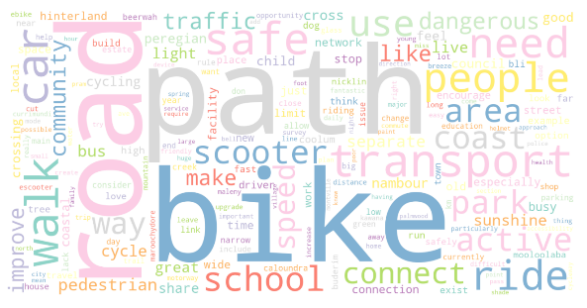

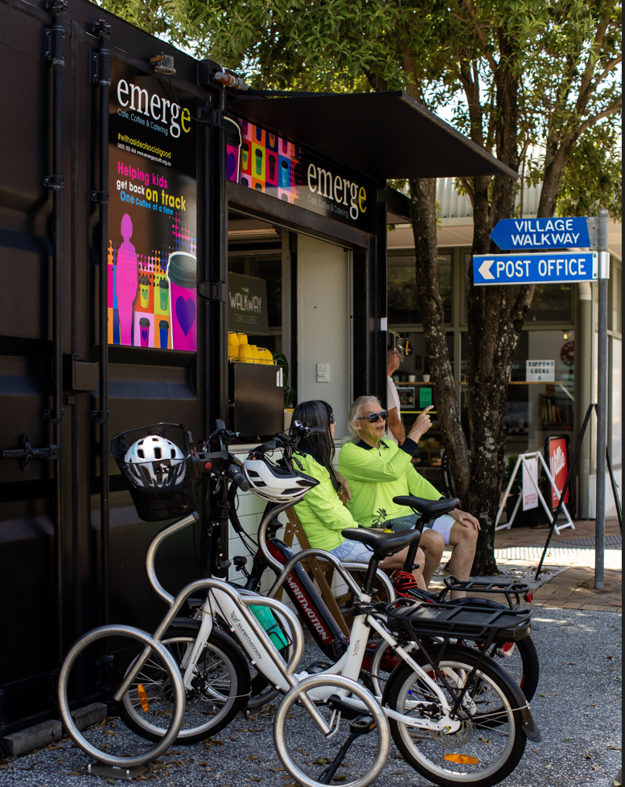

- Policy context
The Draft Plan was developed following a review of relevant international, national, state and local strategies, policies and guidelines.

These documents include:
- United Nations 2030 Agenda for Sustainable Development
- National Road Safety Strategy 2021-2030
- Queensland Transport Strategy (2019)
- Queensland State Infrastructure Strategy 2022-2042
- Movement and Place Policy (2024)
- Queensland Walking Strategy 2019-2029
- Queensland Cycling Strategy 2017-2027
- Road Safety Strategy and Policy 2022-2031
- Queensland Road Safety Action Plan 2022-2024
- ShapingSEQ 2023
- SEQ Regional Transport Plan (2021)
- Local Government Infrastructure Plan (LGIP) amendment (2023)
- Heathy Places, Healthy People (2023)
- Sunshine Coast Corporate Plan 2025-30
The Draft Plan closely aligns with principles in the Movement and Place policy, and Healthy Places, Healthy People framework. These emphasise the importance of planning for people to improve health and wellbeing, the environment and to foster a sense of place.
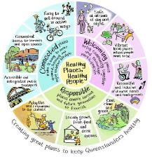
Figure 2: Queensland Health Healthy Places, Healthy People framework (10)
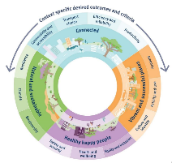
Figure 3: Department of Transport and Main Roads Movement and Place policy (17)

United Nations Sustainable Development Goals
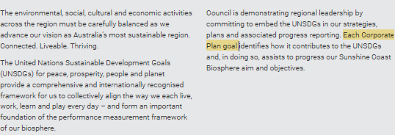
Council is demonstrating regional leadership by committing to embed the UNSDGs in our strategies, plans and associated progress reporting.

The Draft Plan identifies how it contributes to the UNSDGs and, in doing so, assists to progress our Sunshine Coast Biosphere aims and objectives.
Our global commitment
Active transport supports 10 of the 17 UNSDGs. These UNSDGs are embedded in the Draft Plan and are addressed both directly and indirectly through investing, prioritising and championing active transport. Further explanation of how active transport supports UNSDGs 3, 4, 5, 8, 9, 10, 11, 12, 13 and 17 is included in the Appendices.
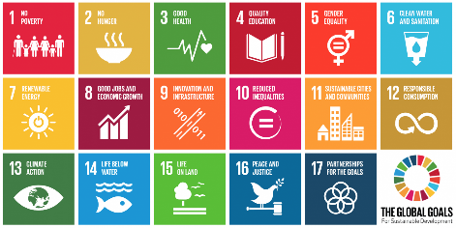
Sunshine Coast Biosphere
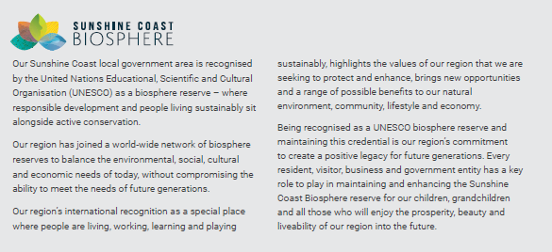

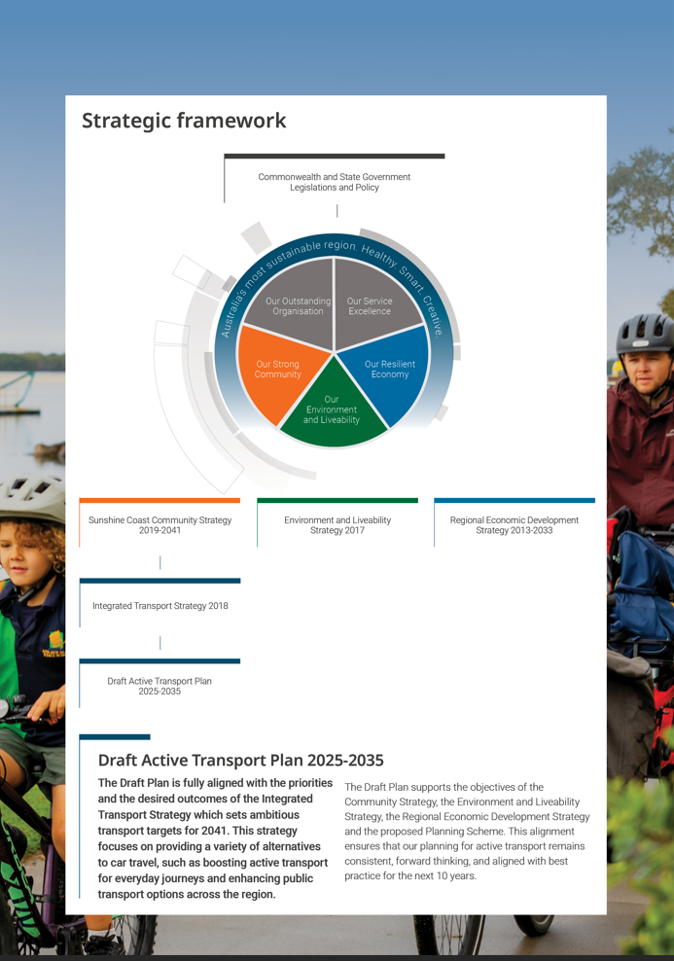
Strategic framework

Figure 1: Policy Framework of the Draft Plan

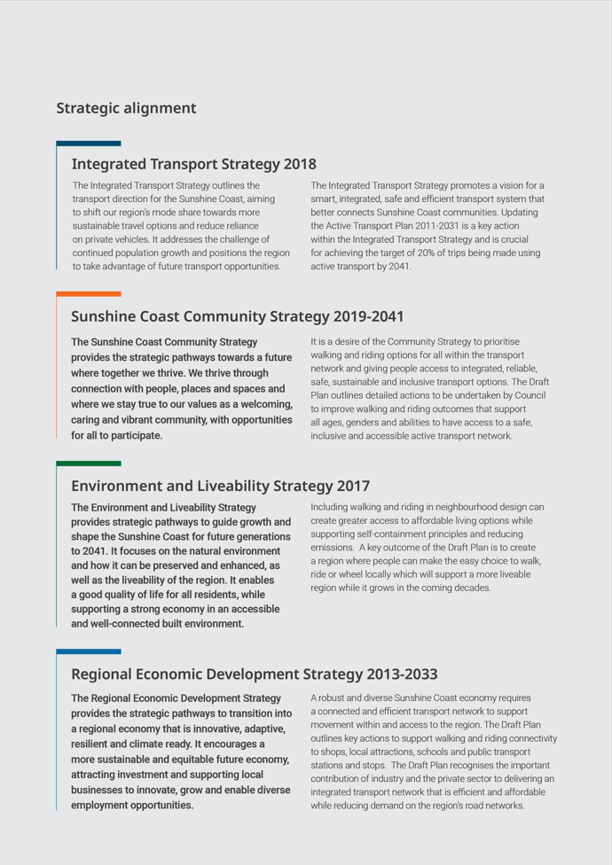
Strategic alignment

Other relevant Council strategies and plans include:
- Transportation Asset Management Plan
- Community Engagement Policy and Excellence in Engagement Framework 2021
- Major Events Strategy 2018-2027
- Open Space Landscape Infrastructure Manual (LIM)
- Parking Management Plan 2017
- Recreation Trail Plan 2012
- Recreation Parks Plan 2021-2031
- Smart City Framework and Implementation Plan 2022-2025
- Sport and Active Recreation Plan 2011-2026
- Urban Lighting Master Plan 2016
- Sunshine Coast Council Organisational Zero-net Emissions Plan 2022
- Sunshine Coast Council Internal Digital Plan 2023-27
- Regional Climate Action Roadmap
- Transport Network Safety Plan 2025-2029 (under development).

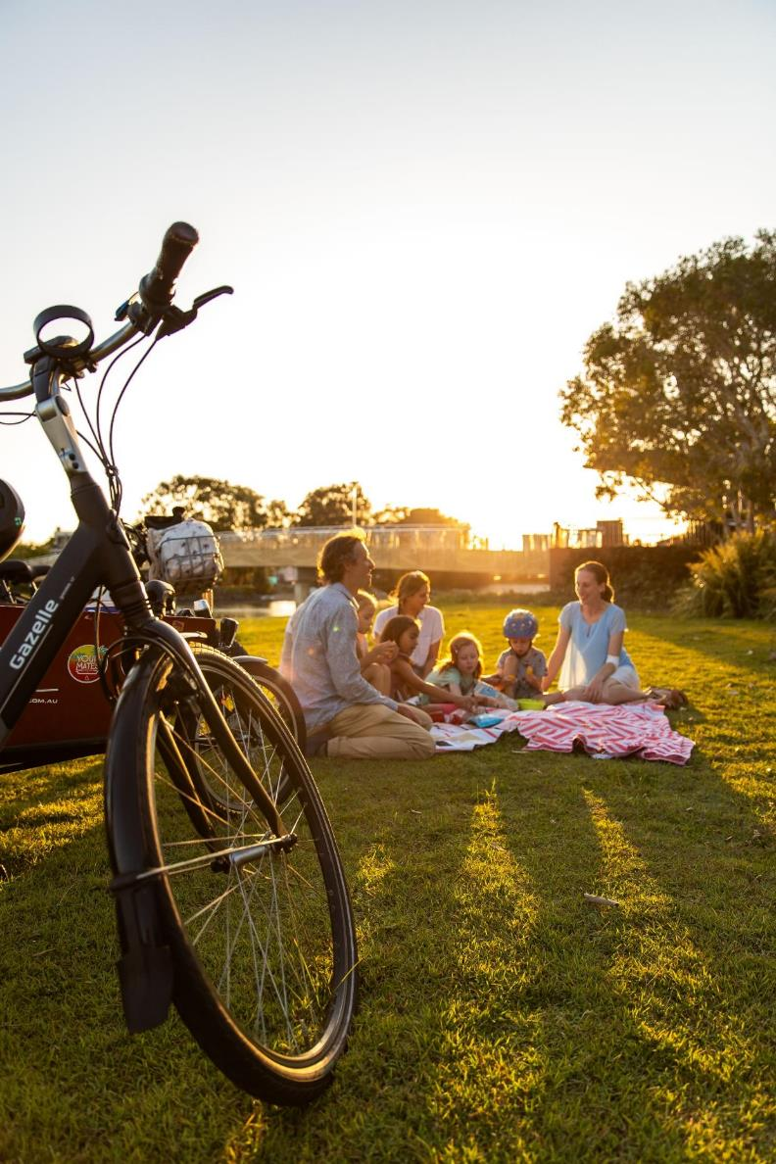
- Vision and guiding objectives
The vision for active transport across the Sunshine Coast
Create a liveable, healthy, safe and connected Sunshine Coast by making walking, riding and wheeling an easy choice for everyday trips.
Guiding objectives
The vision for active transport is underpinned by 4 guiding objectives. The guiding objectives provide the foundation for developing actions that align with the community’s priorities, the strategic context, our understanding of the current networks while looking forward to the growth and major projects planned for delivery over the coming decade.
Equitable Access  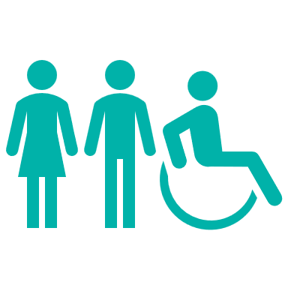 | Creating a safe, inclusive and accessible active transport network for all ages, genders and abilities. The network will be connected, accessible, easy to use and benefit everyone.
Liveable and Sustainable   | Supporting sustainable growth and liveable communities by creating a connected and legible network that promotes walking, riding and wheeling for everyday journeys. Encouraging local connectivity will support active and healthier communities, reduce environmental impacts and help tackle the climate emergency.
Vibrant and Attractive places   | Supporting centres and tourist destinations to thrive, while connecting people to nature and cultural heritage along key routes. Empowering communities to reflect their unique character while complementing the Sunshine Coast’s enviable lifestyle, creating liveable spaces where people want to spend time and enjoy.
Creating Change   | Creating a safety first and active transport first culture within Council, the private sector, industry and the community. Council will lead by example, promoting the benefits of active transport and empowering people to make healthier, more sustainable travel choices for everyday trips.

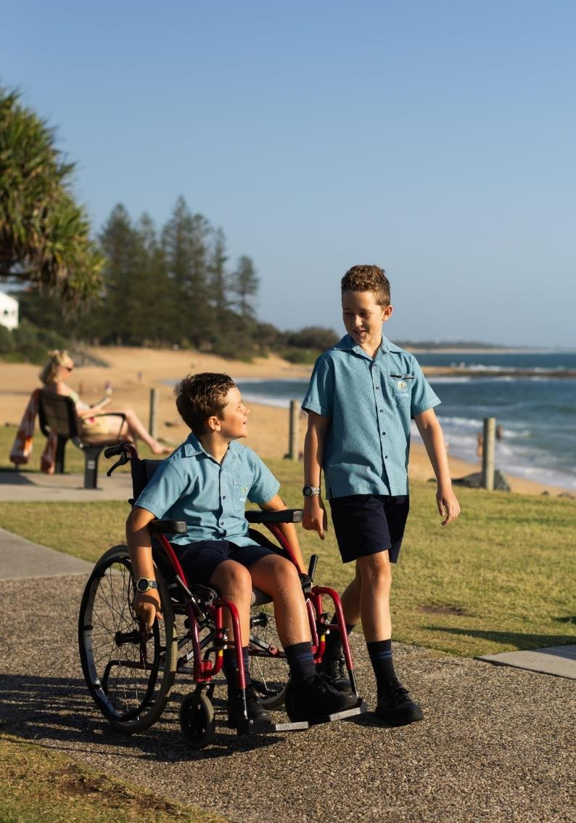

- Aspirational active transport network
The vision for active transport is supported by extensive planned networks for people to walk, ride and wheel. These networks are fundamental to identifying routes to travel and provide connection.
The aspirational network will provide more active transport connections and improve options for travel by walking, riding or wheeling within our community. The network will generally be categorised into 3 route types:
- Regional - These routes provide connection between our cities, towns and smaller communities and provide access to regionally significant destinations such as universities, health precincts, sporting stadiums and venues, regional parks and open space.
- District - These routes provide connection within communities providing access to district parks, local centres and amenities. These routes also provide access to the regional routes.
- Recreation - Parts of the network that are planned for the recreational user however people may use it for transport purpose, often with a focus on access to nature and greenspace. The Coastal Pathway is an example of this type of network.
Assigning a network type guides future planning activities and assists with understanding the appropriate supporting infrastructure to be located within the network.
The following maps outline the aspirational walking and riding networks at the regional level.
More detailed maps for the aspirational walking and riding networks in each of the 10 Council divisions are included in the Appendices.

Aspirational walking network - regional map
Note refer to mapping on Have Your Say site

Aspirational riding network - regional map
Note refer to mapping on Have Your Say site

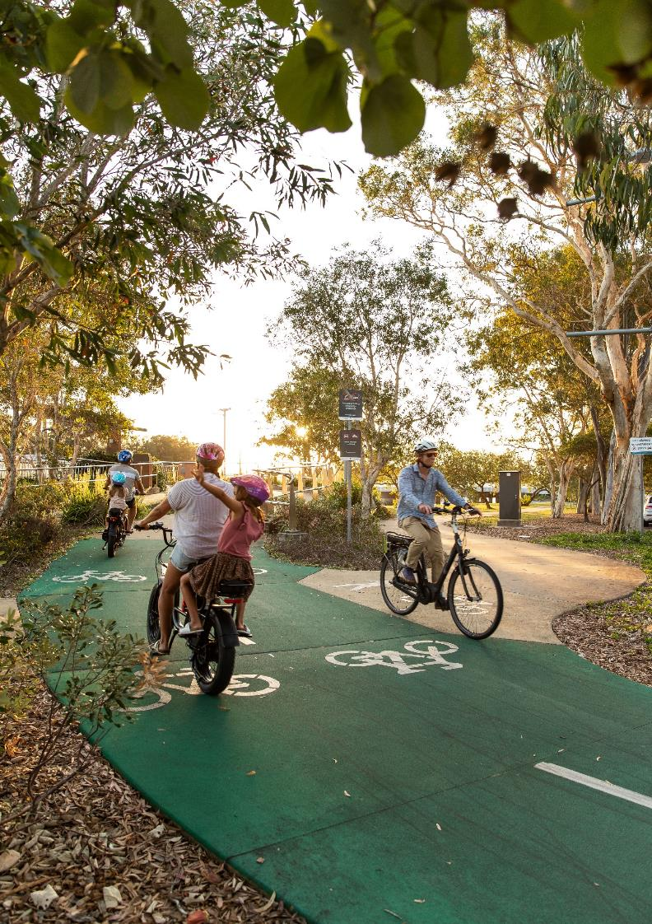
- Action plan
Council currently delivers a range of activities that support active transport across the Sunshine Coast. This action plan looks to recognise that work while identifying key actions for the next 10 years that will enable the Sunshine Coast to connect more by walking, riding and wheeling.
Three priority areas for action
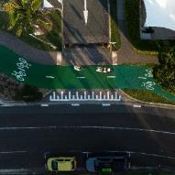 | 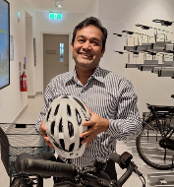 | 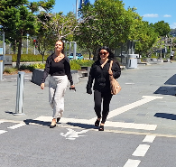
Networks and Infrastructure | Supporting Activities | Promote, Influence and Encourage
Key priorities include:  Providing safe, inclusive and connected walking and riding networks through planning, design and construction.  Identifying low cost methods and solutions to expand, connect and increase accessibility to the network.  Expanding the network while providing links to local destinations. | Key priorities include:  Providing complementary infrastructure and initiatives to support comfortable walking and riding trips from end to end.  Creating an inviting and attractive network experience to enhance liveable communities. | Key priorities include:  Seeking partnership opportunities to promote active transport and deliver improved infrastructure outcomes.  Influencing travel behaviour choices towards walking, riding and wheeling for short trips.  Encouraging active transport to support a connected, liveable and thriving region.
Measure of success
The ultimate measure of success for the Draft Plan will align with the ambitious 2041 mode share targets set in Council’s Integrated Transport Strategy (2018):
- 20% of trips use active transport.
- 10% of trips use passenger transport.
- 70% of trips use private vehicle.
However, reaching the ultimate target will be a work in progress until 2041. Accordingly, individual measures for each of the actions are specified in the Detailed Action Plan. The success of each of the actions will be reviewed annually as part of the Active Transport Plan Annual Report. .

Networks and infrastructure
Our community indicated they wanted increased connectivity that feels safe and values the needs of all users.
Expanding the walking and riding path network to increase connectivity within communities and between communities is the first step to support more people to use active transport.
Council is committed to providing a network that feels safe through good design. Our community wants a network that provides more separation and more space between different user groups and vehicles on the road. Reducing conflict between path users is critical to encourage more people to use active transport more often. Our community wants safer crossings and more support to move across roads safely. Removing barriers from the network and creating more opportunities to cross streets and roads can increase neighbourhood walkability and decrease active transport travel times.
In new communities the Planning Scheme will guide delivery of the network and support best practice outcomes. Our emerging communities are wanting affordable transport options to offset cost of living pressures. In established communities retrofitting the network to balance best practice outcomes with preservation of the existing amenity may require compromise.
Our region is a host city for the Brisbane 2032 Olympic and Paralympic Games. To support the Games and the region’s growth, the State Government has announced funding towards the delivery of public transport infrastructure. Our community indicated that active transport must be integrated into public transport stops and stations with connections to community facilities and recreation areas.

Priority actions
- Expand walking and riding networks and include more separated pathways.
- Expand existing programs to include lower cost solutions to improve connectivity.
- Implement road space reallocation demonstration projects.
- Leverage external grants and funding and target opportunities to work in partnership to deliver infrastructure.
- Accelerate legacy benefits from Brisbane 2032 Olympic and Paralympic Games.
- Advocate for the delivery of safe and inclusive connectivity to public transport stops and stations.
Delivery of the aspirational network will require Council to consider a range of approaches. Our existing road network may provide opportunities for active transport connectivity through road space reallocation. Our community also indicated the importance of filling in the missing links in the network to increase connectivity.
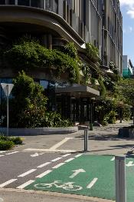
While lower cost solutions and minor changes to the existing network can increase connectivity in a more financially sustainable manner, leveraging State and Federal grant opportunities can support the delivery of more significant infrastructure projects. Council is committed to being a leader in active transport delivery and the safety of people walking, riding and wheeling in the region.

Supporting activities
Our community will enjoy a user friendly and comfortable network enhanced by complementary facilities.
Council is committed to making the network a more pleasant and enjoyable experience from end to end.
Our community told us that personal safety concerns can deter people from using active transport. Factors affecting safety include the time of day or night when traveling, feelings of isolation and vulnerability in certain areas of the network, the number of people on the paths, the increasing use of personal mobility devices and the speed of other path users and passing vehicles.
A user-friendly network can encourage our ‘interested but concerned’ group to feel more confident about using active transport. A clear and legible network is essential to prevent confusion and ensure users don't get lost. Additionally, rest areas and drinking fountains throughout the network offer people of all ages the chance to pause, rest, and hydrate. While easily identifiable end-of-trip facilities also reassure users that they are parking their bikes or scooters in the correct locations.
Our community told us they wanted more shading on the network. Embracing green urban infrastructure and maximising shade coverage can support our path users to have a more comfortable experience during our hottest months and continue to use active transport.
Council is committed to partnering with Traditional Custodians to protect, conserve and promote the region’s cultural heritage. Acknowledging the traditional walking routes of the Kabi Kabi and Jinibara peoples offers a chance to incorporate First Nations knowledge and histories into the active transport network, fostering ongoing celebration and recognition in the public realm.
Priority actions
- Investigate and prioritise a safe urban streets program.
- Investigate and prioritise a program of ‘low traffic, low speed neighbourhoods’.
- Plan and deliver end of trip and complementary facilities with a focus on key centres and major public transport stations and stops.
- Develop a personal mobility device strategy to guide their use within the region.
- Plan and deliver improved shade coverage on walking and riding routes.
- Maintain existing networks.
- Undertake a major update to the Transportation Asset Management Plan.
The community has highlighted the importance of keeping our active transport network assets in good condition through proactive maintenance.
Regular maintenance of the paths, clearing debris and trimming vegetation, will help users feel confident about experiencing a reliable and easy to use network. It is also important that users can report any issues to Council, knowing that Council will respond promptly.

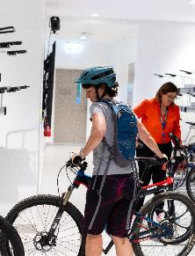
Promote, influence and encourage
Our community’s travel choices can be influenced by a variety of factors and providing a path network is just one element. Promotion, influence and encouragement can all increase a person’s willingness to choose active transport.
Best practice research indicates that to shift travel behaviour, 80% of the effort needs to focus on delivering the right infrastructure. The remaining 20% of the effort should focus on campaigns, awareness-raising and promotional activities targeting potential users (18).
Council is committed to encouraging people to use active transport more. However, it is important to recognise that working collaboratively with other levels of government, the community, industry and representative bodies, businesses, the private sector, schools and individuals will provide greater reach to influence and promote active transport than Council can achieve on its own.
Council has demonstrated its commitment to active travel and sustainable travel choices through its investment in the RideScore Active Schools Program and the ThinkChange Program. Delivering these programs has provided important opportunities to promote and encourage active transport at the grass roots level. Also, understanding their reasons for success and their limitations is important to guide future investment and program refinement.
Data is essential to influencing people using the active transport network. Understanding how, when and where people use the network can provide valuable insights on travel behaviours, community preferences and the impact of infrastructure investment. These insights can influence activities to promote and encourage active transport investment and use.
Priority actions
- Develop an active travel data collection plan.
- Promote and deliver travel behaviour change through ThinkChange program.
- Expand and promote RideScore Active Schools Program.
- Advocate to the Department of Transport Main Roads, Economic Development Queensland, Queensland Health, and Department of Education on Council’s active transport priorities.
- Consider active transport during updates to Council strategies, plans, policies or manuals.
- Review and update Council’s website and promote Council’s app.
- Develop a submission for the UCI Bike City Label.
- Continue to engage with Active Transport representative bodies.
With the Brisbane 2032 Olympic and Paralympic Games and other significant events coming to the Sunshine Coast, Council is committed to showcasing the region as an active transport destination to the world.

Case Study: 2028 UCI Para-cycling Road World Championships - UCI Bike City Label
The Sunshine Coast will host the Union Cyclist Internationale (UCI) Para-cycling Road World Championships in 2028. The event will attract competitors from over 45 countries, showcasing a course featuring the best natural assets of the Sunshine Coast from hinterland to coastline.
These championships feature different classes and categories for athletes with different types of disabilities, including handcycling, tricycle racing and visually impaired cycling.
The event will elevate the region as an international destination, showcasing para-sport and helping to inspire inclusion and diversity within the community.

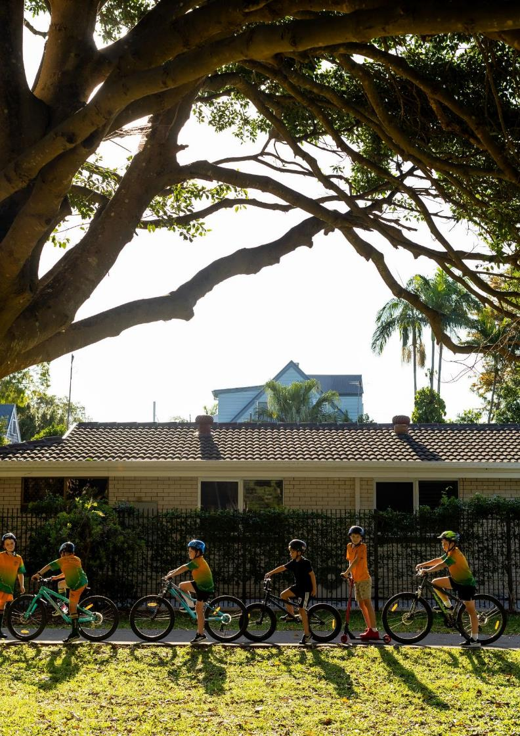
- Detailed action plan
The Draft Plan identifies a total of 54 actions to support delivery of its vision. The actions are to be delivered across the 3 priority areas of:
- Networks and Infrastructure - 17 actions.
- Supporting Activities - 14 actions.
- Promote, Influence and Encourage - 23 actions.

The actions are described according to the following:
Action ID - unique action identifier.
Action - brief action description.
Guiding Objective - identifies the action’s contribution to achieving the active transport vision by acknowledging the guiding objectives it supports.
- EA - Equitable Access.
- LS - Liveable and Sustainable.
- VA - Vibrant and Attractive Places.
- CC - Creating Change.
Priority - identifies the priority for delivering the action according to low, medium and high:
- Low - actions which are expected to have a smaller impact to achieving the vision.
- Medium - actions which are expected to have a medium impact to achieving the vision.
- High - actions which are expected to have a significant impact to achieving the vision.
Timeframe - a proposed timeframe for implementation across the next 10 years. Ongoing actions already undertaken by Council are shown continuing over the 10 year period.
Lead Council Team - a suggested Council team or combination of teams to lead delivery of the action.
Measure - a method to support the ongoing reporting and tracking the delivery of each action.
Funding - identifies the requirements for each action. Some actions may require further funding to support their implementation. Funding which may support the delivery of each action is suggested and includes Council’s Capital Works Program (CWP), Local Government Infrastructure Plan (LGIP) contributions and Transport Levy (TL) funding. External funding may be available through the Department of Transport and Main Road’s Walking Local Government Grants (WLGG) and Cycling Network Local Government Grants (CNLGG) programs.

Networks and infrastructure actions
Action ID | Action | Guiding Objective |  |  |  | Priority | Timeframe |  |  |  |  |  |  |  |  |  | Lead Council Team | Measure | Funding
Action ID | Action | EA | LS | VA | CC | Priority | 2025-26 | 2026-27 | 2027-28 | 2028-29 | 2029-30 | 2030-31 | 2031-32 | 2032-33 | 2033-34 | 2034-35 | Lead Council Team | Measure | Funding
NI-1 | Deliver an expanded walking network. | ✓ | ✓ | ✓ |  | High | · | · | · | · | · | · | · | · | · | · | Transport Capital Works | Length of active transport network delivered by Council, TMR and through development. | Achievable within existing resources.  (CWP)
NI-2 | Seek grant funding and implement Walking Network Plans. | ✓ | ✓ | ✓ |  | High |  | · | · | · | · | · | · | · | · | · | Transport Capital Works | Number of actions delivered. | Subject to additional funding.  (WLGG)
NI-3 | Deliver an expanded riding network and include more separated pathways. | ✓ | ✓ | ✓ |  | High | · | · | · | · | · | · | · | · | · | · | Transport Strategy and Policy | Length of active transport network delivered by Council, TMR and through development. | Achievable within existing resources.  (CNLGG, LGIP)
NI-4 | Advocate for high quality walking and riding outcomes in all Council projects including strategic transport and road network planning, public transport, open space and streetscape works that supports travel at all times of day and night. |  |  | ✓ | ✓ | High | · | · | · | · | · | · | · | · | · | · | Council wide | Number of projects that support improved active transport outcomes. | Achievable within existing resources.  (Advocate)
NI-5 | Identify suitable locations for road space reallocation demonstration projects (e.g. “green streets”) on our road network to improve place outcomes and community benefits through active transport. | ✓ | ✓ | ✓ |  | High | · |  | · | · | · | · | · | · | · | · | Urban Growth Projects | Number of projects that support improved active transport outcomes. | Subject to additional funding.  (TL)
NI-6 | Identify new initiatives for inclusion in existing programs, for lower cost solutions to improve connectivity e.g., missing links, new and improved crossings, incorporating technology. | ✓ | ✓ | ✓ |  | High | · | · | · | · | · | · | · | · | · | · | Transport Capital Works / Network Performance Services / Digital Information Services | Number of projects that support improved active transport outcomes. | Achievable within existing resources. (CWP)
NI-7 | Continue to invest in improvements to support rider safety e.g. speed reduction, shoulder widening and resealing, safety signage and technology. |  | ✓ |  |  | Medium | · | · | · | · | · | · | · | · | · | · | Transport Capital Works / Transport Network Operations / Digital Information Services | Road safety statistics. | Subject to additional funding - program dependent.
NI-8 | Target external funding opportunities and work in partnership to support and grow the delivery of active transport and safety infrastructure. e.g. Department of Transport and Main Roads grant programs | ✓ | ✓ | ✓ |  | High | · | · | · | · | · | · | · | · | · | · | Transport Capital Works | Number of grants received. | Achievable within existing resources. (Advocate, CWP, LGIP, external grants)
NI-9 | Develop a more transparent process of reporting active transport delivery. |  |  |  | ✓ | Medium |  | · | · | · |  |  |  |  |  |  | Urban Growth Projects | Annual reporting on active transport plan actions. | Achievable within existing resources.
NI-10 | Accelerate Brisbane 2032 Olympic and Paralympic Games legacy benefits through early delivery of active transport infrastructure. | ✓ | ✓ | ✓ | ✓ | High |  | · | · | · | · | · | · |  |  |  | Transport Strategy and Policy / SCC Brisbane 2032 Branch | Length of active transport network delivered. | Subject to additional funding.  (CWP, TL, LGIP)
NI-11 | Advocate to the Department of Transport and Main Roads for the delivery of a safe and inclusive active transport network that is integrated with new public transport stations and stops. | ✓ | ✓ |  | ✓ | High | · | · | · | · | · | · | · | · | · | · | Urban Growth Projects | Active transport mode share. | Achievable within existing resources.  (Advocate)
NI-12 | Improve connectivity on Council roads and streets to public transport stops and stations and leverage grant funding opportunities to maximise delivery. | ✓ | ✓ | ✓ |  | High |  |  | · | · | · | · | · | · | · | · | Transport Capital Works | Length of active transport network or/and accessible infrastructure delivered within 1km of public transport stops and stations. | Subject to additional funding. (Advocate, grants, CWP, LGIP)
NI-13 | Within the Council managed network, identify and prioritise signalised intersections where walking and riding delays can be improved and schedule for upgrade. | ✓ | ✓ |  | ✓ | Low |  |  |  |  |  | · | · | · | · | · | Network Performance Services | Number of crossings identified and scheduled. | Achievable within existing resources.
NI-14 | Advocate to the Department of Transport and Main Roads to reduce delays for walking and riding on state controlled signalised intersections. | ✓ | ✓ |  | ✓ | Low |  |  |  |  |  | · | · | · | · | · | Network Performance Services | Number of crossings improved. | Achievable within existing resources.  (Advocate)
NI-15 | Within the Council managed network, identify and prioritise signalised intersections and crossings where safety can be improved and schedule for upgrade. | ✓ | ✓ |  | ✓ | High |  |  | · | · | · | · |  |  |  |  | Network Performance Services | Number of crossings identified and scheduled. | Subject to additional funding. (CWP)
NI-16 | Advocate to the Department of Transport and Main Roads for safety improvements at signalised intersections and crossings. | ✓ | ✓ |  | ✓ | High |  |  | · | · | · | · |  |  |  |  | Network Performance Services | Number of crossings improved. | Subject to additional funding.  (Advocate)
NI-17 | Within the Council managed network, identify and prioritise existing unsignalised crossings to improve safety and accessibility (e.g., side road, mid-block, slip lanes and single lane urban roundabout approaches) and schedule for upgrade. | ✓ | ✓ |  | ✓ | High |  | · | · | · | · |  |  |  |  |  | Transport Capital Works | Number of crossings identified and scheduled. | Subject to additional funding. (CWP)

Supporting activities actions
Action  ID | Action | Objective Theme |  |  |  | Priority | Timeframe |  |  |  |  |  |  |  |  |  | Lead Council Team | Measure | Funding
Action  ID | Action | EA | LS | VA | CC | Priority | 2025/26 | 2026/27 | 2027/28 | 2028/29 | 2029/30 | 2030/31 | 2031/32 | 2032/33 | 2033/34 | 2034/35 | Lead Council Team | Measure | Funding
SA-1 | Investigate a proactive safe urban streets program and prioritise a list of streets to reduce speed. | ✓ | ✓ | ✓ | ✓ | High |  | · | · | · | · | · |  |  |  |  | Transport Capital Works | Number of streets with reduced speed. | Achievable within existing resources.
SA-2 | Establish a framework to investigate and recommend a program of "Low Traffic, Low Speed Neighbourhoods” and prioritise locations across the region. | ✓ | ✓ | ✓ | ✓ | High |  |  |  |  |  | · | · | · | · | · | Transport Capital Works /  Network Performance Services | Kilometres of network with reduced speed. | Subject to additional funding.
SA-3 | Plan and deliver improved shade coverage on walking and riding routes to align with Council policy. |  | ✓ | ✓ |  | High | · | · | · | · | · | · | · | · | · | · | Council wide | Number of new street trees planted along pathways. | Achievable within existing resources. (CWP)
SA-4 | Develop a personal mobility device strategy to guide their use within the region. | ✓ | ✓ |  | ✓ | High |  |  | · | · | · | · | · | · |  |  | Transport Strategy and Policy | Delivery of personal mobility device strategy. | Subject to additional funding.
SA-5 | Identify locations to better understand night-time walking and riding travel demand, for consideration in future projects and programs. | ✓ | ✓ | ✓ | ✓ | Medium |  |  |  |  |  | · | · | · | · | · | Council wide | Community perceptions of night-time safety. | Subject to additional funding.
SA-6 | Plan and deliver end-of-trip and complementary facilities to support walking and riding with a focus on key centres and major public transport stations and stops. | ✓ | ✓ | ✓ | ✓ | High |  |  | · | · | · | · | · | · | · | · | Council wide | Number of facilities delivered. | Achievable within existing resources
SA-7 | Encourage businesses and organisations to report opportunities for small scale complementary improvements which may facilitate increased walking, riding and wheeling. | ✓ | ✓ | ✓ | ✓ | Low |  |  | · | · | · | · | · | · | · | · | Active Travel & Transport Services | Number of reports received. | Subject to additional funding.
SA-8 | Identify Council owned facilities to prioritise installation of bike parking in secure and convenient locations. | ✓ | ✓ |  | ✓ | Medium | · | · | · | · | · | · | · | · | · | · | Transport Strategy and Policy | Number of facilities delivered. | Subject to additional funding.
SA-9 | Identify locations to deliver bicycle parking demonstration projects. | ✓ |  | ✓ |  | Medium | · | · | · | · | · |  |  |  |  |  | Active Travel & Transport Services | Usage rates at facilities. | Subject to additional funding. (TL)
SA-10 | Consolidate Council's understanding of First Nations walking routes through mapping. | ✓ | ✓ | ✓ |  | Medium | · | · | · | · | · | · | · | · | · | · | Geospatial and Mapping Services / First Nations Partnerships | Map of First Nations walking routes for Council reference. | Achievable within existing resources.
SA-11 | Audit and prioritise delivery of improved wayfinding infrastructure. |  | ✓ | ✓ |  | Medium |  |  |  | · | · | · | · | · | · | · | Active Travel & Transport Services | Number of wayfinding signage installed. | Subject to additional funding.
SA-12 | Promote the Sunshine Coast app for active transport benefits including maintenance reporting. | ✓ | ✓ | ✓ |  | High | · | · | · | · | · | · | · | · | · | · | Active Travel & Transport Services | Increase use of the Sunshine Coast App. | Achievable within existing resources. (Advocate)
SA-13 | Undertake proactive and responsive maintenance of the active transport network | ✓ | ✓ | ✓ |  | High | · | · | · | · | · | · | · | · | · | · | Parks and Gardens | Number of maintenance activities completed. | Achievable within existing resources.
SA-14 | Support the delivery of a major update to the Transportation Asset Management Plan with specific elements for active transport identified. | ✓ | ✓ | ✓ |  | High | · | · | · | · |  |  |  |  |  |  | Strategic Asset Management | Delivery of the Transportation Asset Management Plan. | Achievable within existing resources.

Promote, influence and encourage actions
Action  ID | Action | Objective Theme |  |  |  | Priority | Timeframe |  |  |  |  |  |  |  |  |  | Lead Council Team | Measure | Funding
Action  ID | Action | EA | LS | VA | CC | Priority | 2025/26 | 2026/27 | 2027/28 | 2028/29 | 2029/30 | 2030/31 | 2031/32 | 2032/33 | 2033/34 | 2034/35 | Lead Council Team | Measure | Funding
PIE-1 | Promote and deliver travel behaviour change activities through Council's ThinkChange Program. | ✓ | ✓ |  | ✓ | High | · | · | · | · | · | · | · | · | · | · | Active Travel & Transport Services / Communications Branch | Number of ThinkChange initiatives delivered. | Achievable within existing resources. (TL)
PIE-2 | Develop an active travel data collection plan to understand the usage of the active transport network. | ✓ | ✓ | ✓ |  | High | · | · | · | · | · | · | · | · | · | · | Urban Growth Projects | Enhanced travel data collected. | Subject to additional funding (TL)
PIE-3 | Identify opportunities to better understand and support active transport through the Smart City Framework |  |  | ✓ | ✓ | Medium |  |  | · | · | · |  |  |  |  |  | Urban Growth Projects | Number of active transport measures reported. | Subject to additional funding.
PIE-4 | Promote and expand the trial RideScore Active Schools Program including the delivery of supporting infrastructure. | ✓ | ✓ |  | ✓ | High | · | · | · | · | · | · | · | · | · | · | Active Travel & Transport Services / Communications Branch | Number of schools participating in the trial RideScore Active Schools program. | Subject to additional funding.
PIE-5 | Investigate opportunities to support increased walking and riding in underrepresented groups (e.g. families, young people and older persons). | ✓ | ✓ |  | ✓ | Medium |  |  |  | · | · | · | · |  |  |  | Active Travel & Transport Services | Number of targeted programs delivered. | Achievable within existing resources.
PIE-6 | Advocate Council's priorities for walking and riding to the Department of Transport and Main Roads, Economic Development Queensland, Queensland Health and Department of Education |  |  |  | ✓ | High | · | · | · | · | · | · | · | · | · | · | Council wide | Number of advocacy activities. | Achievable within existing resources. (Advocate)
PIE-7 | Investigate an incentive program for community, commercial businesses or bike groups to encourage the uptake of e-bike and e-cargo bike use. |  | ✓ |  | ✓ | Medium |  |  |  |  |  | · | · | · | · | · | Active Travel & Transport Services | Active transport mode share. | Subject to additional funding. (TL)
PIE-8 | Continue to promote positive behaviour amongst users of our path networks. | ✓ |  |  | ✓ | Medium | · | · | · | · | · | · | · | · | · | · | Active Travel & Transport Services | Number of customer complaints received. | Achievable within existing resources. (TL)
PIE-9 | Promote and celebrate new active transport infrastructure via events, marketing and media campaigns. | ✓ |  |  | ✓ | Medium | · | · | · | · | · | · | · | · | · | · | Communications Branch | Walking and riding counts. | Achievable within existing resources. (TL)
PIE-10 | Collaborate with external partners to encourage safer behaviours between all users of the transport network. | ✓ |  |  | ✓ | Medium | · | · | · | · | · | · | · | · | · | · | Active Travel & Transport Services | Number of conflicts and incidents reported. | Achievable within existing resources. (Advocate, TL)
PIE-11 | Support key advocacy groups to deliver activities which promote walking and riding in the region, such as Queensland Walks, Bicycle Queensland, Heart Foundation and RACQ. | ✓ |  |  | ✓ | Medium | · | · | · | · | · | · | · | · | · | · | Active Travel & Transport Services | Number of activities supported. | Achievable within existing resources. (Advocate)
PIE-12 | Continue to promote events such as National Walk2School Day and Ride2School Day. | ✓ |  |  | ✓ | Medium | · | · | · | · | · | · | · | · | · | · | Active Travel & Transport Services | Number of students participating. | Achievable within existing resources.
PIE-13 | Raise awareness of programs such as National Ride2Work Day, Queensland Walks Month. | ✓ |  |  | ✓ | Medium | · | · | · | · | · | · | · | · | · | · | Active Travel & Transport Services | Participation counts. | Achievable within existing resources.
PIE-14 | Provide resources to event organisers to encourage safe active transport and the inclusion of supporting facilities (e.g. bike racks). | ✓ |  |  | ✓ | Medium |  |  | · | · | · | · | · |  |  |  | Tourism & Major Events / Community Festivals & Events / Active Travel & Transport Services | Participation counts. | Achievable within existing resources (TL, Advocate)
PIE-15 | Develop an active travel culture within Sunshine Coast Council employees and visitors. |  | ✓ |  | ✓ | Medium |  | · | · | · | · | · | · | · | · | · | Active Travel & Transport Services | Number of employees and visitors using active transport to access Council offices and facilities. | Achievable within existing resources (TL)
PIE-16 | Coordinate the delivery of education and training to build organisation capacity in partnership with the Department of Transport and Main Roads. |  |  |  | ✓ | Medium |  |  |  |  |  | · | · | · | · | · | Active Travel & Transport Services | Delivery of active transport focused training. | Subject to additional funding.
PIE-17 | Review Council’s website for walking, wheeling and riding content and update to better promote active transport. | ✓ |  |  | ✓ | High |  | · | · | · | · |  |  |  |  |  | Active Travel & Transport Services / Web Team / Communication Branch | Website updated. | Achievable within existing resources. (Advocate)
PIE-18 | Develop material to promote the ease of using active transport to access public transport stops and stations coinciding with the commencement of services on ‘The Wave’. | ✓ | ✓ |  | ✓ | Medium |  | · | · | · | · | · |  |  |  |  | Active Travel & Transport Services / Communication Branch | Active transport promotional material for major public transport projects. | Subject to additional funding. (TL)
PIE-19 | Develop a submission for the UCI Bike City Label, in anticipation of the 2028 UCI Para-Cycling Road World Championships on the Sunshine Coast. |  | ✓ |  | ✓ | High | · | · | · | · | · | · | · | · | · | · | Sports and Major Events | Achieve the UCI Bike City Label. | Achievable within existing resources.
PIE-20 | Collaborate with local and national tourism bodies to promote the Sunshine Coast as an active transport destination. |  | ✓ |  | ✓ | Medium | · | · | · | · | · | · | · | · | · | · | Economic Development | Visitor travel behaviour information. | Achievable within existing resources.
PIE-21 | Promote Council’s grants program to community groups to deliver improved active transport initiatives. | ✓ |  |  | ✓ | Medium | · | · | · | · | · | · | · | · | · | · | Grants Team | Number of grant submissions. | Achievable within existing resources. (Advocate)
PIE-22 | Continue to engage with active transport representative bodies. | ✓ |  |  | ✓ | High | · | · | · | · | · | · | · | · | · | · | Council wide | Number of engagement activities. | Achievable within existing resources. (Advocate)
PIE-23 | Consider active transport when updating or refreshing Council’s strategies, plans, policies or manuals. | ✓ | ✓ | ✓ | ✓ | High |  | · | · | · | · |  |  |  |  |  | Council wide | Number of policies that include active transport levers. | Achievable within existing resources. (Advocate)

Glossary

Accessibility
The ease for people to travel from one place to another, including access by people with disabilities.
Accessible
A location or place that can be reached and entered by all potential users.
Active transport
A range of mobility types like walking, riding and wheeling that rely on human power and effort. It also includes wheelchairs, mobility aids, skateboards, rollerblades and unpowered scooters.
Activity centre
The focal points of communities based on the Planning Scheme, where people can access services, employment, education and leisure.
Adapted bikes
A special kind of bicycle that has been modified to accommodate the mobility needs of the rider. It can include tricycles/trikes (three wheel), quadricycles (four wheel), handcycles, or recumbents (reclined tricycles).
Bicycle / bike
A human powered vehicle with 2 or more wheels using a belt, chain or gears.
Bicycle parking
Any facility where bicycles or personal mobility devices can be stored when not in use.
Catchment
The area around a key destination, like activity centre, school or healthcare which can be accessed within a set time or distance. For example, a typical 10-minute walk would cover around 800m.
Connectivity
How well an area links with other places or amenities that people often travel to through links and connections.
Department of Transport and Main Roads
Queensland State Government Department of Transport and Main Roads.
E-bike
An electronically assisted bicycle using a small battery and electric motor.
E-cargo bike
An electronically assisted bicycle that has been adapted to carry goods or people, in addition to the rider.
Emerging community
A newly developing or growing urban area that seeks to create functional, efficient and attractive places for people to live, work and recreate with the potential for future expansion or development.
End-of-trip facilities
Amenities located in trip destinations like workplaces, schools and hospitals which can include bicycle parking, lockers, change rooms and showers for pedestrians and riders.
First and last mile
The first or last part of a trip when using public transport. For example, a walk to a bus stop (first mile) then walk from a bus stop to the workplace (last mile).
Footpath
An off-road path, typically adjacent or away from a road which can be used by people walking, jogging, running or using a mobility device. In Queensland, bicycle riders can use footpaths.
Level of traffic stress
A rating given to a road or crossing point that provides an indication for the traffic stress it can impose on riders. The rating is between 1 and 4, with the higher number indicating a higher stress environment.
LGA
Local Government Area.
LGIP
Local Government Infrastructure Plan.
Mode share
The percentage of overall transport trips that use a type of transport (mode). This usually includes a target as a desirable percentage using a mode of transport.
Modal filter
Is a road design that restricts the passage of certain types of vehicles. Often used to create low-traffic neighbourhoods or improve safety and amenity for people walking, riding and wheeling by reducing motor vehicle traffic.
Network
The footpaths, bike tracks, bike lanes, road crossings and bridges that create routes between different places.
One network approach
Council works in partnership with all levels of government to deliver one integrated transport network.
Personal mobility devices
An electric powered small device that is designed to transport a person over small to medium distances. Examples include e-scooters and e-skateboards.
Principal Cycle Network
The Principal Cycle Network (PCN) shows the core riding routes across Queensland that are needed to make it easy to ride a bicycle for everyday journeys. It is designed to be a clear framework for Council to plan, design and construct the riding network and prioritise its delivery.
Road space reallocation
Road space reallocation involves re-distributing road space currently used by private vehicles (including parking and traffic lanes) to prioritise sustainable modes including walking, cycling, and public transport, as well as green space.
Riding
People who ride bicycles, tricycles, adapted bikes, e-bikes and cargo bikes on shared paths, roads and cycle tracks. It also includes unpowered skateboards, scooters and roller-skates.
SCATAC
The Sunshine Coast Active Transport Advisory Committee is an advisory body which brings together strong walking, riding and wheeling advocates to share learnings and ideas to increase the uptake of active transport in the region, created by the Sunshine Coast Council and Queensland Government in 2021.
SEQ
South East Queensland.
Separated cycle tracks or paths
Footpaths dedicated for people riding. Sometimes also referred to as segregated paths. These separated facilities are supported by separate footpaths to reduce conflicts between people walking and riding.
Shared paths
Wide footpaths that can accommodate both people walking, riding and wheeling. Current guidance recommends a minimum width of 3m or 4m ideally.
ThinkChange
The Sunshine Coast Council’s travel behaviour change program to help the community find ways to reduce car use and contribute to a more connected, liveable and thriving Sunshine Coast.
Walking
People moving on footpaths covering a range of travel types like walking on your feet, pushing prams, moving luggage, using walking canes or other aids.
Wayfinding
Methods or features to help people orientate themselves in an area and guide people from place to place.
Wheeling
People using a wheelchair, mobility scooter or other wheeled mobility aid.
Appendices
Appendix 1 - United Nations sustainable development goals
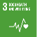
UNSDG 3 - This Draft Plan seeks to support healthy lives and promote well-being for all ages and abilities by increasing opportunities for people to choose active transport as part of day-to-day activities through safe and inclusive local connections.

UNSDG 4 – Council understands that reliable and safe transport is crucial for providing equitable access to quality education. The Draft Plan prioritises safe routes and crossings to schools, places of education, and access to public transport options.

UNSDG5 – This Draft Plan recognises that different genders have different experiences when moving about by walking, riding and wheeling. It supports this goal by seeking to remove the barriers that prevent achieving gender equity in active transport use.
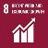
UNSDG8 - Lack of access to equitable transport options can inhibit a person’s opportunity for employment. This Draft Plan seeks to provide a low-cost transport alternative which reduces the need to own a private car to access decent work.
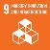
UNSDG9 - This Draft Plan understands that building resilient infrastructure that invites and supports people to move about by active transport instead of using the car will need to need to consider and incorporate the impacts of a changing climate in the region.
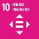
UNSDG10 - This Draft Plan seeks to promote greater social inclusion by ensuring that it is inclusive for all ages, genders and abilities. The Draft Plan increases social equity, through enhancing walking, riding and wheeling mobility to create inclusive communities.
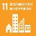
UNSDG11- This Draft Plan seeks to improve access to safe, affordable, accessible and sustainable transport systems for all. It recognises initiatives that target infrastructure improvement and greater efforts required to thoughtfully incorporate walking, riding and wheeling in the built environment to create liveable, thriving and resilient places.
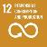
UNSDG12 - This Draft Plan recognises the important contribution that active transport can have to improve the management of and use of natural resources. Sustainable transport choices require reducing unnecessary travel by the car. Many of the actions will be achieved through the collaboration with community and private sector to promote walking, riding and wheeling opportunities.

UNSDG13 - This Draft Plan understands that there is an urgent need to take climate action. It provides support for this need by identifying actions which can reduce the emissions from the region, including transitioning to public transport alternatives, and promoting active travel choices as part of everyday trips.

UNSDG17 - This Draft Plan recognises the need to collaborate and work collectively to achieve our shared goal of increasing walking, riding and wheeling on the Sunshine Coast. Collaborative partnerships with governments, businesses and communities are crucial to achieve the vision, promote best practices, technologies and behaviours.

Appendix 2 - Divisions 1-10 aspirational walking network maps
Note refer to mapping on Have Your Say site

Appendix 3 - Divisions 1-10 aspirational riding network maps
Note refer to mapping on Have Your Say site

References

- Department of State Development, Infrastructure, Local Government and Planning. Shaping SEQ. State of Queensland. 2023.
- Roads, Department of Transport and Main. Queensland Houshold Travel Survey 2021-2024. [Online] 2025.
- Roads, Department of Transport and Main, Queensland Walking Strategy 2019-2029, State of Queensland. 2019
4. —. Multimedia walking content. [Online] 2024. https://www.tmr.qld.gov.au/travel-and-transport/pedestrians-and-walking/our-vision-for-walking/multimedia-walking-content.
5. Welfare, Australian Institute of Health and. Physical activity - Australian Institute of Health and Welfare. [Online] June 2024. https://www.aihw.gov.au/reports/physical-activity/physical-activity.
6. Badawi, Y, Maclean, F, and Mason, B. Economics of Walking. Victoria Walks. [Online] 2018. https://www.victoriawalks.org.au/Economics-of-Walking/.
7. —. Cycling Investment in Queensland. [Online] 2024. https://www.tmr.qld.gov.au/travel-and-transport/cycling/cycling-investment-in-queensland.
8. Garrard, Jan. Active transport: Children and young people. s.l. : VicHealth, 2009.
9. Department of Transport and Main Roads. Business Case for Walking. 2020.
10. Queensland Health. Healthy Places, Healthy People Framework. [Online] 2020. https://www.health.qld.gov.au/public-health/industry-environment/environment-land-water/healthy-places-healthy-people/framework.
11. Eady, J; Poetter, A; Rossiter, B. Walking Matters: Key evidence to support council planning. Victoria Walks, Melbourne, May 2024
12. Sunshine Coast Council. All Abilities Action Plan. 2024-2028.
13. Geller, Roger. Four Types of Cyclists. Portland : Portland Office of Transportation, 2009.
14. Cycling and Walking Australia and New Zealand. National Walking and Cycling Participation Survey 2023. [Online] 1 September 2023. https://www.cwanz.com.au/national-walking-and-cycling-participation-survey-2023/.
15. Sunshine Coast Council. Active Transport Plan 2025 Survey Results. [Online] 2024.
16. Department of Transport and Main Roads. Walking in Queensland Report: Walking for everyone, every day. [Online] 2019.
17. Department of Transport and Main Roads. Movement and Place. [Online] December 2024. https://www.tmr.qld.gov.au/community-and-environment/planning-for-the-future/movement-and-place.
18. Dufour, Dirk. PRESTO Cycling Policy Guide - General Framework. 2010.
Climate Council. Shifting Gear: The Path to Cleaner Transport. [Online] 2023. https://www.climatecouncil.org.au/resources/shifting-gear-the-path-to-cleaner-transport/.
United Nations. UN Environment report: Put people, not cars first in transport systems. [Online] 2016. https://www.un.org/sustainabledevelopment/blog/2016/10/un-environment-report-put-people-not-cars-first-in-transport-systems/.

