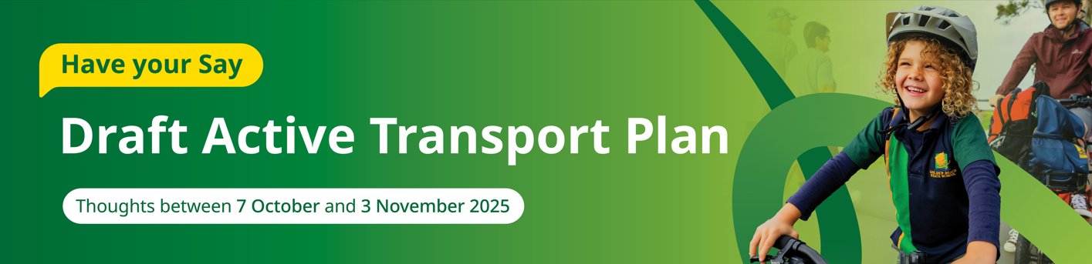

Council’s Corporate Plan 2025-30 has a clear vision to be Australia’s most sustainable region. Connected. Liveable. Thriving. Active transport can help Council to achieve this vision.
Our region is growing and as more people move about our community it is important that our transport networks are well connected. Supporting people to feel that walking, riding and wheeling is a safe and easy way to travel can help reduce congestion on our roads.
The Draft Active Transport Plan outlines actions for the next 10 years that aim to support people of all ages, genders and abilities to feel safe and included when they choose to travel by walking, riding or wheeling.

Understanding active transport
Active transport refers to walking, riding or wheeling - travelling from place to place using physical effort.
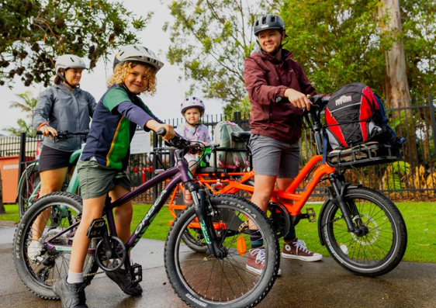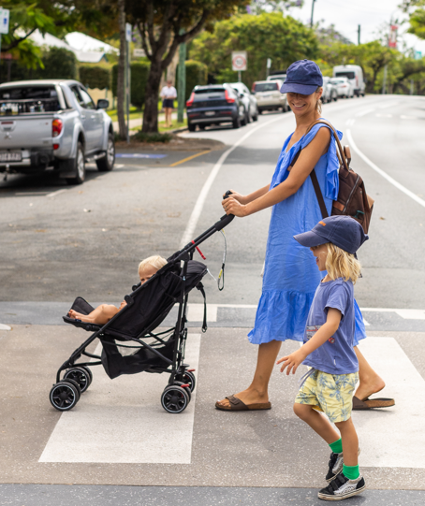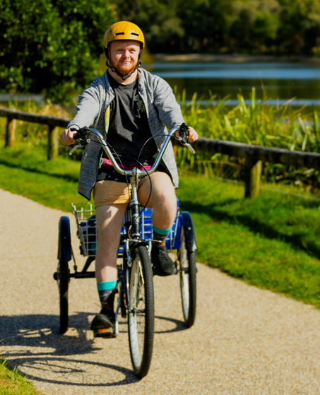
Short, local trips of less than 5km are well-suited to active transport and typically include:
- Commuting to work, school or volunteering activities
- Completing errands
- Accessing services or facilities
- Engaging in leisure or recreational activities.
There are many health, economic and environmental benefits when people choose to walk, ride or wheel instead of travel by car.
What is not active transport?
Council does not recognise certain electric-assisted personal mobility devices, such as e-scooters and e-skateboards, as ‘active’ transport due to their low physical effort requirements.

Informing the Draft Plan

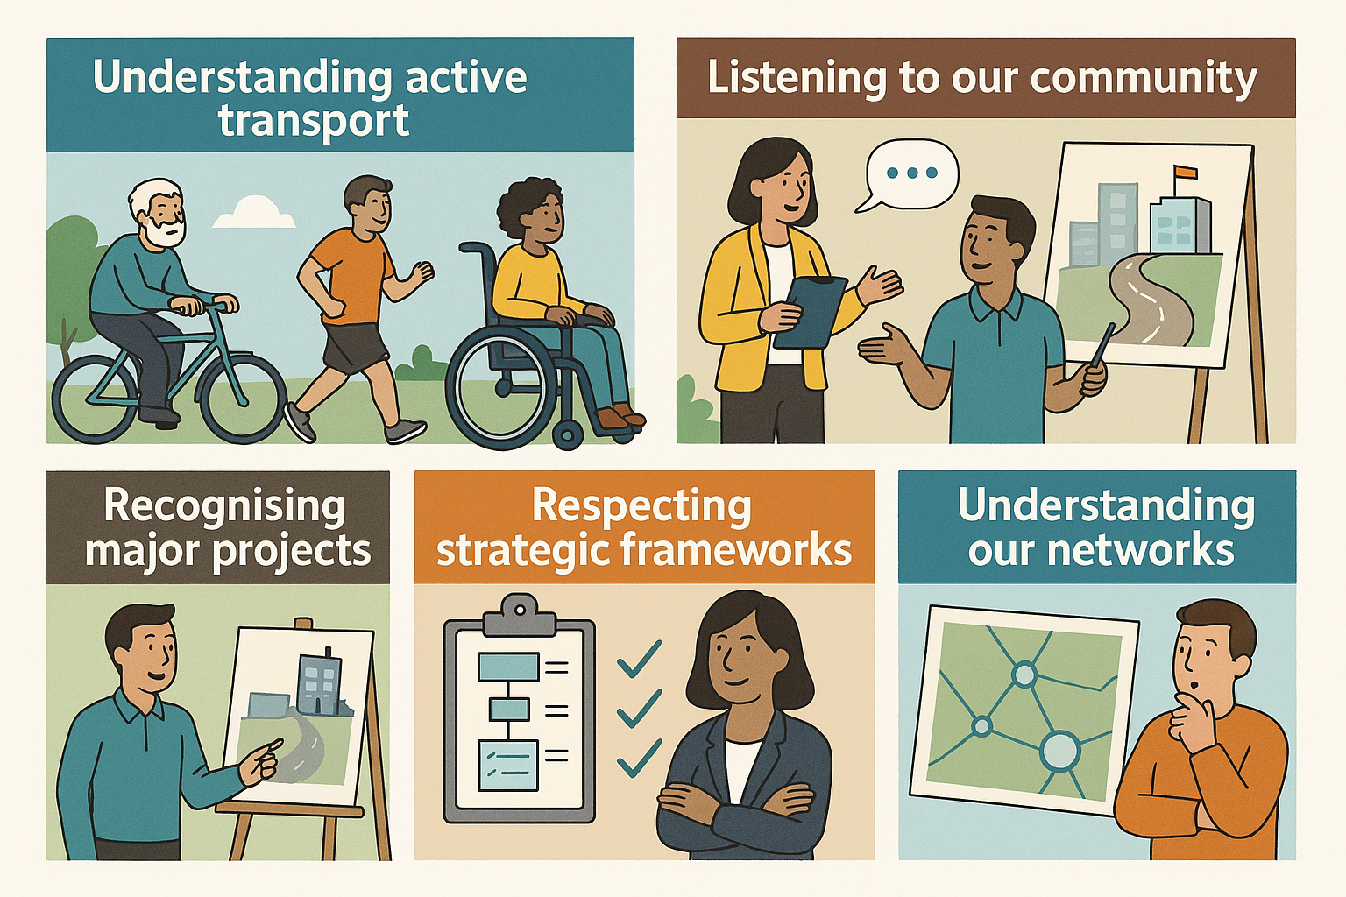

Listening to our community
In June 2024 Council engaged with the community to understand their perceptions and use of active transport.
The community identified three key priorities they would like addressed:
- Increasing connectivity
Improving the network, connectivity and facilities.
- Removing barriers for inclusivity
Safer environments for walking and riding.
- Valuing the needs of all
Balancing the needs of different path users.

Recognising major projects
The Wave incorporating Direct Sunshine Coast Rail with metro links and Brisbane 2032 Olympic and Paralympic Games venues and events are being planned for the region.

Respecting strategic frameworks
Protecting our lifestyle and character of our communities and landscapes as our population grows requires strategic frameworks and policies to guide and manage the impacts to our people, places and spaces.

Understanding our networks
Knowing where our paths are located helps to understand who can use them safely and their level of connectivity. Being curious about people who walk, ride and wheel helps to understand their level of confidence in using active transport, how far they travel and their most frequent type of trip.

Vision for active transport
Create a liveable, healthy, safe and connected Sunshine Coast by making walking, riding and wheeling an easy choice for everyday trips.

Guiding objectives
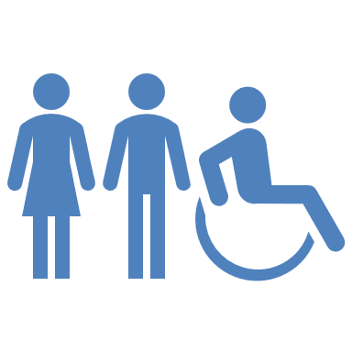 | Equitable Access  Everyone feels safe and included
 | Liveable and Sustainable  Preserving our lifestyle and amenity as change occurs
 | Vibrant and Attractive places  Creating places where people want to spend time
 | Creating Change  Becoming a place where safety and walking and riding is the norm

Aspirational active transport network
The following aspirational walking and riding network maps can be viewed on Council’s Have Your Say webpage for the Draft Active Transport Plan:
- Regional walking map
- Regional riding map
- Divisions 1-10 walking maps
- Divisions 1-10 riding maps

Three priority areas for action
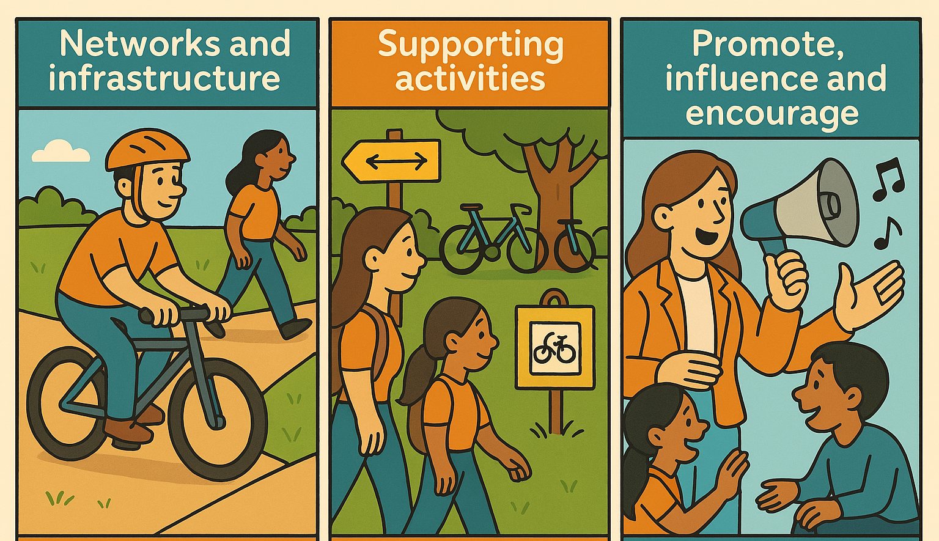

Networks and infrastructure
- Providing safe, inclusive and connected walking and riding networks through planning, design and construction.
- Identifying low cost and methods and solutions to expand, connect and increase accessibility to the network.
- Expanding the network while providing links to local destinations.

Supporting activities
- Providing complementary infrastructure and initiatives to support comfortable walking and riding trips from end to end (e.g. racks).
- Creating an inviting and attractive network experience to enhance liveable communities (e.g. shade).

Promote, influence and encourage
- Seeking partnership opportunities to promote active transport and deliver improved infrastructure outcomes.
- Influencing travel behaviour choices towards walking, riding and wheeling for short trips.
- Encouraging active transport to support a connected, liveable and thriving region.
Detailed action plan
There are 54 detailed actions identified for Council to implement independently or in partnership with others to encourage and support people of all ages, genders and abilities to choose to walk, ride and wheel more.

Provide your feedback via Council’s Have your Say page by 3 November 2025.

