Networks and Infrastructure
Our community indicated they want increased connectivity that feels safe and values the needs of all users.
Council is committed to delivering a connected, safe and inclusive active transport network. Expanding the walking and riding network is the foundation for increasing connectivity within communities and between communities, enabling more people to walk, ride or wheel.
Local connections and better connectivity
The Draft Plan aims to deliver safe and inclusive active transport infrastructure and address the need to expand the network.
Preparing and implementing walking network plans in partnership with the Department of Transport and Main Roads will guide planning, design and construction activities to improve our walking network. The preparation of walking network plans will focus on enabling easy walking choices around town centres, public transport stops and stations, schools, shops and health precincts.
To support improved riding choices providing dedicated and separated riding infrastructure will enhance connectivity to local destinations. This approach prioritises safety and equity for all active transport users, while reducing conflicts between path users and road users. Allocating space for people to dwell and travel at their own pace recognises the diverse needs of people of all ages, genders and abilities using the networks.
A place-based approach is supported by the Draft Plan to further enhance local connectivity. This approach can create stronger social and economic opportunities by ensuring there is a focus on planning, design and use of the active transport network in spaces and places shaped for our community. It will support outcomes that include more walkable neighbourhoods while giving meaning to places in which our communities can thrive by considering land use, the built form, amenity and the environment.
Road space reallocation
The Draft Plan will adopt a people-first approach to address the needs of all users within the transport network. Currently, the transport network prioritises private vehicle travel and car parking. To encourage more active transport this priority should recognise the needs of people choosing sustainable transport options and that includes walking, riding, wheeling and using public transport.
Active transport takes up the least amount of space compared to other transport modes, and when paired with public transport, they can move larger amounts of people. Reallocating road space allows for widening footpaths, the addition of protected bike lanes, more green space and the management of road speeds in busy areas. Changes to streets through place-based design and introducing separation through kerb separators and line markings, can create more usable and safer spaces at an affordable cost. Green streets offer a way to decarbonise road transport, lower emissions and create a sense of vibrancy through street designs that prioritise active transport users, shading and green urban infrastructure.
Road space reallocation demonstration projects offer a valuable opportunity to test and learn within a Sunshine Coast setting. Giving our community the opportunity to provide feedback on what can be improved and what works well can lead to better outcomes and increased community ownership in the future.
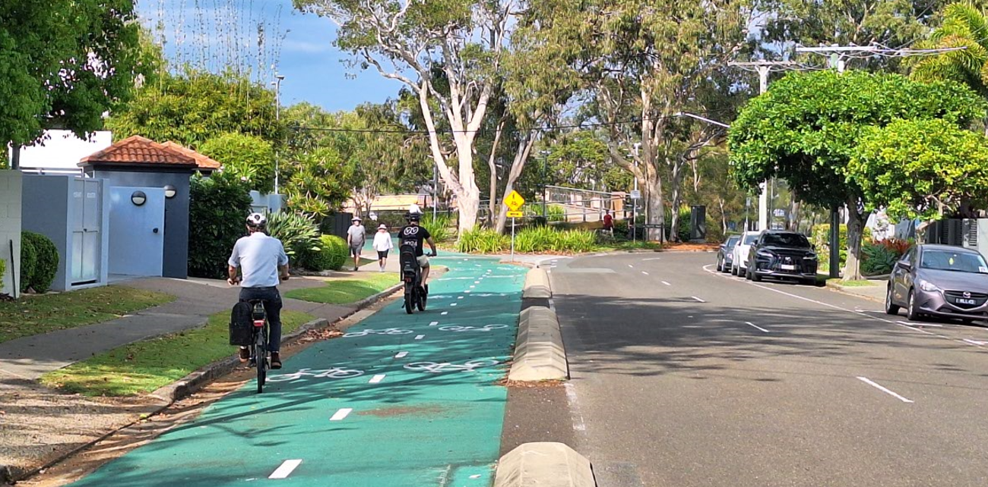
Figure 1: Reallocation of road space on River Esplanade in Mooloolaba. This example uses a low-cost approach to provide space for a separated riding facility while maintaining road vehicle access.
Lower cost big value solutions
The Draft Plan intends to prioritise implementing solutions that are fit for purpose, value for money and environmentally sustainable, while improving connectivity, accessibility and equity within our community.
While the Draft Plan identifies a range of improvements, the focus will be on lower cost and small-scale initiatives which may include:
- Addressing gaps in the path network
- Widening paths
- Installing missing kerb ramps
- Incorporating modal filters within neighbourhood road networks that improve safety and amenity by reducing volume and speed of vehicle traffic.
These improvements are designed to minimise the need for large scale investment while amplifying active transport benefits for the community. These can all support more people to walk, ride and wheel without requiring significant capital expense.
Other non-infrastructure solutions that are low cost but provide high impact are discussed in the separate information sheet Promote, Influence and Encourage.
The Draft Plan recognises the need to support active transport in rural areas that is outside of local townships and includes measures such as targeted speed reductions, shoulder widening, shoulder resealing, safety signage and technology to improve rider safety.
Project integration
The Draft Plan will prioritise the integration of walking and riding infrastructure into the planning, design and delivery of all Council projects. Recognising active transport as an organisation-wide responsibility will position Council to be a leader in safe active transport.
Infrastructure delivery
For new communities and developments, the Sunshine Coast Planning Scheme will guide and shape infrastructure planning and delivery to both align with the networks aspirations and ensure consistent best practice outcomes in new developments.
For our established communities, some areas already have walking and riding infrastructure. Where new walking and riding infrastructure is needed it will be retrofitted to balance safe, inclusive and connected active transport options with preserving the existing amenity. Best practice retrofit solutions will be considered and benchmarked with designs in consultation with local communities.
The Sunshine Coast Planning Scheme will provide design guidance and standards with further references to the Department of Transport and Main Roads and Austroads for best practice technical guidance.
For the Brisbane 2032 Olympic and Paralympic Games, the focus will be on the early delivery of walking, riding and wheeling infrastructure to event venues. This will support spectators attending The Games events while accelerating the benefits of connectivity and accessibility for the people in our community now.
Supporting public transport
Active transport provides the first and last mile connection to public transport stops and stations. Prioritising safe active transport links to stops and stations expands the reach and accessibility of the region’s public transport network, making it more viable for everyday journeys. This can further support the community to achieve the recommended amount of daily physical activity.
The Wave - Stages 1, 2 and 3 will transform the way we travel by providing new public transport options. Council will advocate for and collaborate with stakeholders to prioritise the integration of active transport into public transport stops and stations with connections to community facilities and recreation areas.
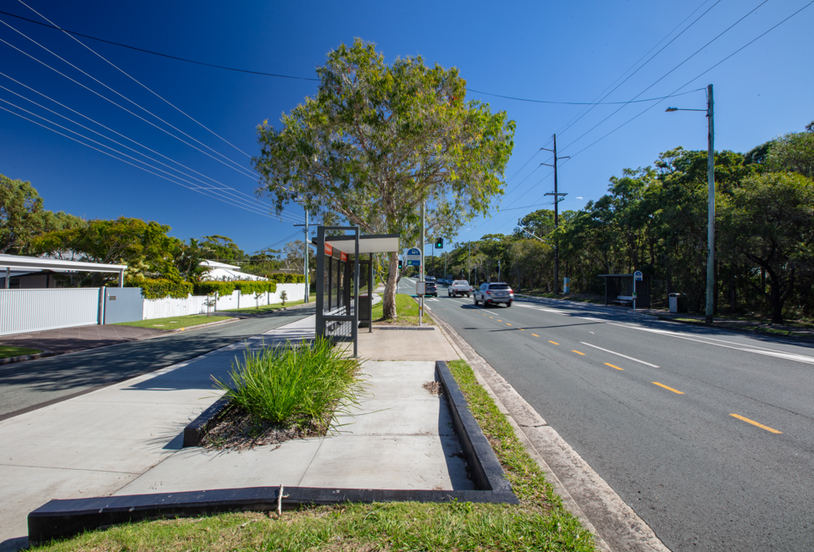
Figure 2: Active transport connection to a local bus stop
Safer crossings and streets
The community wants neighbourhoods and streets to be safe inclusive and accessible. A key priority will be improving safety at road crossings and providing more equitable opportunities to travel across roads.
To reduce crossing distances and improve safety at signalised crossings, protected corners, kerb ramps, indicator lights, countdown timers and buildouts may be retrofitted or installed. A review of signalised crossing timings will support prioritising active transport, targeting reduced waiting times and increased crossing times.
Time delays crossing heavily trafficked streets can reduce acceptable walking distances by up to 15% and inconvenient street layouts can reduce them by up to 20%.
Council will advocate to the Department of Transport and Main Roads to prioritise a review of state-controlled road traffic signals to support similar improvements seeking a coherent outcome across the network.
At side roads, mid blocks, slip lanes and single lane urban roundabout approaches, Council supports safer crossings for walking and riding. This can be achieved by introducing raised priority crossings, continuous footpath treatments and wombat crossings at these locations. To support the delivery of active transport infrastructure on state-controlled roads and to access public transport stops and stations, Council will advocate to the Department of Transport and Main Roads.
Case study: Wagga Wagga active transport network
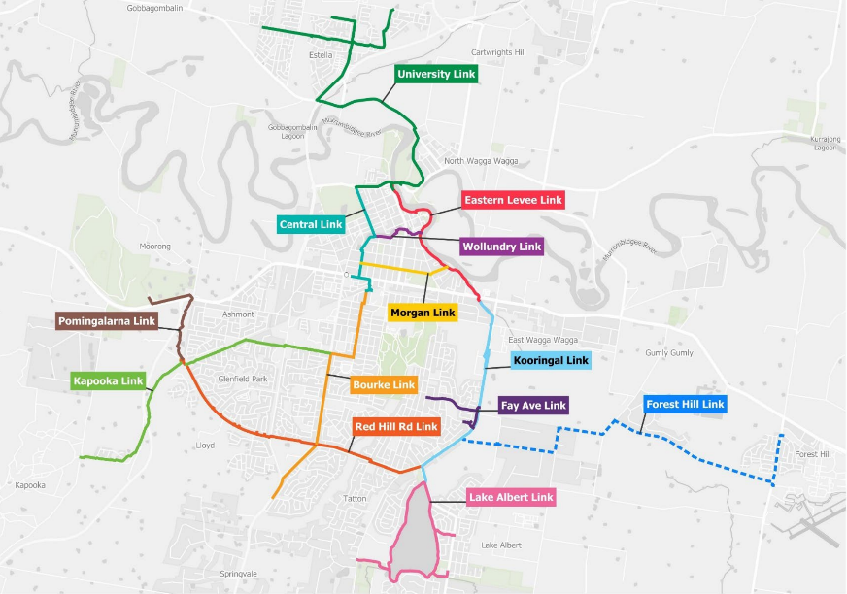
Wagga Wagga in New South Wales received $15 million from the Cycling Infrastructure Fund (Transport for NSW) to develop a 57km active transport network across the city. The result was an extensive, high quality, safe and accessible walking and riding network built between 2020 and 2022.
The project delivered new or resurfaced shared paths focusing on connectivity to schools, universities, workplaces, recreation and leisure facilities.
The local community using the network were found to be almost 4 times more likely to meet physical activity guidelines, improving health and wellbeing of the community.
Image used with permission of Wagga Wagga City Council
Funding and reporting
The Draft Plan acknowledges that external funding is critical to deliver the aspirational active transport networks. Funding sources can be leveraged for the planning and delivery of the aspirational network and complementary facilities, as well as for data collection and monitoring.
Available grant programs through the State and Federal Governments may include:
- Active Travel Infrastructure Program (ATIP)
- Black Spot Program
- Community Road Safety Grants (CRSG)
- Cycling Infrastructure Policy (CIP)
- Cycle Network Local Government Grants (CNLGG)
- Transport Infrastructure Development Scheme (TIDS)
- Walking Network Planning Infrastructure Program
- Walking Network Local Government Grants (WNLGG)
- Safer Local Roads and Infrastructure Program (SLRIP).
Council will report annually on the implementation of the Draft Plan.
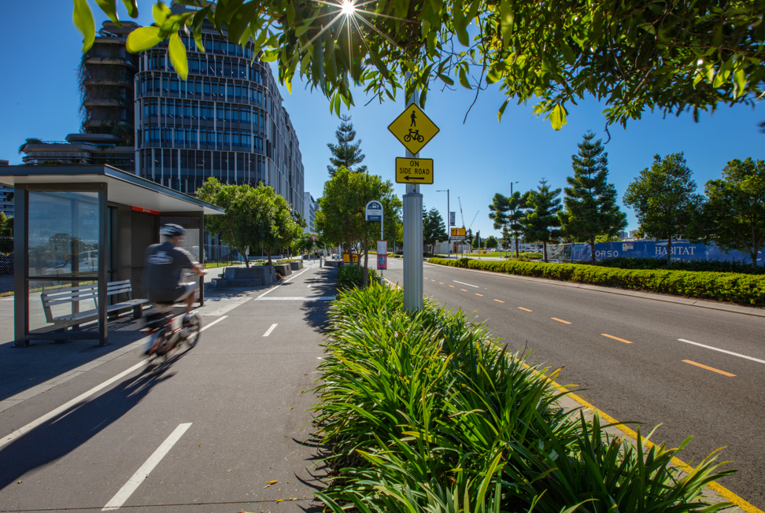
Figure 3: Continuous footpath treatment to enable safer active transport in Maroochydore City Centre.

