Supporting Activities
Our community will enjoy a user friendly and comfortable network enhanced by complementary facilities.
Council is committed to making the network a more pleasant and enjoyable experience from end to end.
Prioritising safety
Our community told us that traffic safety and personal safety concerns are a major barrier to choosing active transport. Personal safety is a sensitive issue that varies between individuals. Factors affecting safety include the time of day or night when traveling, feelings of isolation and vulnerability in certain areas of the network, the number of people on the paths, the increasing use of personal mobility devices and the speed of other path users and passing vehicles. The Draft Plan prioritises addressing these safety concerns to help create a more inclusive and accessible active transport network. Council’s Planning Scheme prioritises safety and safe system outcomes for transport.
The Draft Plan recognises that the Australian Government has committed to a goal of zero traffic deaths and serious injuries by 2050 on the Sunshine Coast through its National Road Safety Strategy 2021-30 (1). With more people using active transport, providing safer streets and roads is necessary to achieve this goal.
The Draft Plan supports a safe urban streets program focusing on reducing road speeds and providing traffic calming at locations around schools, health precincts, aged care facilities and activity centres.
If a person is hit by a car travelling 30km/h or less, evidence shows a person has 90% chance of surviving.
If a person is hit by a car travelling at 50km/h, they have a 90% chance of being killed.
Similarly, low traffic, lower speed neighbourhoods can contribute to creating thriving, quality places. With lower traffic stress they can support higher street activity and vitality, with people feeling safer to walk, ride, wheel and dwell. Measures to lower speed can include lower signposted speeds, raised priority crossings, traffic calming and road space reallocation.
Case study: Cotton Tree raised crossings - creating safe walkable neighbourhoods
Nine raised pedestrian priority crossings and reduced speed limits are being introduced in Cotton Tree to slow motor vehicles and enhance safety.
Eight raised crossings will be installed at side roads on Sixth Avenue, with an additional raised zebra crossing on Fourth Avenue. Speed limits will be reduced to 40km/h, and 2m shared paths will also be installed to improve accessibility and safety.

Recognising that travel occurs at all times of the day and night demonstrates the need to ensure that night-time travel is considered in the planning and delivery of all projects which support people to use active transport. This consideration seeks to create safe, inviting connections and spaces for everyone, whenever they travel. It will also be important to have an awareness of other light related initiatives such as the proposed Dark Sky Reserve and light dimming initiatives to support turtle nesting and hatchling behaviours when considering lighting for night time travel.
These initiatives will focus on areas with high night-time activity and economy and include entertainment precincts, major public transport stops and stations, high density residential zones and areas with a high percentage of night-time shift workers, such as health precincts. Good night-time design solutions will also support active transport users to be more visible at night and improve the perception of safety.
The Draft Plan understands there is growing use of personal mobility devices such as e-scooters on the transport networks. The Draft Plan prioritises developing a Personal Mobility Device Strategy to guide their safe integration into the broader transport network. The strategy may influence usage, minimise path conflicts and promote safety through education and awareness programs.
Complementary facilities
The Draft Plan seeks to support people have a pleasant and enjoyable experience travelling on the active transport network. It recognises the need to create a framework of complementary facilities to facilitate safe, attractive and comfortable user experiences from end to end of their journey. These complementary facilities can include drinking water fountains, wayfinding, rest areas, shading and end of trip facilities.
The provision of end of trip facilities, which may include bicycle parking, showers and change rooms, and locker facilities are necessary to support people to use active transport. Acknowledging that active transport refers to travelling from place to place using physical effort, these facilities support people to feel refreshed after travel and confident that their bike or scooter along with other personal belonging to enable safe and comfortable travel, such as a helmet, are securely stored. Facilities at workplaces or are publicly available, support access to employment, high-activity precincts and Council owned facilities.
The Draft Plan supports the investigation and delivery of bicycle parking demonstration projects to assist with understanding opportunities for innovative and low-cost bicycle parking solutions across the region.
Council’s Planning Scheme provides guidance on complementary facilities and embeds an active transport first outcome in new developments. In Council’s parks, new facilities will need to align with the Recreation Parks Plan and the Landscape Infrastructure Manual.
The Draft Plan looks to encourage businesses and organisations to report potential opportunities for small scale complementary treatments to Council and improve accessibility to their location. This may include reporting opportunities to provide bike parking, seating or installing kerb ramps to support and make using active transport easier.
The Draft Plan wants to make it easier for people to travel from place to place using the active transport network and support them to access local destinations, parks, open space and activity precincts. Improved wayfinding will be prioritised to identify local destinations along the path networks while the Sunshine Coast App will provide a ready digital resource of maps to guide and plan connections. In addition, opportunities will be explored to brand or profile key active transport corridors making them easier to recognise, connect with and move through.
First Nations heritage
Council is committed to partnering with Traditional Custodians to protect, conserve and promote the regions cultural heritage. The Draft Plan will integrate knowledge, culture and values into the active transport network, recognising that walking routes have long supported First Nations peoples to navigate their way within and across the region. Collaborating with the Kabi Kabi peoples and Jinibara peoples will ensure local First Nations walking routes and connections can be identified and recorded to support ongoing celebration and recognition.
Case study: Maroochydore Bike Parking
Council has recently installed a new BikeHub in Maroochydore at the Duporth Avenue entrance to the Big Top Shopping Centre. An initiative of Council’s ThinkChange program, it aims to support sustainable travel choices and enhance the community’s riding experience.
The provision of the BikeHub was in response to customer enquiries and makes use of available space without affecting accessibility and supports the shared zone status of Duporth Avenue. The BikeHub features parking for up to 10 bikes or scooters and includes a smart camera for monitoring usage, to evaluate its use during the trial period.
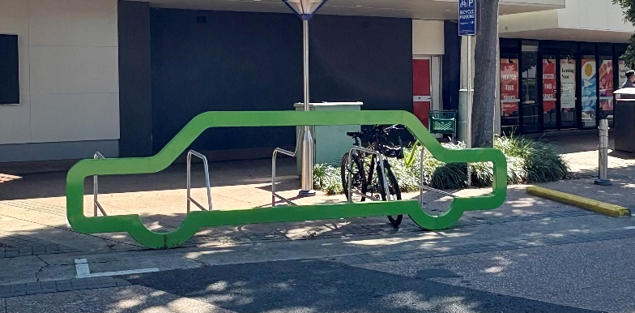
Figure 1: Maroochydore BikeHub demonstration project

Greening the networks
The Draft Plan aims to connect communities across the Sunshine Coast and encourage people to enjoy the beautiful natural environment and climate in the region. With rising temperatures due to climate change, and Queensland’s high skin cancer rates, reducing these impacts to our community is a priority.
The Draft Plan looks for opportunities to support the Healthy Places Healthy People framework and improve shade coverage across the active transport network using tools such as CanopyCast. Providing natural shade coverage across the active transport network and embracing the inclusion of green urban infrastructure will help Council to achieve its shade targets, support improved user comfort outcomes and make it easier and more inviting for people to incorporate active transport throughout the year.
Maintaining our assets
The community has highlighted the importance of keeping our active transport network assets in good condition through proactive maintenance. The Draft Plan recognises the importance of regular maintenance of the paths, clearing debris and trimming vegetation, to help users feel confident about experiencing a reliable and easy to use network. The Sunshine Coast App is a regionally recognised and easy to use platform for reporting maintenance to Council. It will be promoted as an important resource for our community to report active transport maintenance concerns to Council and enabling a prompt response.
The Draft Plan will prioritise a major update to Council’s Transportation Asset Management Plan which will include specific elements for the active transport network.
References
- Department of Infrastructure, Transport, Regional Development and Communications, National Road Safety Strategy. Commonwealth of Australia. 2021
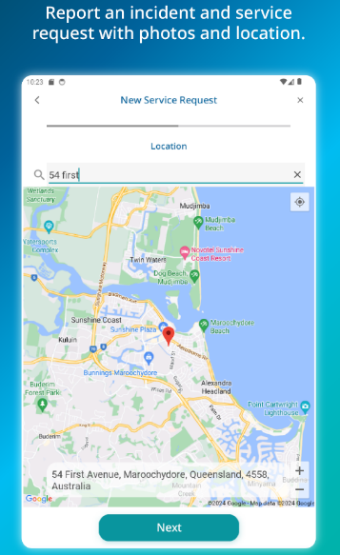Figure 2: Sunshine Coast App service request feature

Dark sky areas are locations with low impacts from artificial lighting, like street lighting, providing an enhanced night sky for scientific or public enjoyment
CanopyCast is a tool developed for Queensland Health to inform the design of the built environment and reduce heat-related health impacts.

