General themes:
 More beach access, staircases and ramps
 More information on revegetation plans and park changes
 Less grey concrete used in the seawall
 General support and understanding for the seawall and stormwater improvements
 Maintain access to the Pumicestone Passage

Project background
As part of the Bribie Island Breakthrough Action Plan, Sunshine Coast Council is designing a revised seawall and drainage renewals to safeguard the foreshore between Lamerough Canal and the June Street boat ramp along Diamond Head at Golden Beach. This work follows damage caused by storm surges, high tides, and erosion linked to the Bribie Island breakthrough and recent severe weather events.
In November and December 2025, Council invited community feedback on the Diamond Head Seawall and Foreshore Improvement project. We presented our community with multiple artist impressions of the seawall and foreshore improvements and provided information on the proposed works. We engaged with the community online and across four pop-up events for four weeks in conjunction with the Coastal Hazard Adaptation Precinct Planning (CHAPP) project.

Feedback summary
We chose to keep the feedback open-ended to capture a broad range of community perspectives on the project. While responses varied, overall sentiment was generally supportive of the proposed works.
Several common themes emerged:
- the importance of maintaining, and where possible enhancing, access to the beach and Pumicestone Passage;
- reducing the use of plain grey concrete;
- softening the design through additional planting; and
- providing more detailed information about the revegetation and parkland components of the project.

What actions will be taken following feedback?
We will continue working with the design team to incorporate feedback wherever feasible. To date, we have already:
- Investigated alternatives to plain concrete, including the use of coloured concrete for the vertical wall elements.
- Incorporated additional staircases and access ramps into the design, spaced appropriately across the site to improve connectivity and access.
- Included a new pedestrian ramp near Military Jetty, responding directly to a key community request. This ramp is planned for delivery as part of Stage 1.
- Collaborated closely with Council’s landscape architects to explore opportunities to soften the seawall through low-level plantings. More detailed information on revegetation and parkland treatments will be provided during the next round of consultation.
- Reviewed requests for additional public toilets along the coastal pathway. The area currently has two facilities spaced evenly, and based on service standards and usage expectations, it is considered adequately serviced at this stage.
- Acknowledged community requests to retain sandy beach areas. Ongoing maintenance dredging is planned along Diamond Head to help keep much of the seawall and stormwater extensions buried. After major storm events, some structures
may become temporarily visible until natural sand movement re-covers them.

Where to from here?
The project team will continue progressing the detailed design and preparing the required permit amendments for the seawall. Landscape and parkland plans will be further developed and presented to our community for a second phase of engagement later in the year.
We will aim to start stage 1 construction works in 2026, aligning with our capital works budgeting and Qcoast2100 grant funding. Construction is expected to take 8-12 months (weather permitting) and will extend from Lamerough Canal to approximately the Military jetty boat ramps. Further stages will be delivered as additional funding and grant opportunities become available.

Further information
For further information about this project, please visit our website or contact the Project Officer, Mat Wright, on 5475 7272.
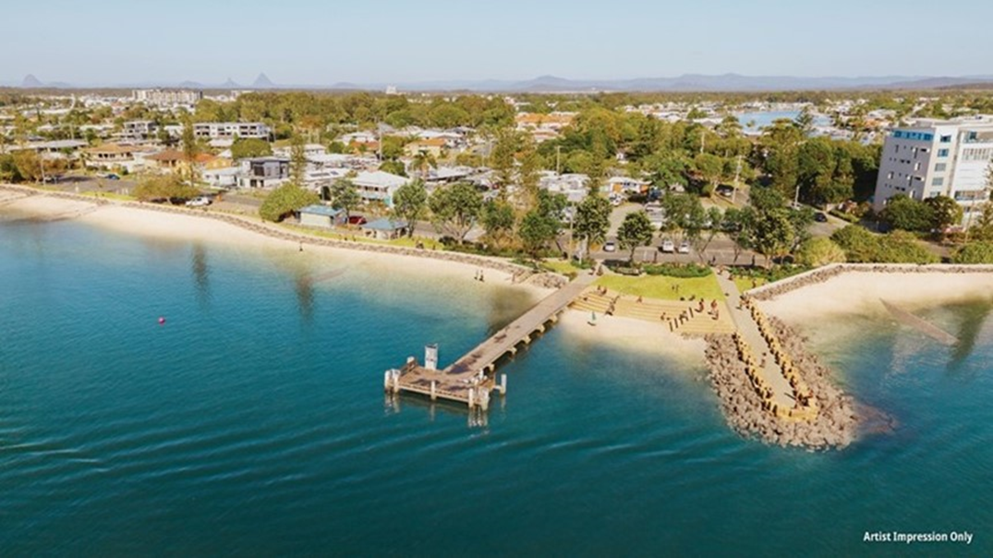
Sunshine Coast Council | sunshinecoast.qld.gov.au | Customer.Service@sunshinecoast.qld.gov.au
07 5475 7272 | Locked Bag 72 Sunshine Coast Mail Centre Qld 4560

