Council is collaborating with the Young Leaders Academy and young people across the Sunshine Coast to develop a new Youth Plan aimed at improving the lives of young people. The Youth Plan will include actions for us to work on together. This report summarises the community engagement activities undertaken in the first stage of the project, which prioritised listening to young people. This input will ensure the Youth Plan is focused on what matters most to young people in our region.

Overview
Community engagement took place over a six-week period between 2 June and 15 July 2025. The purpose of the engagement was to hear from young people about what they like about living on the Sunshine Coast and what needs to change.
Various engagement methods were used, including online and face-to-face activities. These methods were chosen to facilitate input from young people located across the region.
During this stage of engagement, 2,056 people visited the Have your Say webpage, 582 young people completed the online survey, 450 young people participated in pop-ups, and 85 young people attended the Youth Forum.
Up to 1100 young people aged 12-24 years contributed to the project, providing a strong foundation for the Youth Plan.

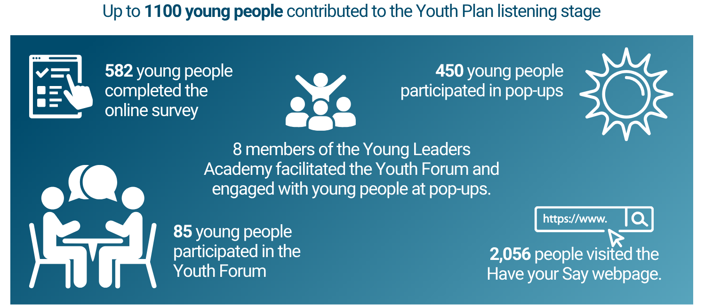

Engagement Activities

Young Leaders Academy members
The Young Leaders Academy is a youth development program supported by Council focused on civic leadership and participatory action.
This year, members of the Young Leaders Academy were heavily involved in planning and facilitating the Youth Forum. They also facilitated discussions at the various pop-up events and reviewed the online engagement hub and survey.
All of these young people juggled their involvement in the project alongside study, work and other commitments. We sincerely appreciate their contributions so far!
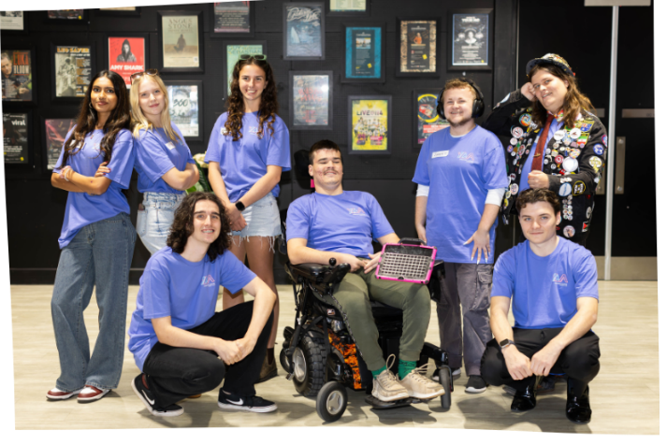
YLA members at the Youth Forum 2025.

Youth Forum
The Youth Forum, co-hosted by Council and the Young Leaders Academy, was held on 28 May 2025 at Venue 114. Young people aged 12-24 years from across the region were able to attend, with a primary focus on attendance from high school students.
In total, 85 young people attended, including representatives from 14 schools.
The Youth Forum used a variety of participatory engagement methods to ensure young people felt safe and able to participate. A lived-experience panel with members of the Young Leaders Academy started the day, followed by discussions about our vision for the future and what needs to change to achieve the vision. After lunch we discussed collective actions that could be taken, as well as doing a reflective activity focused on personal action.
More information about the forum and feedback findings is available on Have your Say Sunshine Coast.
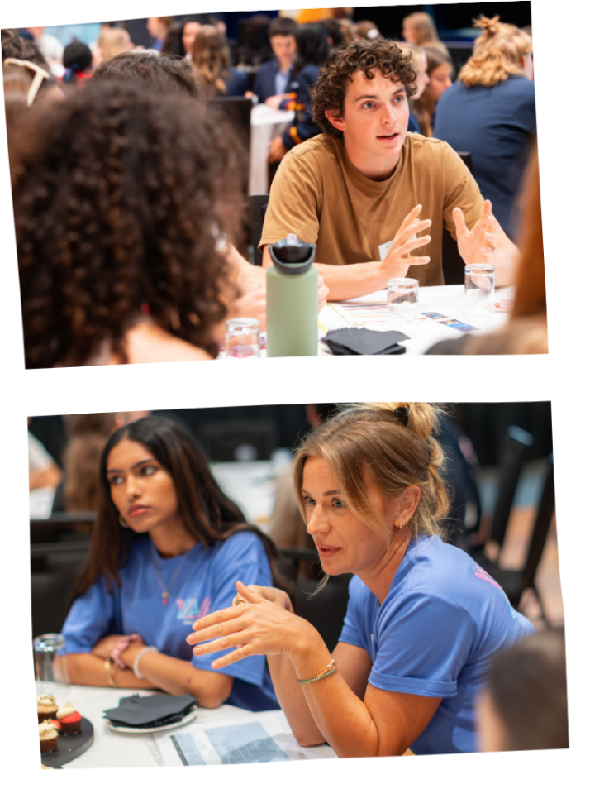

Youth survey
582 young people completed the online youth survey during the six-week engagement period, including 458 young people aged 12-17 years and 117 young adults aged 18-24 years.
Most young people agreed that the Sunshine Coast is a great place to live, primarily due to their friends and family and access to the natural environment. However, mental health, housing affordability and safety were raised as challenges. Young people also shared many valuable ideas for collaborative action.
The results of the survey are available on Have your Say Sunshine Coast.

Pop-up events
The pop-up activities were an important part of the engagement program as they helped engage with young people where they were - out shopping, playing community sport, enjoying the weekend or at university.
The pop-up activities focused on a discussion of what is good about the Sunshine Coast and what could be improved.
In total, 450 young people participated at 12 pop-up events:
- Youth Fest Baringa: 11 April
- All Access Day at Caloundra: 4 May
- Salty Saturdays at Coolum: 14 June
- Maleny Library: 18 June
- Nambour Quota Park: 22 June
- Caloundra Street Fair: 29 June
- Sunshine Plaza Maroochydore: 5 July
- NAIDOC Flag Raising Ceremony: 8 July
- Sharks Rugby League Club: 12 July
- UniSC orientation week: 14 July
- TAFE Mooloolaba and Nambour: 15 July.

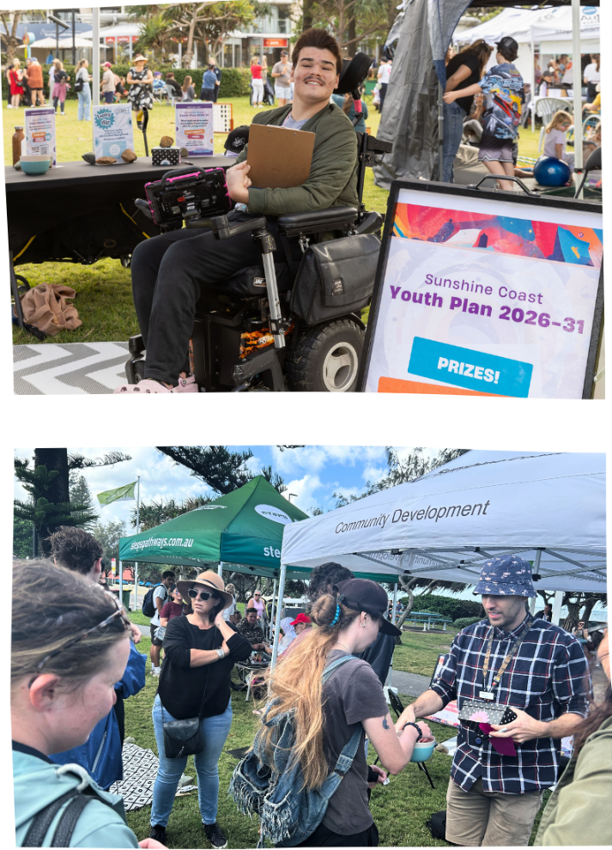

Youth sector survey
Older adults who work closely with young people were able to complete a separate online survey. 35 responses were received from workers providing services such as:
- Accommodation and transition support
- Mental health, education and employment support
- Community development
- Youth programs.

Council team engagement
A workshop was also held with team members from Council on 8 May. Council team members who engage, connect and collaborate with young people shared their ideas about the needs of young people.

Summary of engagement findings
Overall, young people told us that the most significant current challenges are:
- Cost of living and financial stress: Housing availability and affordability, and increased cost of living generally, is contributing to an uncertain financial future for young people that is causing stress about career choices and worry about potentially needing to move away from the region.
- Crime and safety: Young people are concerned about their physical safety in their neighbourhoods, youth crime and safety online.
- Mental health challenges: This included serious illness as well as matters of confidence, body image and stress associated with balancing school and work pressures.
The following were also important priorities identified by young people:
- Difficulty getting around: Inadequate public transport and cost of travel limit the ability of young people to travel independently. E-scooters and e-bikes are generally supported as they fill a gap in the transport network, but young people noted more needs to be done to ensure safe use.
- Job and career opportunities: A limited range of available education and career options is a challenge, as well as the difficulty of making informed decisions about a future career with limited information.
- Family and community connections: Young people value their relationships with family and friends and want more opportunities to connect in person to foster deeper connection and belonging.
- Climate change and the environment: Young people value access to the natural environment and are concerned about pollution, habitat loss, urban sprawl and climate change.
- Not feeling heard, included or valued: Young people often feel stereotyped, misunderstood or excluded from decision making. Discrimination, stigma and negative media coverage contribute to a sense of not being valued, heard or welcome in public spaces. Some also feel the Sunshine Coast is not accepting of diversity and has a conservative attitude to social issues.
- More things to do (events, activities, programs, hang out): Many young people feel the Sunshine Coast lacks affordable things to do including arts, music, sports and other entertainment options. They want more events, activities, and safe places to hang out to feel connected and engaged.

Next steps
Thank you to everyone who provided their valuable input into the Youth Plan during this first stage of engagement.
A draft Youth Plan will now be developed based on this input. It will be released later in 2025 for community feedback. The final Youth Plan will be presented to Council in early 2026.

More information
Visit Have your Say Sunshine Coast for more information about the project or contact the Community Development team by email: youngpeople@sunshinecoast.qld.gov.au.

